Unit 4 Lesson 20: Add and Subtract Within 1,000,000

WU Notice and Wonder: Subtracting Tens of Thousands (Warm up)

Student Task Statement
What do you notice? What do you wonder?
A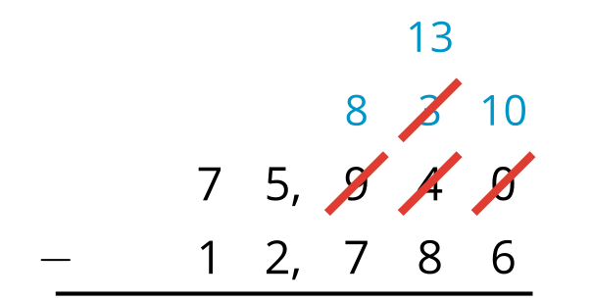
B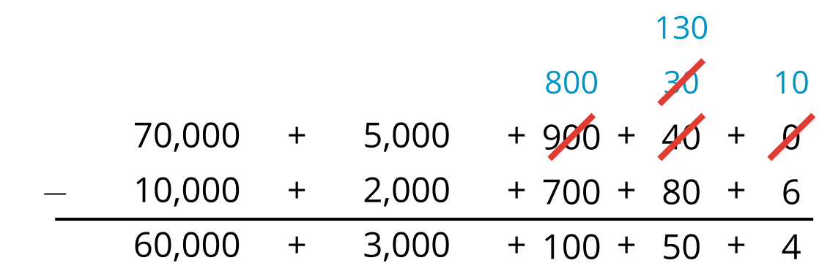
​​​​​​

1 Add and Subtract Large Numbers

Student Task Statement
- Use the standard algorithm to find the value of each sum and difference. If you get stuck, try writing the numbers in expanded form.
  - $7,​106+2,​835$
  - $8,​179−3,​599$
  - $142,​571+10,​909$
  - $268,​322−72,​145$
- Find the missing number that would make each computation true.
- a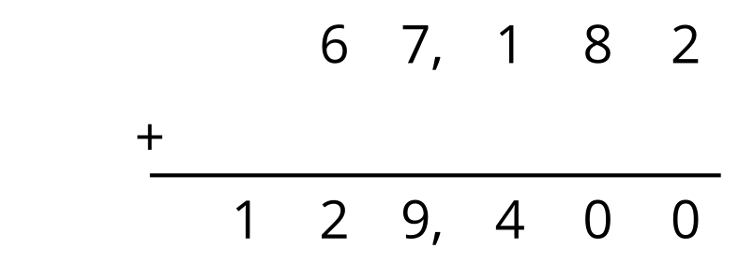
- b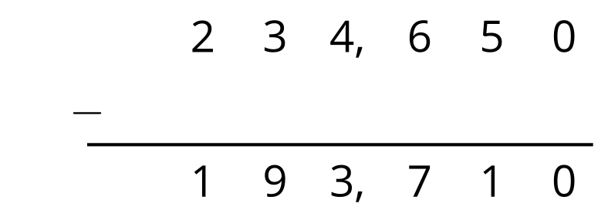

2 Spot Errors

Student Task Statement
- Kiran is trying to find the sum of 204,500 and 695. He isn’t sure how to set up the calculation so he wrote down two ideas. Which way is correct? Be ready to share your thinking with your partner.
- A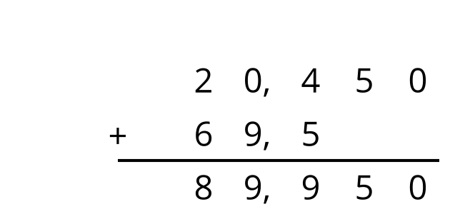

- B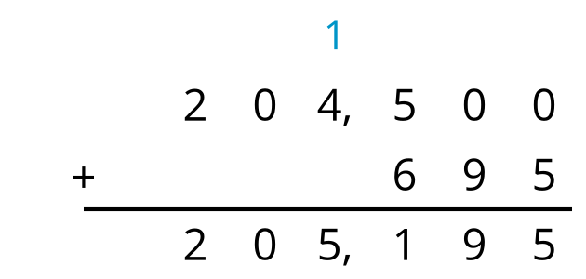
- Lin made some errors when subtracting 4,325 from 61,870. Identify as many errors as you can find. Then, show the correct way to subtract.
- 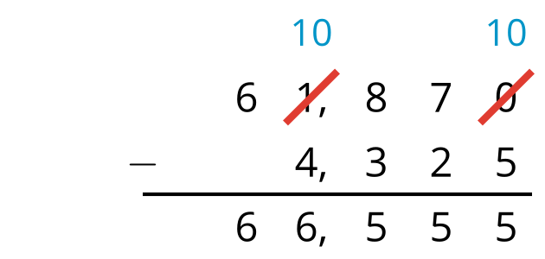

Images for Activity Synthesis
A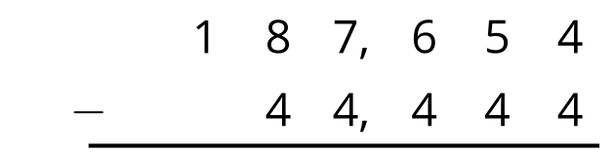
B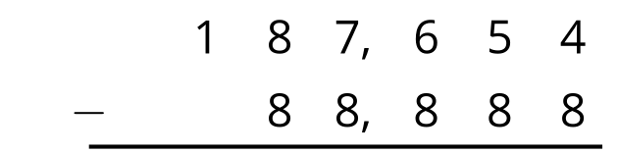
© CC BY 2021 Illustrative Mathematics®

