Unit 3 Lesson 16: Methods for Multiplying Decimals

1 Multiplying by 10 (Warm up)

Student Task Statement
- In which equation is the value of $x$ the largest?
- $x⋅10=810$
- $x⋅10=81$
- $x⋅10=8.1$
- $x⋅10=0.81$
- How many times the size of 0.81 is 810?

2 Fractionally Speaking: Multiples of Powers of Ten

Student Task Statement
- Select all expressions that are equivalent to $(0.6)⋅(0.5)$. Be prepared to explain your reasoning.
  - $6⋅(0.1)⋅5⋅(0.1)$
  - $6⋅(0.01)⋅5⋅(0.1)$
  - $6⋅\frac{1}{10}⋅5⋅\frac{1}{10}$
  - $6⋅\frac{1}{1,000}⋅5⋅\frac{1}{100}$
  - $6⋅(0.001)⋅5⋅(0.01)$
  - $6⋅5⋅\frac{1}{10}⋅\frac{1}{10}$
  - $\frac{6}{10}⋅\frac{5}{10}$
- Find the value of $(0.6)⋅(0.5)$. Show your reasoning.
- Find the value of each product by writing and reasoning with an equivalent expression with fractions.
  - $(0.3)⋅(0.02)$
  - $(0.7)⋅(0.05)$

3 Using Properties to Reason about Multiplication

Student Task Statement
Elena and Noah used different methods to compute $(2.4)⋅(1.3)$. Both calcuations were correct.
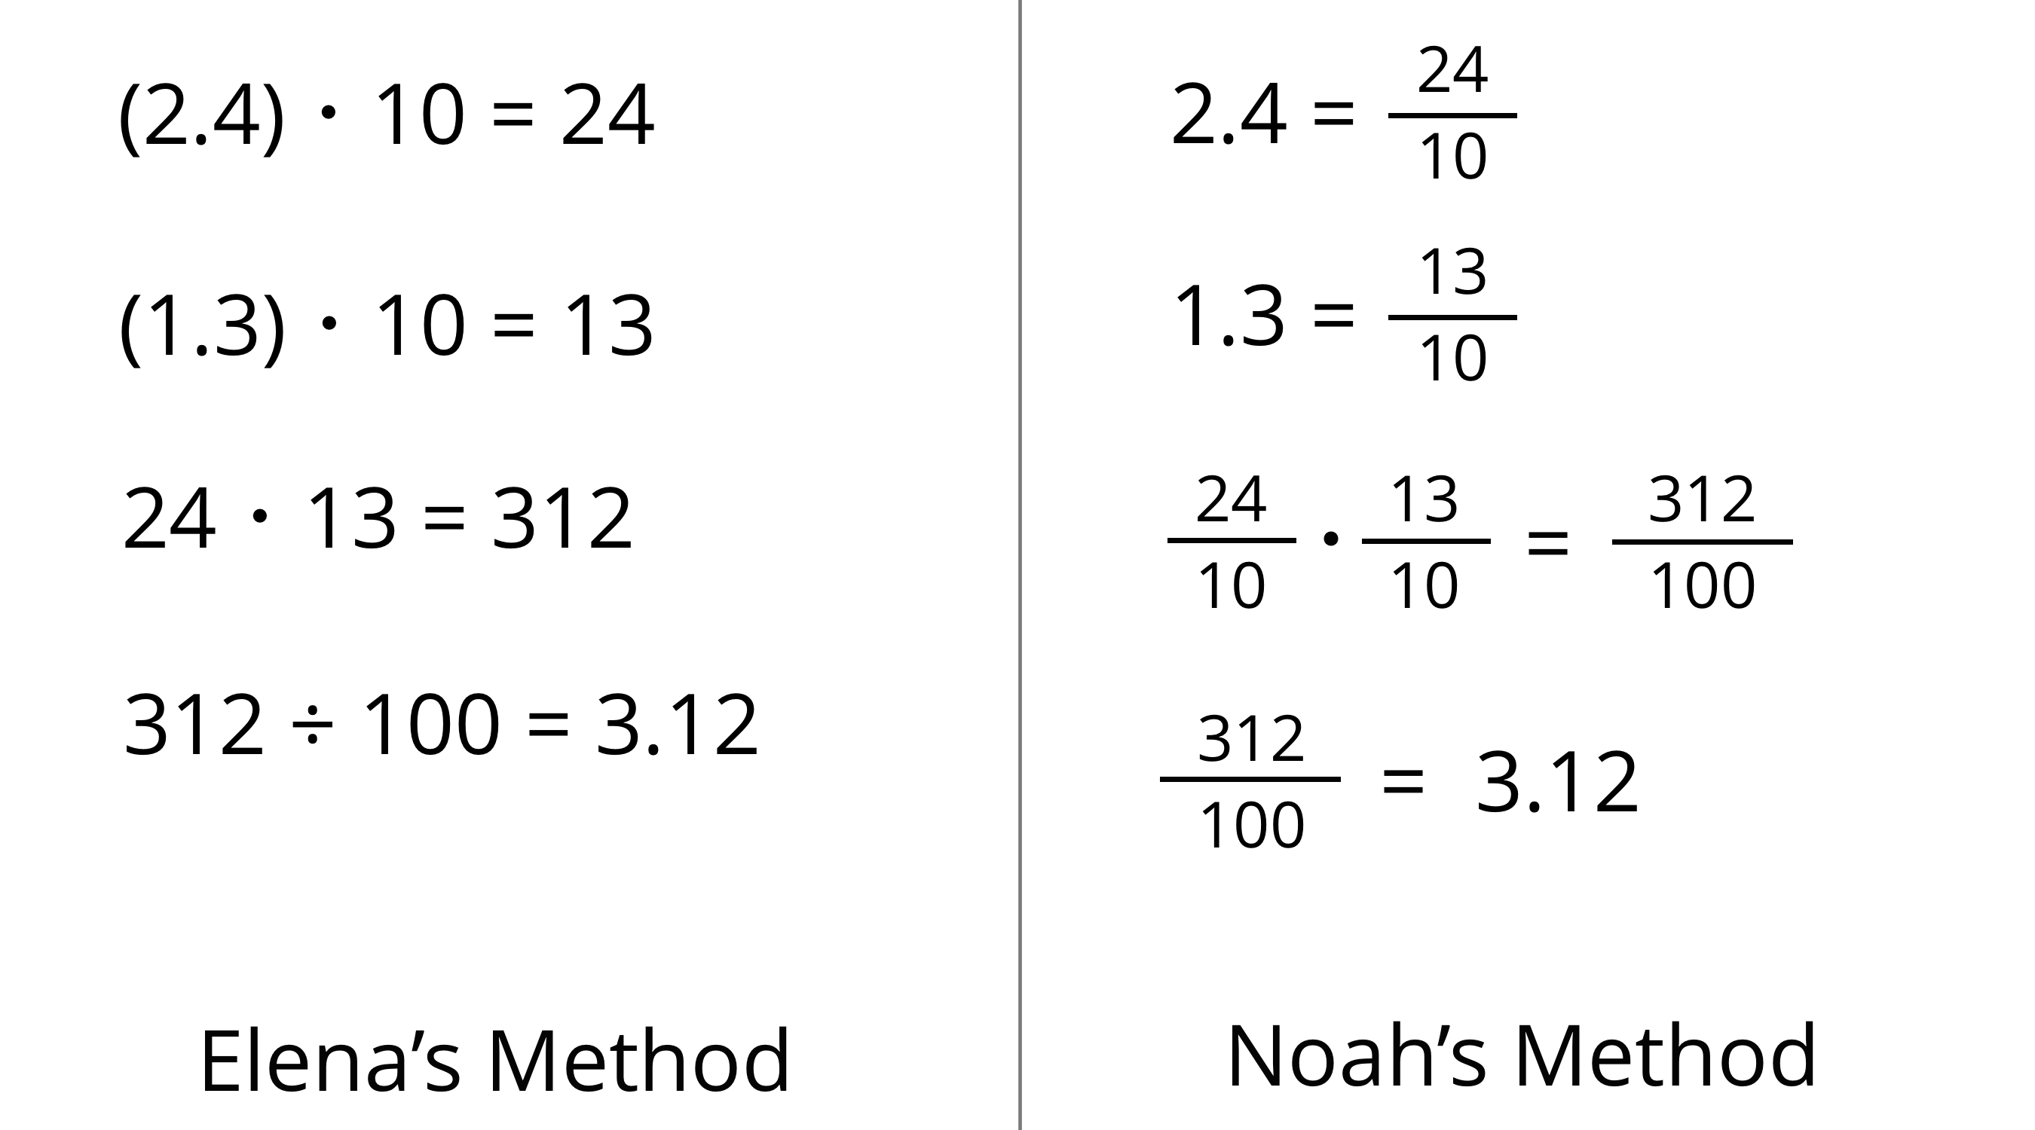
- Analyze the two methods, then discuss these questions with your partner.
  - Which method makes more sense to you? Why?
  - What might Elena do to compute $(0.16)⋅(0.03)$? What might Noah do to compute $(0.16)⋅(0.03)$? Will the two methods result in the same value?
- Compute each product using the equation $21⋅47=987$ and what you know about fractions, decimals, and place value. Explain or show your reasoning.
  - $(2.1)⋅(4.7)$
  - $21⋅(0.047)$
  - $(0.021)⋅(4.7)$

4 Connecting Area Diagrams to Calculations with Decimals

Student Task Statement
- You can use area diagrams to represent products of decimals. Here is an area diagram that represents $(2.4)⋅(1.3)$.
- 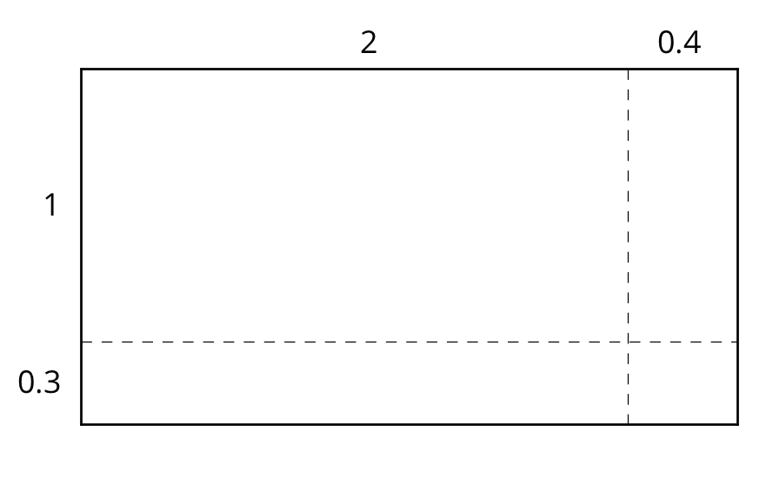
  - Find the region that represents $(0.4)⋅(0.3)$. Label it with its area of 0.12.
  - Label the other regions with their areas.
  - Find the value of $(2.4)⋅(1.3)$. Show your reasoning.
- Here are two ways of calculating $(2.4)⋅(1.3)$.
- 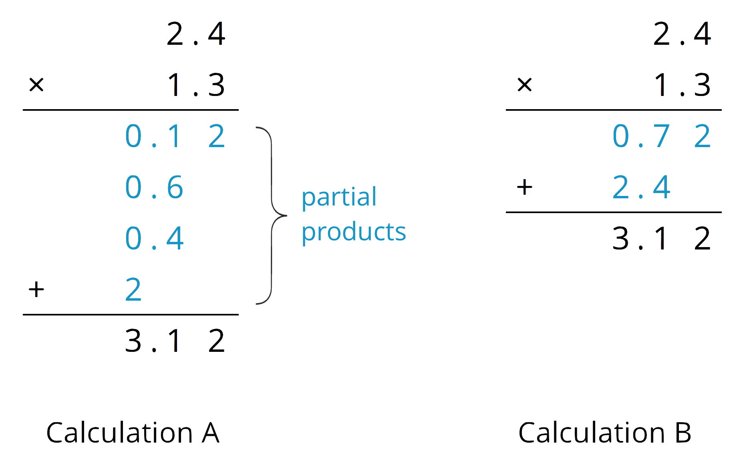
- Analyze the calculations and discuss these questions with a partner:
  - In Calculation A, where does the 0.12 and other partial products come from?
  - In Calculation B, where do the 0.72 and 2.4 come from?
  - In each calculation, why are the numbers below the horizontal line aligned vertically the way they are?
- Find the product of $(3.1)⋅(1.5)$ by drawing and labeling an area diagram. Show your reasoning.
- Show how to calculate $(3.1)⋅(1.5)$ using numbers without a diagram. Be prepared to explain your reasoning. If you are stuck, use the examples in a previous question to help you.

Activity Synthesis
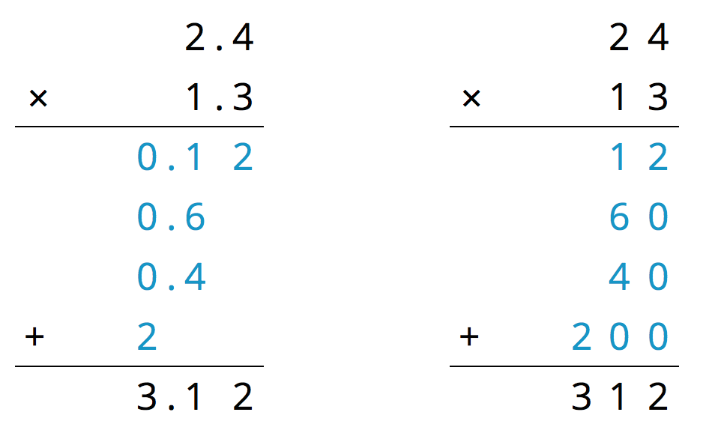
© CC BY Open Up Resources. Adaptations CC BY IM.

