Lesson 8: Comparing Relationships with Equations

8.1: Notice and Wonder: Patterns with Rectangles
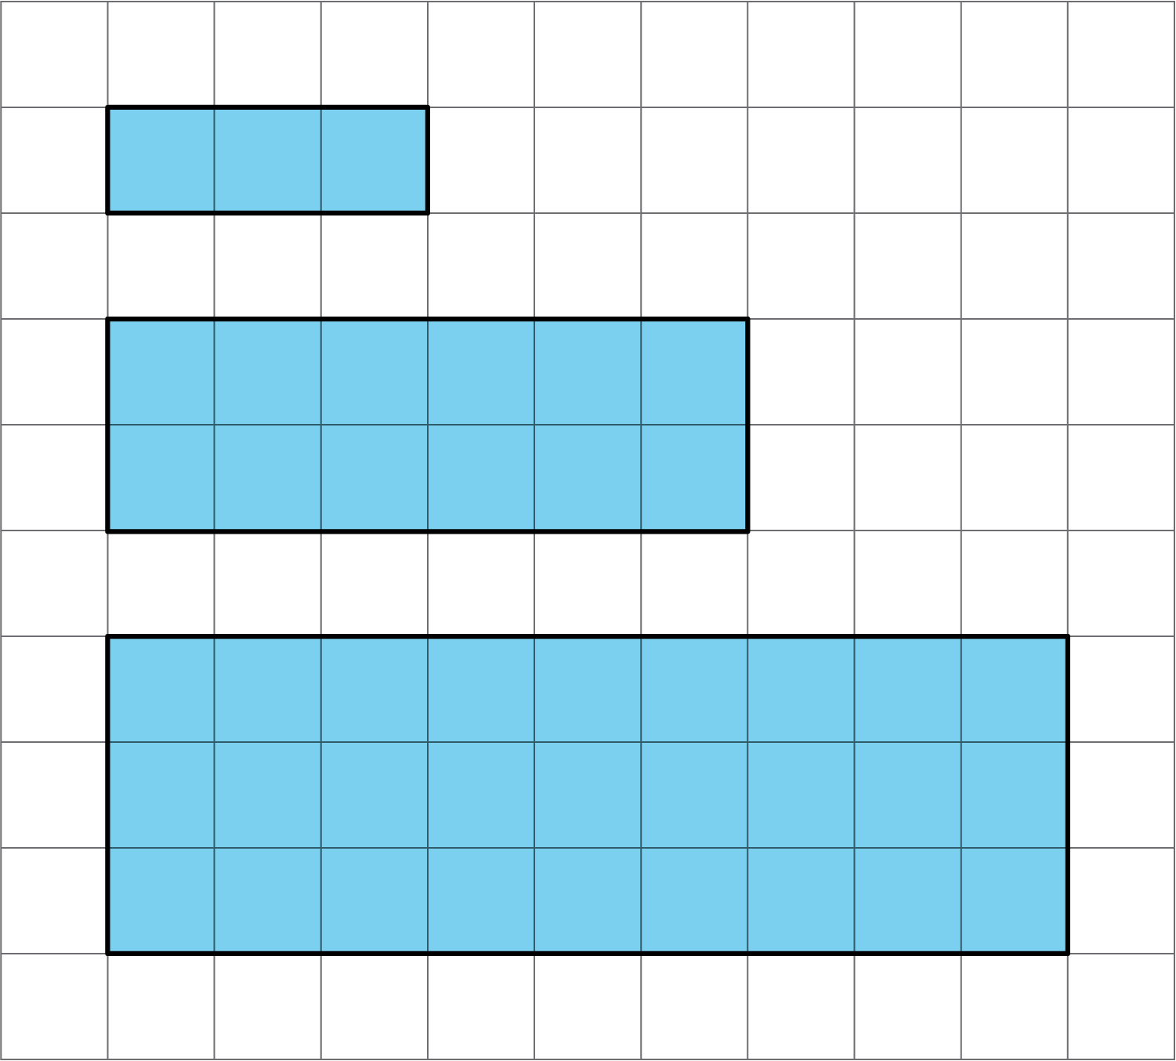
Do you see a pattern? What predictions can you make about future rectangles in the set if your pattern continues?

8.2: More Conversions
The other day you worked with converting meters, centimeters, and millimeters. Here are some more unit conversions.
- Use the equation $F=\frac{9}{5}C+32$, where $F$ represents degrees Fahrenheit and $C$ represents degrees Celsius, to complete the table.
- temperature $(^{∘}\text{C})$ | - temperature $(^{∘}\text{F})$
- 20
- 4
- 175
- Use the equation $c=2.54n$, where $c$ represents the length in centimeters and $n$ represents the length in inches, to complete the table.
- length (in) | - length (cm)
- 10
- 8
- 3$\frac{1}{2}$
- Are these proportional relationships? Explain why or why not.

8.3: Total Edge Length, Surface Area, and Volume
Here are some cubes with different side lengths. Complete each table. Be prepared to explain your reasoning.
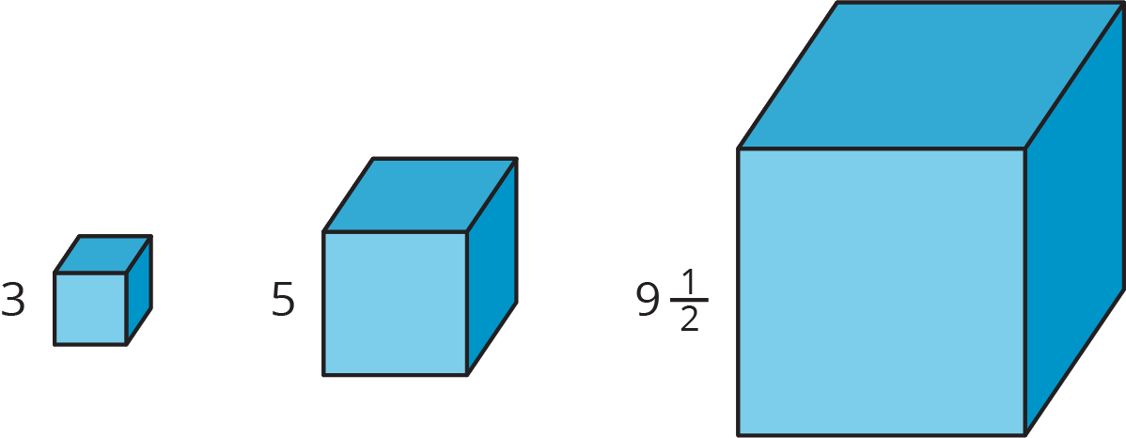
- How long is the total edge length of each cube?
- side  length | - total  edge length
- 3
- 5
- $9\frac{1}{2}$
- $s$
- What is the surface area of each cube?
- side  length | - surface  area
- 3
- 5
- $9\frac{1}{2}$
- $s$
- What is the volume of each cube?
- side  length | - volume
- 3
- 5
- $9\frac{1}{2}$
- $s$
- Which of these relationships is proportional? Explain how you know.
- Write equations for the total edge length $E$, total surface area $A$, and volume $V$ of a cube with side length $s$.

Are you ready for more?
- A rectangular solid has a square base with side length $ℓ$, height 8, and volume $V$. Is the relationship between $ℓ$ and $V$ a proportional relationship?
- A different rectangular solid has length $ℓ$, width 10, height 5, and volume $V$. Is the relationship between $ℓ$ and $V$ a proportional relationship?
- Why is the relationship between the side length and the volume proportional in one situation and not the other?

8.4: All Kinds of Equations
Here are six different equations.
$y=4+x$
$y=\frac{x}{4}$
$y=4x$
$y=4^{x}$
$y=\frac{4}{x}$
$y=x^{4}$
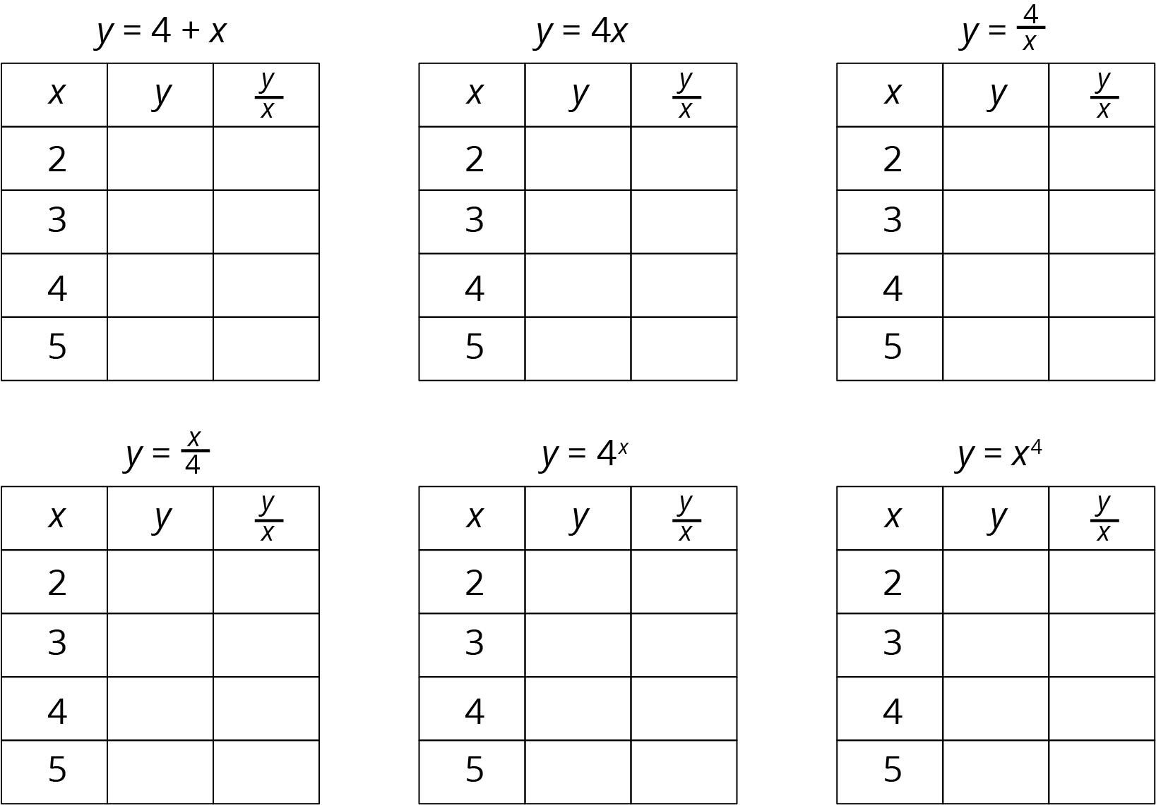
- Predict which of these equations represent a proportional relationship.
- Complete each table using the equation that represents the relationship.
- Do these results change your answer to the first question? Explain your reasoning.
- What do the equations of the proportional relationships have in common?

Lesson 8 Summary
If two quantities are in a proportional relationship, then their quotient is always the same. This table represents different values of $a$ and $b$, two quantities that are in a proportional relationship.
$a$ | $b$ | $\frac{b}{a}$
20 | 100 | 5
3 | 15 | 5
11 | 55 | 5
1 | 5 | 5
Notice that the quotient of $b$ and $a$ is always 5. To write this as an equation, we could say $\frac{b}{a}=5$. If this is true, then $b=5a$. (This doesn’t work if $a=0$, but it works otherwise.)
If quantity $y$ is proportional to quantity $x$, we will always see this pattern: $\frac{y}{x}$ will always have the same value. This value is the constant of proportionality, which we often refer to as $k$. We can represent this relationship with the equation $\frac{y}{x}=k$ (as long as $x$ is not 0) or $y=kx$.
Note that if an equation cannot be written in this form, then it does not represent a proportional relationship.
© CC BY Open Up Resources. Adaptations CC BY IM.

