Lesson 10 Practice Problems
- For each graph, calculate the slope of the line.
- 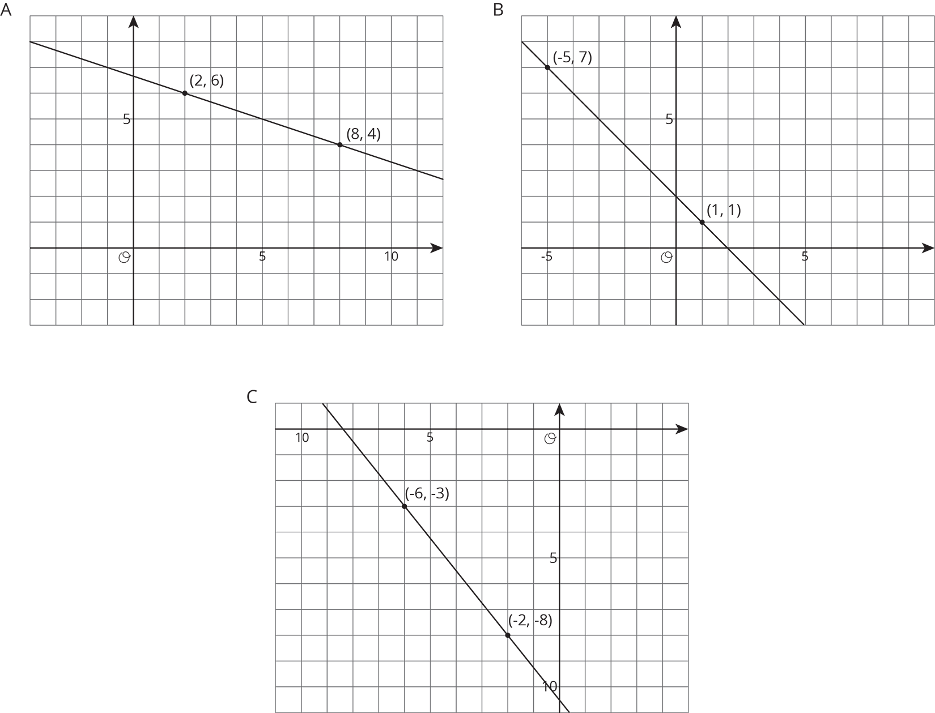
- Match each pair of points to the slope of the line that joins them.
  - $\left(9,10\right)$ and $\left(7,2\right)$
  - $\left(\text{-}8,\text{-}11\right)$ and $\left(\text{-}1,\text{-}5\right)$
  - $\left(5,\text{-}6\right)$ and $\left(2,3\right)$
  - $\left(6,3\right)$ and $\left(5,\text{-}1\right)$
  - $\left(4,7\right)$ and $\left(6,2\right)$
  - 4
  - $\text{-}3$
  - $\text{-}\frac{5}{2}$
  - $\frac{6}{7}$
- Draw a line with the given slope through the given point. What other point lies on that line?
- 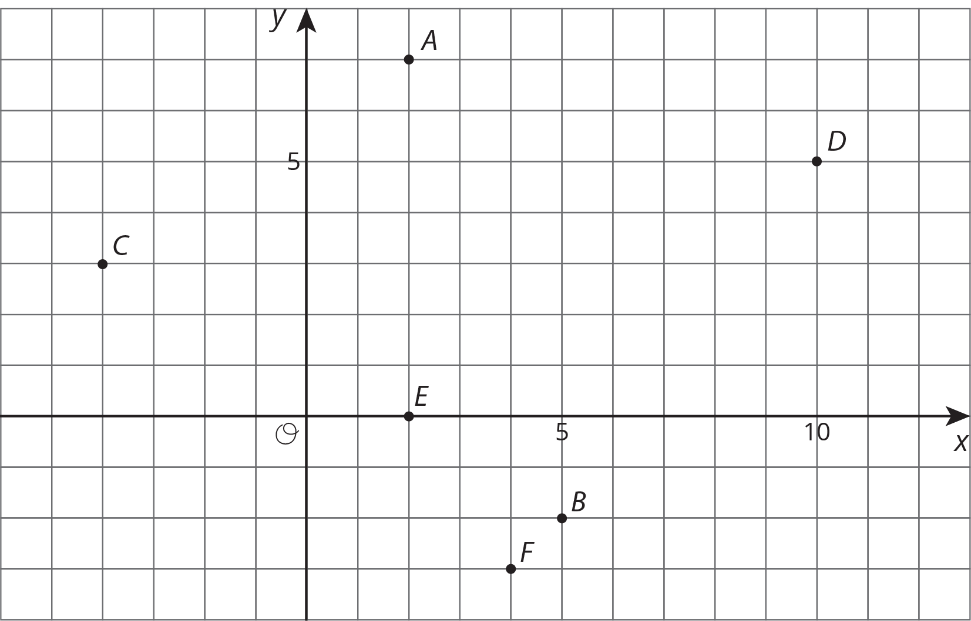
  - Point A, slope = $\text{-}3$
  - Point A, slope = $\frac{\text{-}1}{4}$
  - Point C, slope = $\frac{\text{-}1}{2}$
  - Point E, slope = $\frac{\text{-}2}{3}$
- Make a sketch of a linear relationship with a slope of 4 and a negative $y$-intercept. Show how you know the slope is 4 and write an equation for the line.
- (From Unit 3, Lesson 8.)
© CC BY Open Up Resources. Adaptations CC BY IM.

