Unit 3 Lesson 4: Linear Models

1 Notice and Wonder: Crowd Noise (Warm up)

Student Task Statement
What do you notice? What do you wonder?

$y=1.5x+22.7$
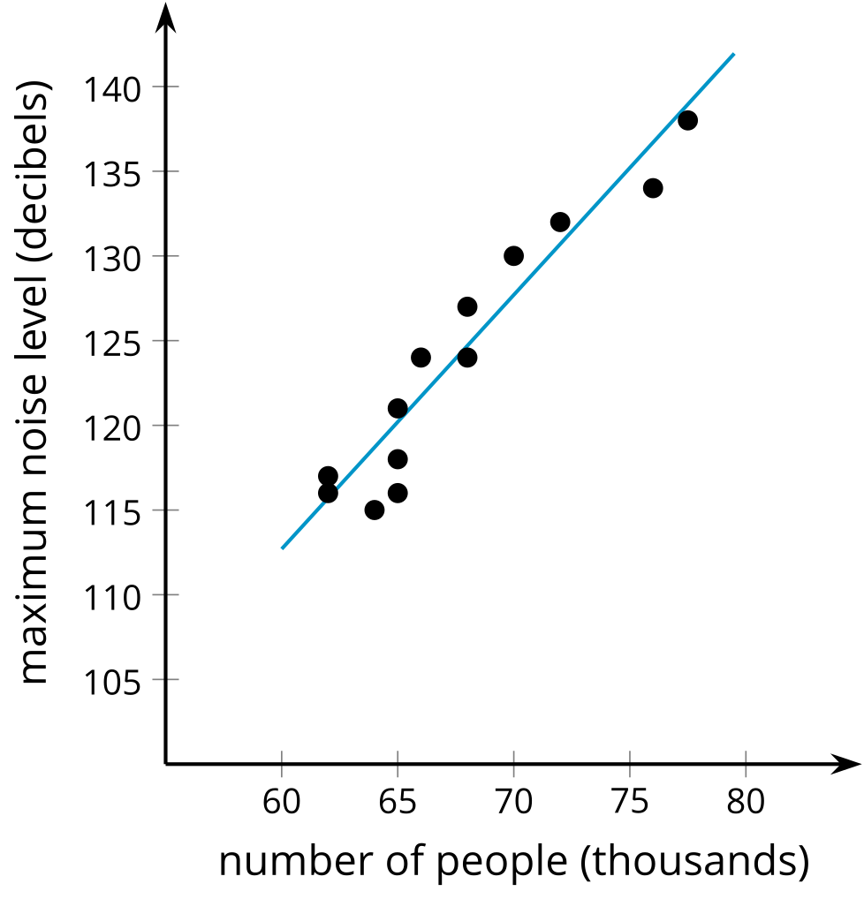

2 Orange You Glad We’re Boxing Fruit?

Student Task Statement
- Watch the video and record the weight for the number of oranges in the box.
- number of oranges | - weight in kilograms
- 3
- 4
- 5
- 6
- 7
- 8
- 9
- 10
- Create a scatter plot of the data.
- 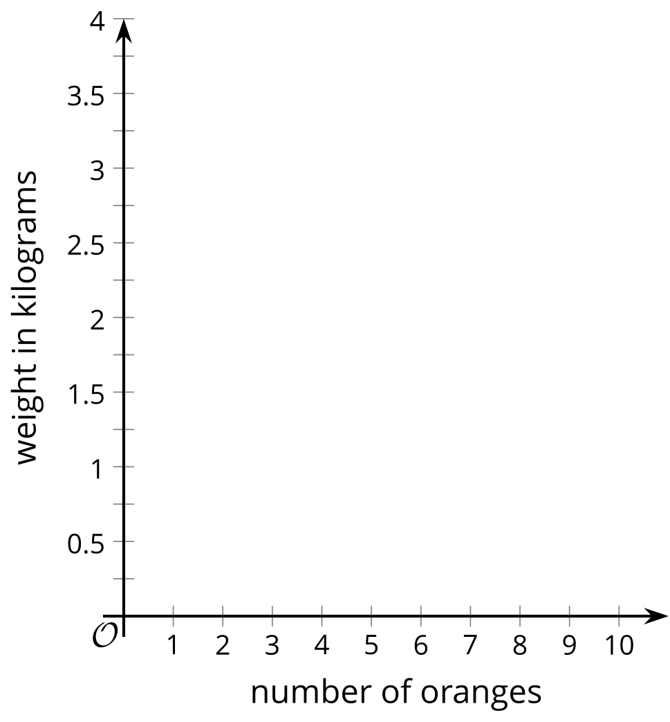
- Draw a line through the data that fits the data well.
- Estimate a value for the slope of the line that you drew. What does the value of the slope represent?
- Estimate the weight of a box containing 11 oranges. Will this estimate be close to the actual value? Explain your reasoning.
- Estimate the weight of a box containing 50 oranges. Will this estimate be close to the actual value? Explain your reasoning.
- Estimate the coordinates for the vertical intercept of the line you drew. What might the $y$-coordinate for this point represent?
- Which point(s) are best fit by your linear model? How did you decide?
- Which point(s) are fit the least well by your linear model? How did you decide?

Activity Synthesis
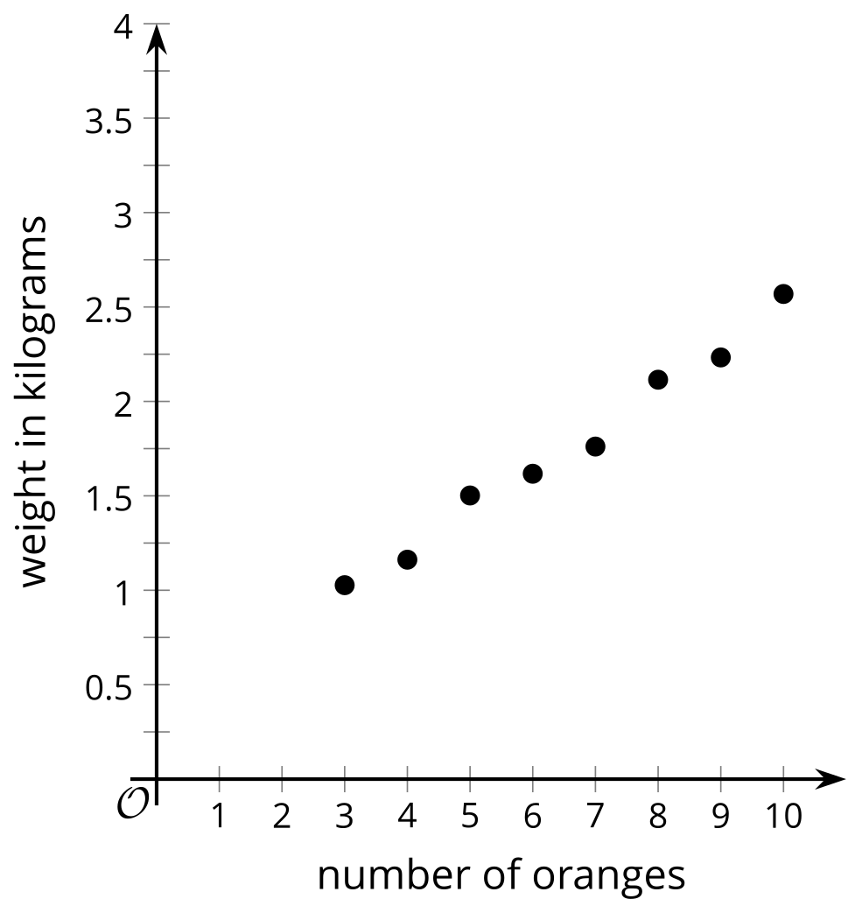

$y=0.216x+0.345$
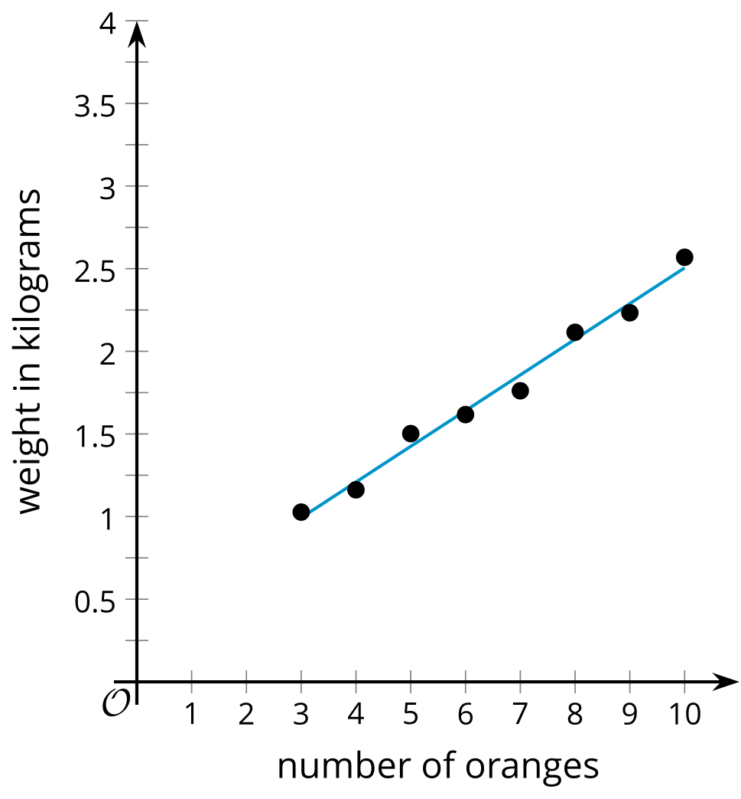

3 Food Markup

Student Task Statement
The scatter plot shows the sale price of several food items, $y$, and the cost of the ingredients used to produce those items, $x$, as well as a line that models the data. The line is also represented by the equation $y=3.48x+0.76$.
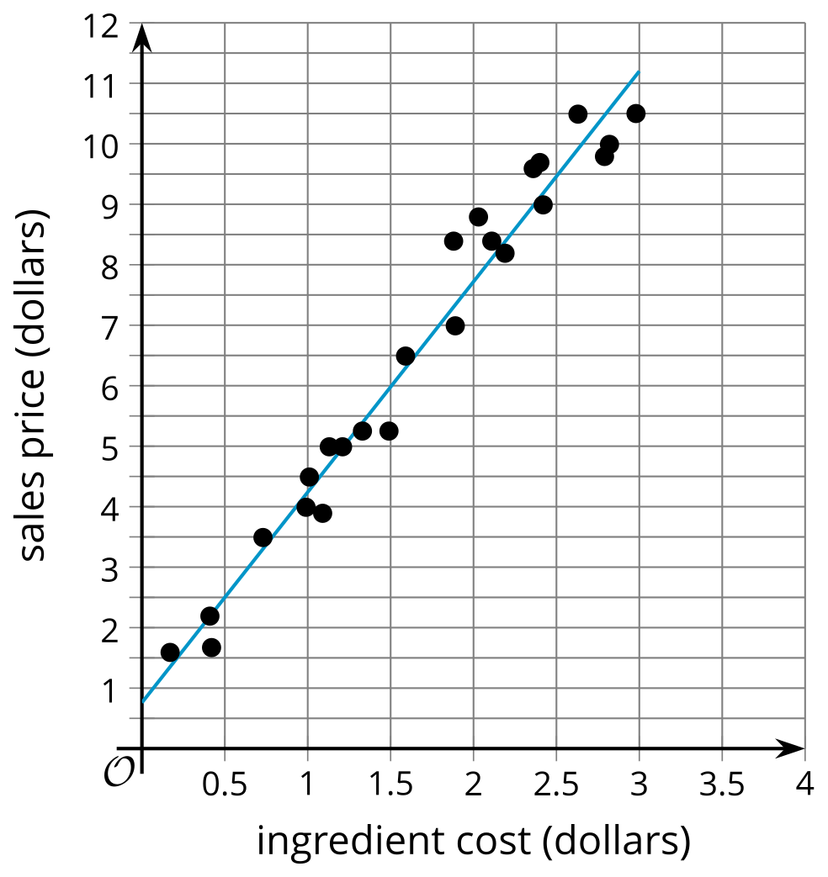
- What is the predicted sale price of an item that has ingredients that cost $1.50? Explain or show your reasoning.
- What is the predicted ingredient cost of an item that has a sale price of $7? Explain or show your reasoning.
- What is the slope of the linear model? What does that mean in this situation?
- What is the $y$-intercept of the linear model? What does this mean in this situation? Does this make sense?

4 The Slope is the Thing

Student Task Statement
- Here are several scatter plots.

- A. $y=\text{-}9.25x+400$
- 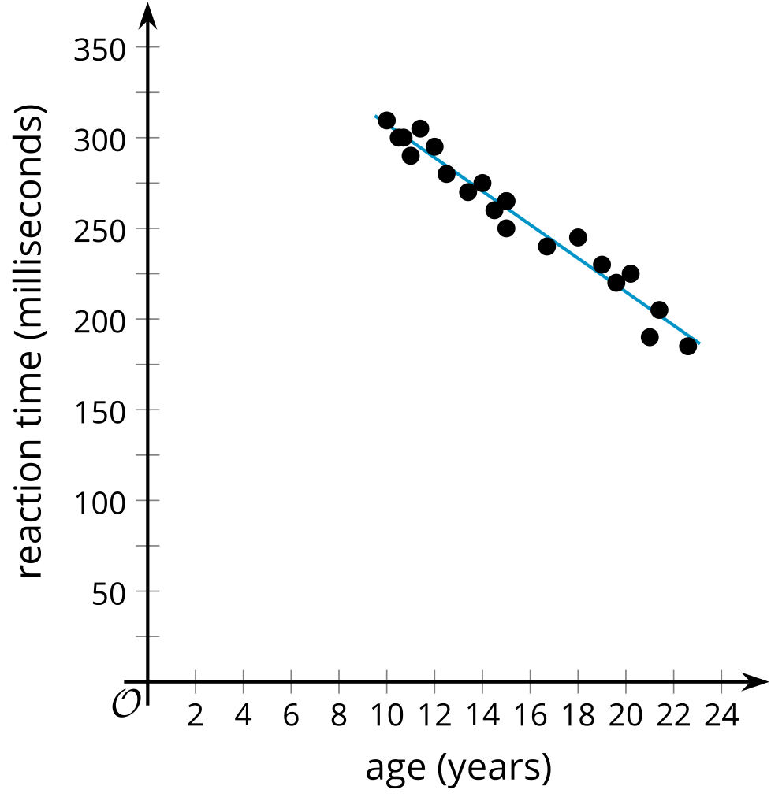

- B. $y=0.44x+0.04$
- 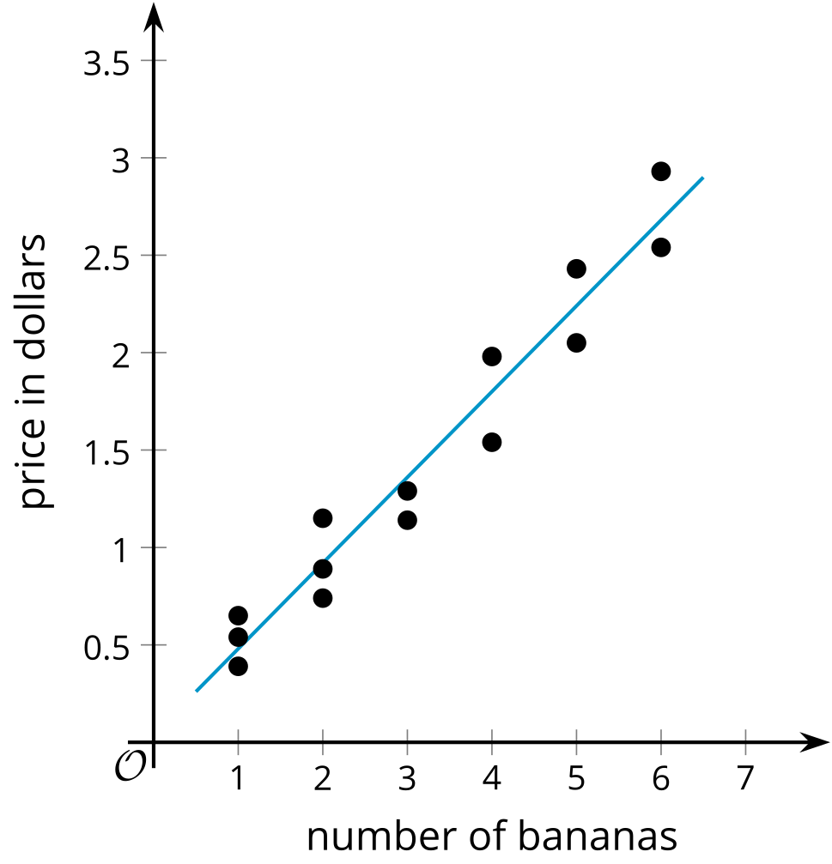

- C. $y=4x+87$
- 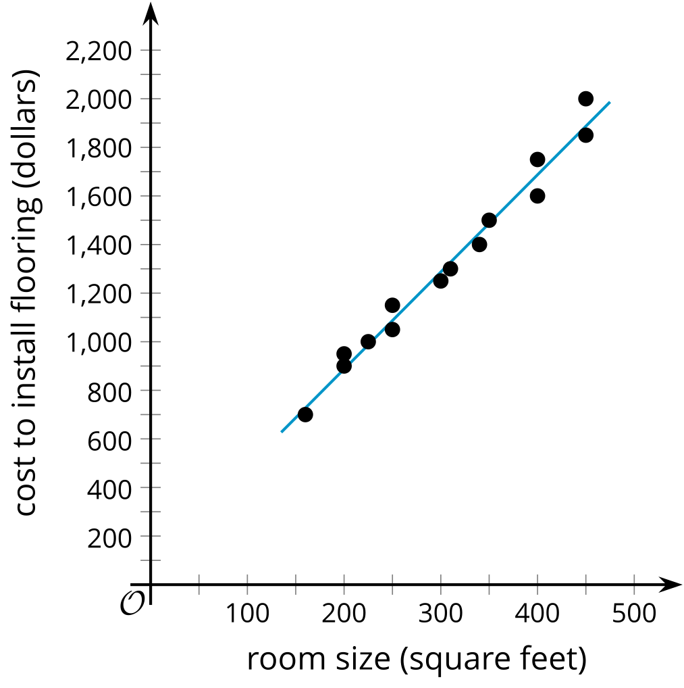

- D. $y=\text{-}2.4x+25.0$
- 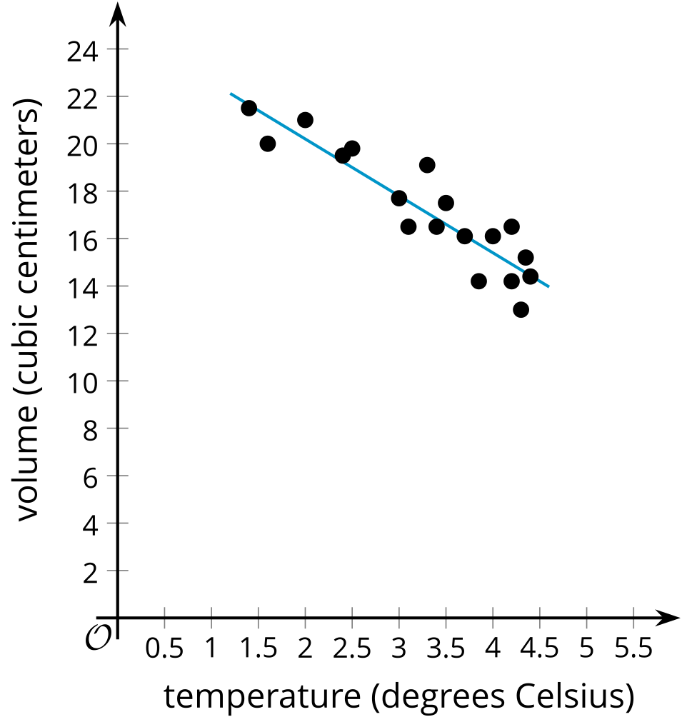
  - Using the horizontal axis for $x$ and the vertical axis for $y$, interpret the slope of each linear model in the situations shown in the scatter plots.
  - If the linear relationship continues to hold for each of these situations, interpret the $y$-intercept of each linear model in the situations provided.
© CC BY 2019 by Illustrative Mathematics®

