Lesson 10: Represent Data Using Picture Graphs and Bar Graphs
- Let’s make our own picture graphs and bar graphs.

Warm-up: Which One Doesn’t Belong: Data
Which one doesn’t belong?
A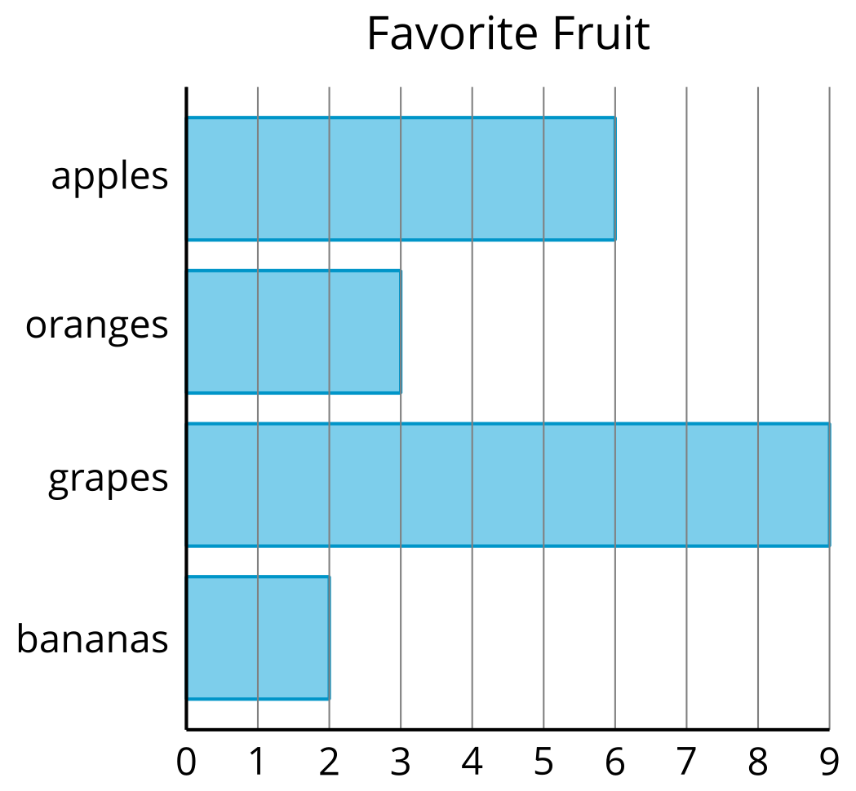
B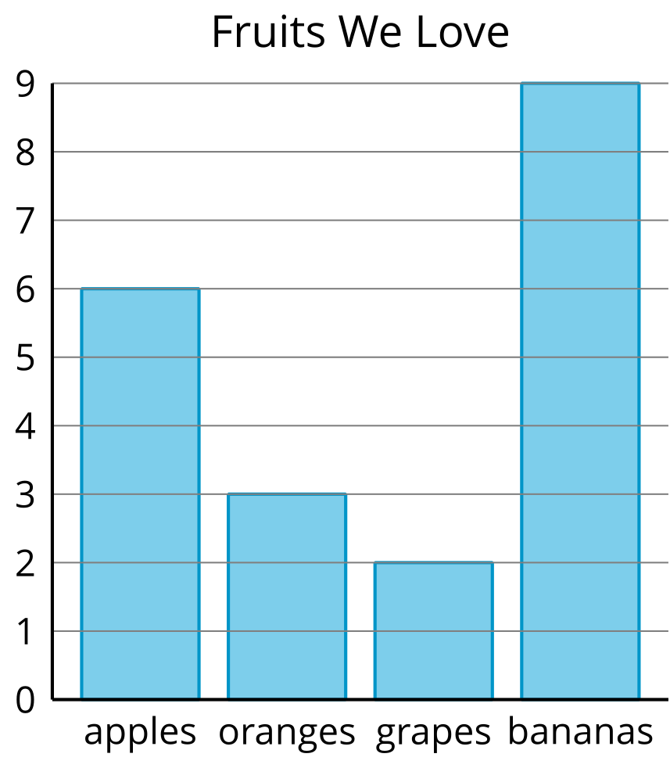
C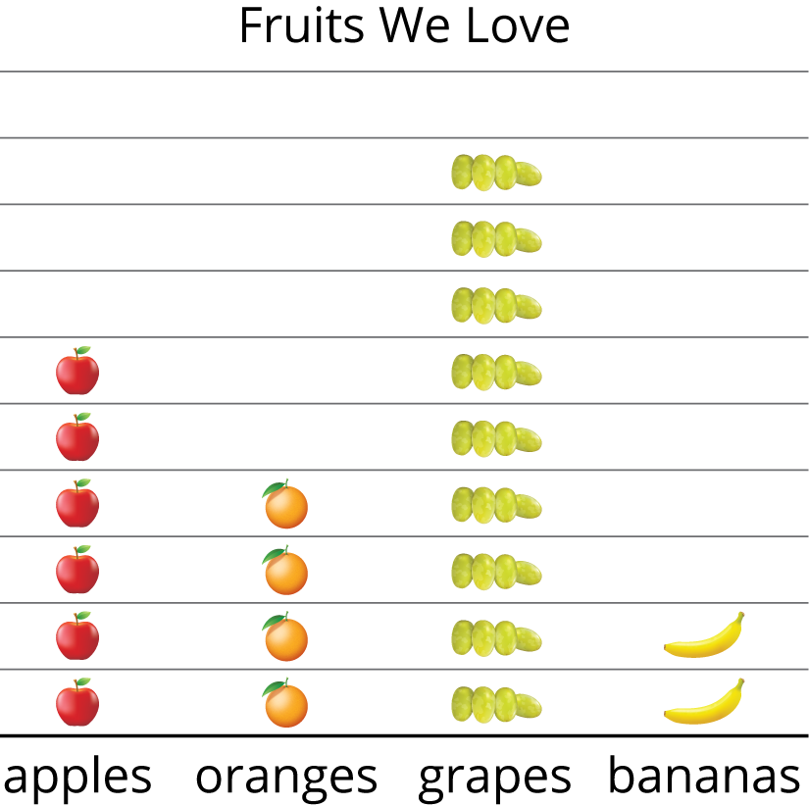
D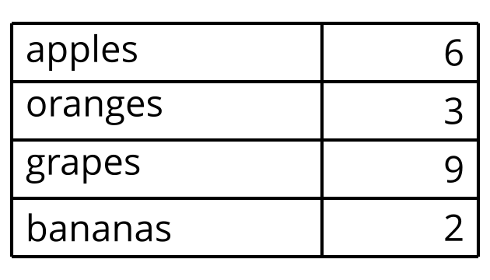

10.1: Draw Picture Graphs
A group of 2nd graders were asked, “What is your favorite sport?” Their responses are shown in this picture graph.
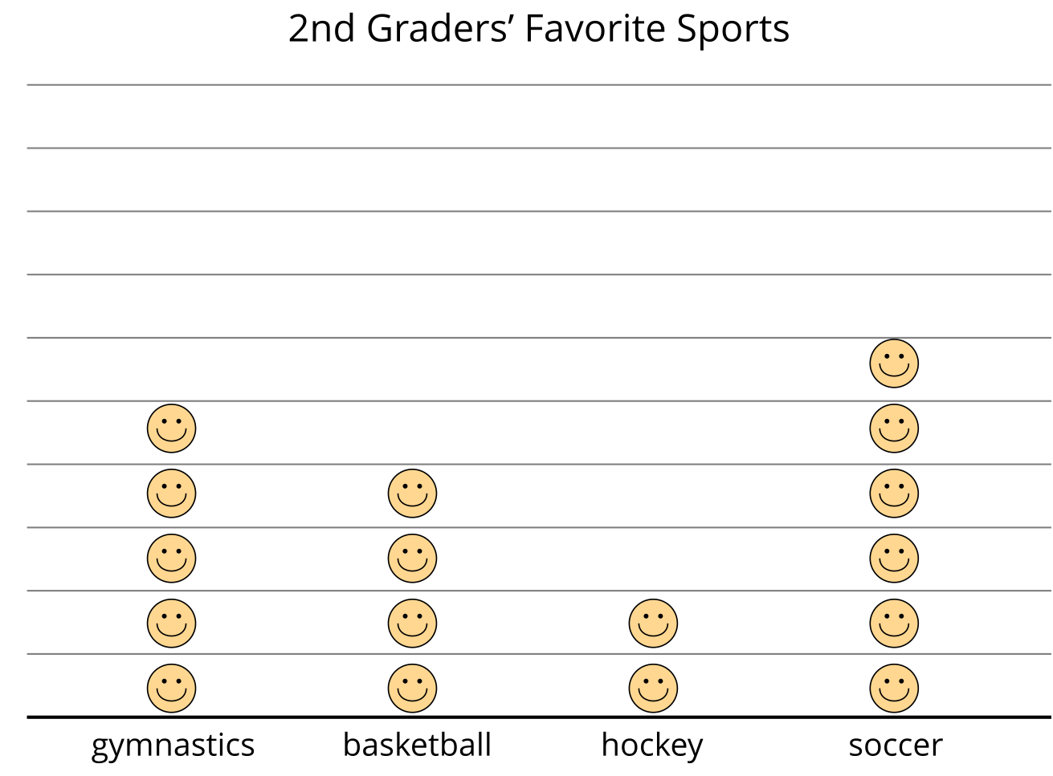
Represent the data shown in your table in a picture graph.
Table # _______

10.2: Draw Bar Graphs
A group of students were asked, “What fruit do you love to eat?” Their responses are shown in this bar graph.
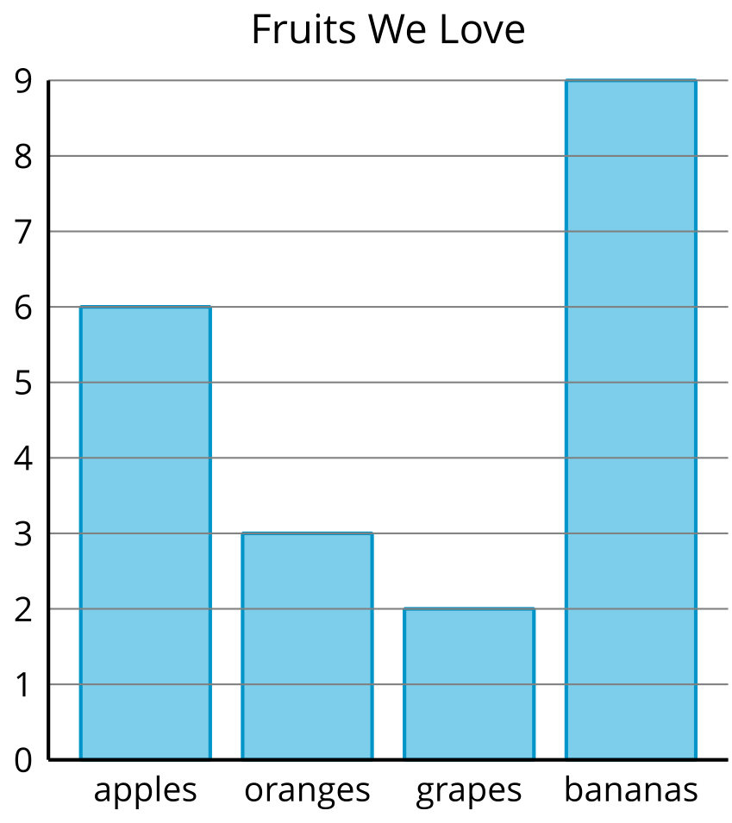
Represent the data shown in your table in a bar graph.
Table # _______
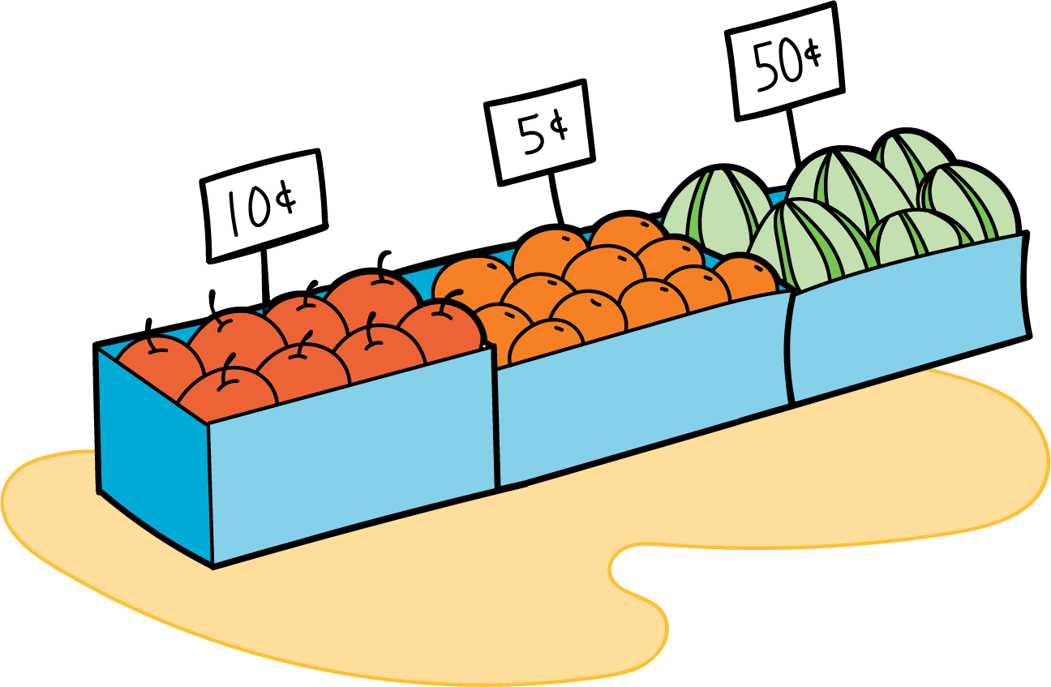
© CC BY 2021 Illustrative Mathematics®

