Lesson 9: Show Me Your Number
- Let’s show numbers in different ways.

Warm-up: Which One Doesn’t Belong: Tens and Ones
Which one doesn’t belong?
A
B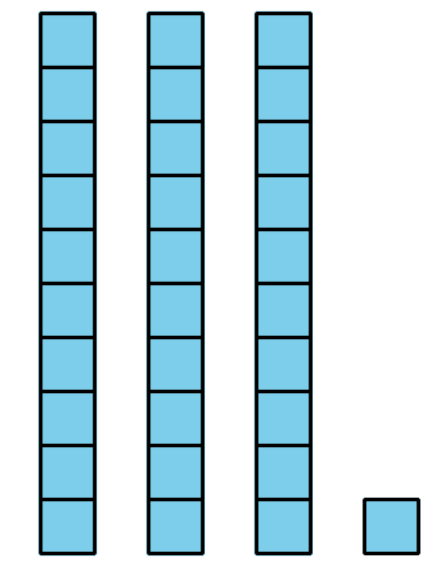
C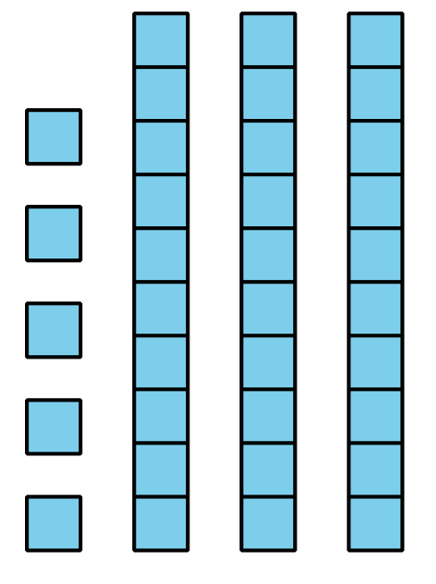
D

9.1: Create a Collection
Show your number in as many ways as you can.
Our number: __________

9.2: Show Collections In Many Ways
Show each collection in as many ways as you can.
Visit at least 4 collections.
Collection 1
Collection 2
Collection 3
Collection 4

9.3: Centers: Choice Time
Choose a center.
Grab and Count
Shake and Spill
Check It Off
© CC BY 2021 Illustrative Mathematics®

