Unit 6 Lesson 8: Reasoning about Solving Equations (Part 2)

1 Equivalent to $2\left(x+3\right)$ (Warm up)

Student Task Statement
Select all the expressions equivalent to $2\left(x+3\right)$.
- $2⋅\left(x+3\right)$
- $\left(x+3\right)2$
- $2⋅x+2⋅3$
- $2⋅x+3$
- $\left(2⋅x\right)+3$
- $\left(2+x\right)3$

2 Either Or

Student Task Statement
- Explain why either of these equations could represent this hanger:
- 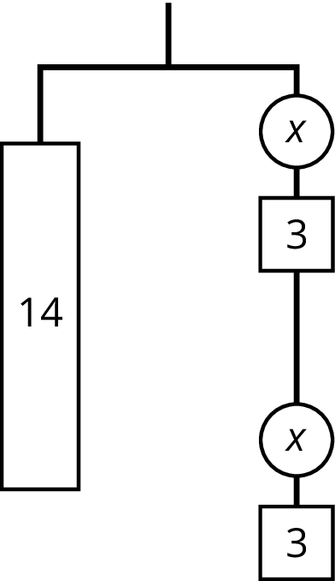
- $14=2\left(x+3\right)$ or $14=2x+6$
- Find the weight of one circle. Be prepared to explain your reasoning.

Activity Synthesis
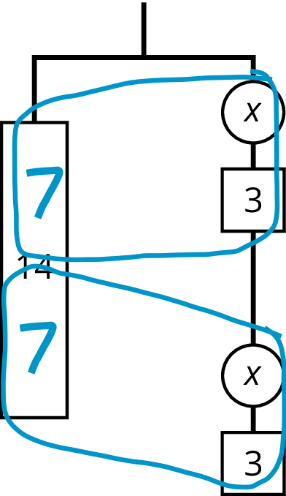
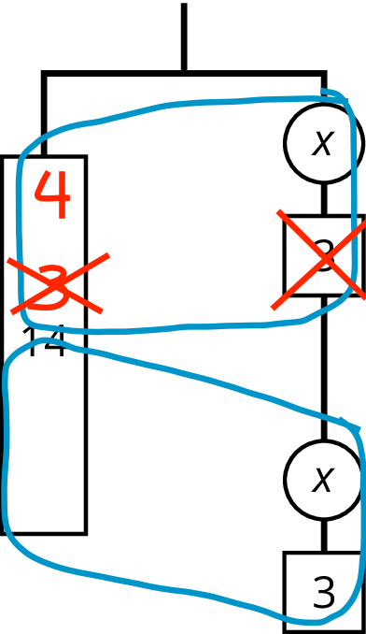

3 Use Hangers to Understand Equation Solving, Again

Student Task Statement
Here are some balanced hangers. Each piece is labeled with its weight.
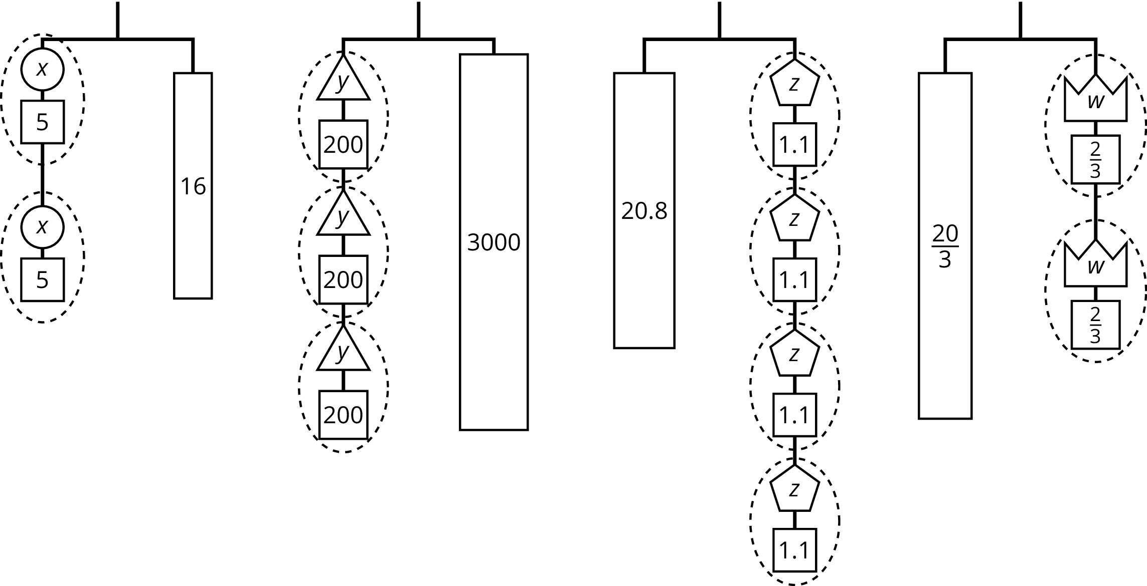
For each diagram:
- Assign one of these equations to each hanger:
- $2\left(x+5\right)=16$
- $3\left(y+200\right)=3​,000$
- $20.8=4\left(z+1.1\right)$
- $\frac{20}{3}=2\left(w+\frac{2}{3}\right)$
- Explain how to figure out the weight of a piece labeled with a letter by reasoning about the diagram.
- Explain how to figure out the weight of a piece labeled with a letter by reasoning about the equation.
© CC BY Open Up Resources. Adaptations CC BY IM.

