Unit 2 Lesson 1 Cumulative Practice Problems
- In a fruit basket there are 9 bananas, 4 apples, and 3 plums.
  - The ratio of bananas to apples is ________ : ________.
  - The ratio of plums to apples is ________ to ________.
  - For every ________ apples, there are ________ plums.
  - For every 3 bananas there is one ________.

- Complete the sentences to describe this picture.
  - The ratio of dogs to cats is ________.
  - For every ________ dogs, there are ________ cats.

- Write two different sentences that use ratios to describe the number of eyes and legs in this picture.
- 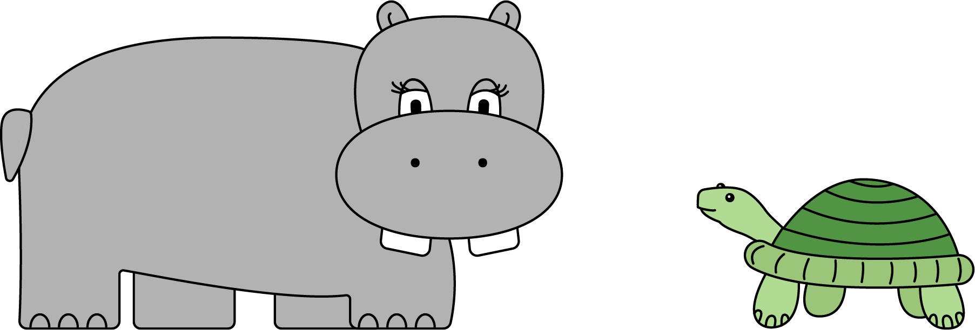
- Choose an appropriate unit of measurement for each quantity.
  - area of a rectangle
  - volume of a prism
  - side of a square
  - area of a square
  - volume of a cube
  - cm
  - cm³
  - cm²

- (From Unit 1, Lesson 17.)
- Find the volume and surface area of each prism.
  - Prism A: 3 cm by 3 cm by 3 cm
  - ​
  - Prism B: 5 cm by 5 cm by 1 cm
  - 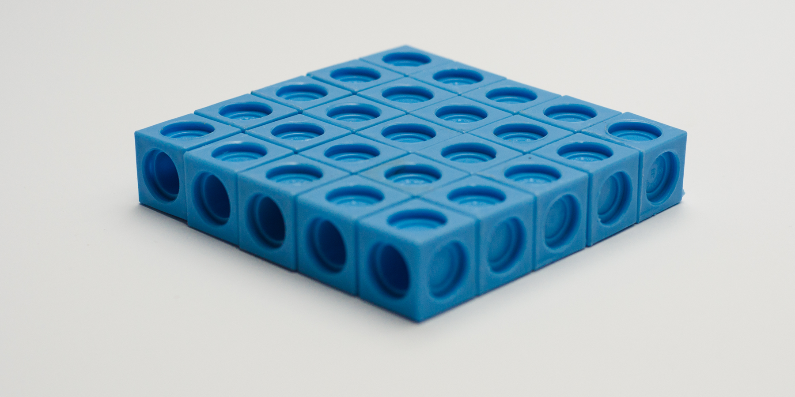
  - Compare the volumes of the prisms and then their surface areas. Does the prism with the greater volume also have the greater surface area?

- (From Unit 1, Lesson 16.)
- Which figure is a triangular prism? Select all that apply.
- 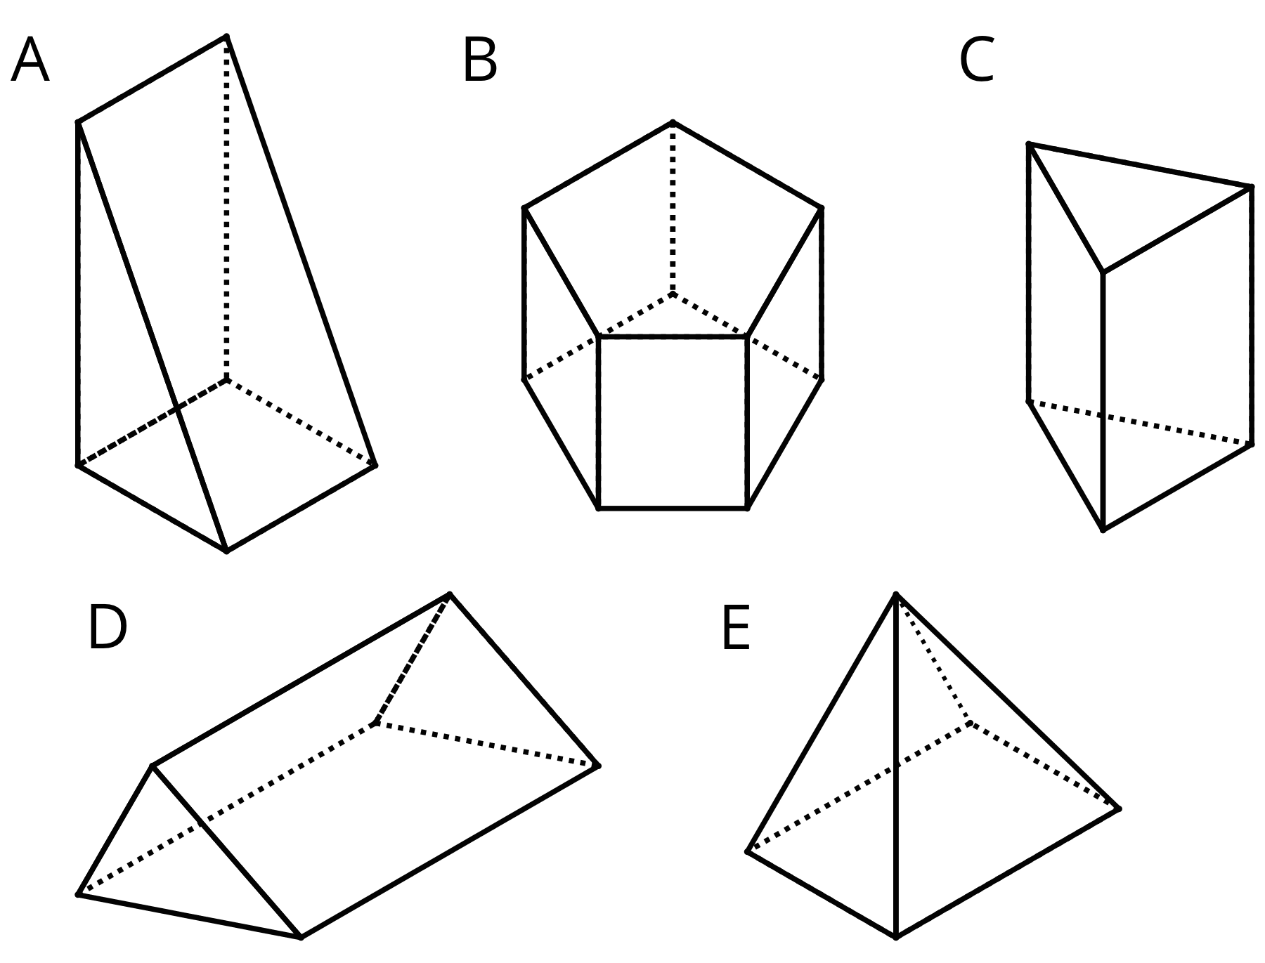
  - A
  - B
  - C
  - D
  - E
- (From Unit 1, Lesson 13.)
© CC BY Open Up Resources. Adaptations CC BY IM.

