Unit 4 Lesson 12: The Number $e$

1 Matching Situations and Equations (Warm up)

Student Task Statement
Match each equation to a situation it represents. Be prepared to explain how you know. Not all equations have a match.
$f(t)=400⋅(0.5)^{0.1t}$
$g(t)=400⋅(1.25)^{0.1t}$
$h(t)=400⋅(0.75)^{0.1t}$
$j(t)=400⋅(2)^{10t}$
$k(t)=400⋅(2)^{0.1t}$
- A scientist begins an experiment with 400 bacteria in a petri dish. The population doubles every 10 hours. The function gives the number of bacteria $t$ hours since the experiment began.
- A patient takes 400 mg of a medicine. The amount of medicine in her bloodstream decreases by 25% every 10 hours. The function gives the amount of medicine left in her bloodstream after $t$ hours of taking the medicine.
- The half-life of a radioactive element is 10 years. There are 400 g of the element in a sample when it is first studied. The function gives the amount of the element remaining $t$ years later.
- In a lake, the population of a species of fish is 400. The population is expected to grow by 25% in the next decade. The function gives the number of fish in the lake $t$ years after it was 400.

2 Notice and Wonder: Moldy Growth

Student Task Statement
A spot of mold is found on a basement wall. Its area is about 10 square centimeters. Here are three representations of a function that models how the mold is growing.
time (weeks) | area of mold (sq cm)
0 | 10
1 | 27
2 | 74
3 | 201
4 | 546
$a(t)=10⋅e^{t}$
What do you notice? What do you wonder?

3 $(1+\text{tiny})^{\text{huge}}$

Student Task Statement
- Here are some functions. For each function, describe, in words, the outputs for very tiny, positive values of $x$ and for very large values of $x$.
- $a(x)=1^{x}$
- $b(x)=\text{-}x$
- $d(x)=\frac{1}{x}$
- $f(x)={\left(\frac{1}{x}\right)}^{x}$
- $g(x)={\left(1+\frac{1}{x}\right)}^{x}$
- $h(x)=e^{x}$
- $k(x)=1+x$

- Remember that $e≈2.718$. What does the function $g$ have to do with the number $e$?
- What do you notice about the relationship between $h$ and $k$ for very small, positive values of $x$?

Activity Synthesis
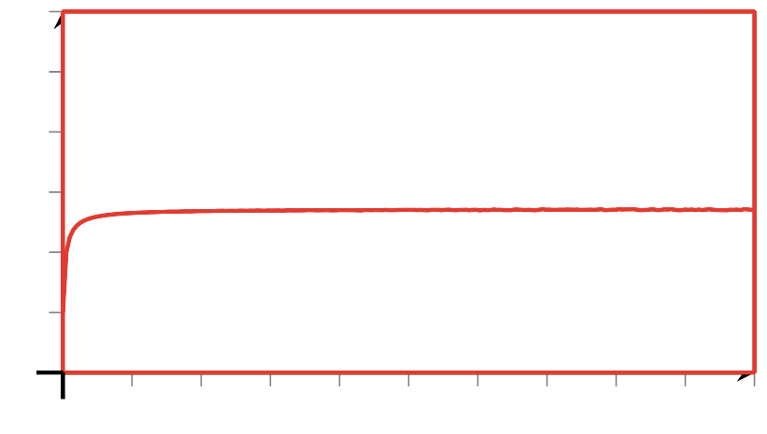
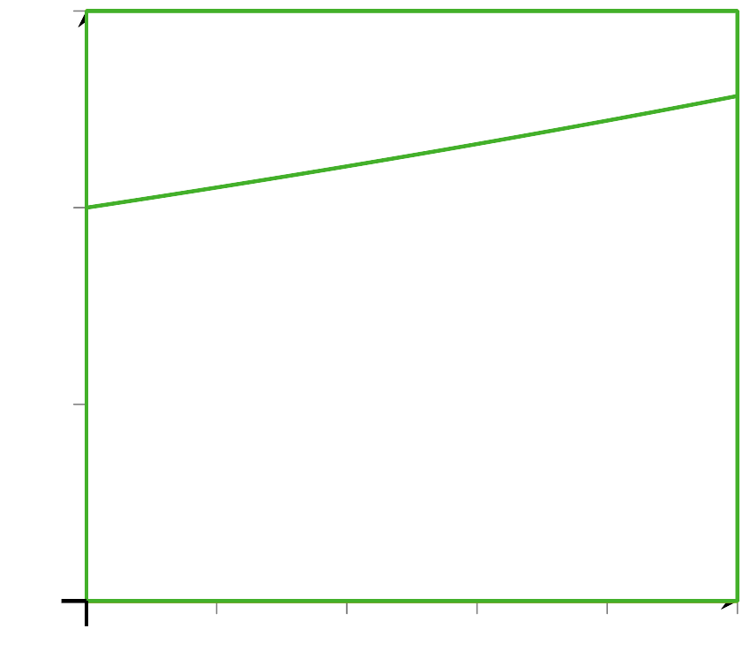
© CC BY 2019 by Illustrative Mathematics®

