Unit 7 Lesson 10: Angles, Arcs, and Radii

1 Comparing Progress (Warm up)

Student Task Statement
Han and Tyler are each completing the same set of tasks on an online homework site. Han is using his smartphone and Tyler is using his tablet computer. Their progress is indicated by the circular bars shown in the image. The shaded arc represents the tasks that have been completed. When the full circumference of the circle is shaded, they will be finished with all the tasks.

Han's progress

Tyler's progress
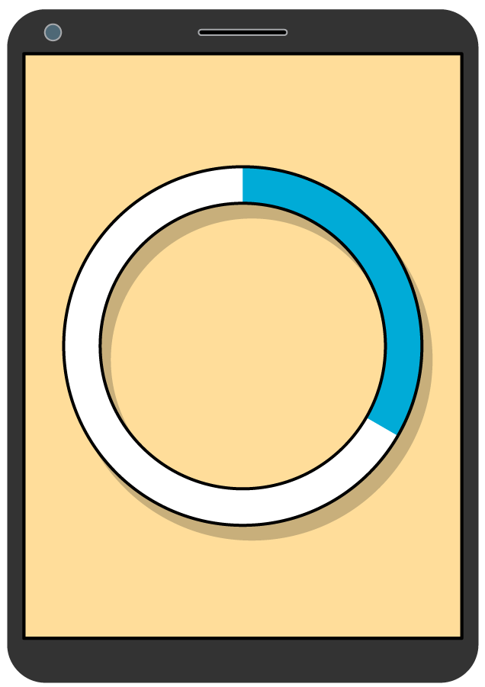
Tyler says, “The arc length on my progress bar measures 4.75 centimeters. The arc length on Han’s progress bar measures 2.25 centimeters. So, I’ve completed more tasks than Han has.”
- Do you agree with Tyler? Why or why not?
- What information would you need to make a completely accurate comparison between the two students’ progress?

2 A Dilated Circle

Student Task Statement
The image shows 2 circles. The second circle is a dilation of the first circle using a scale factor of 3.
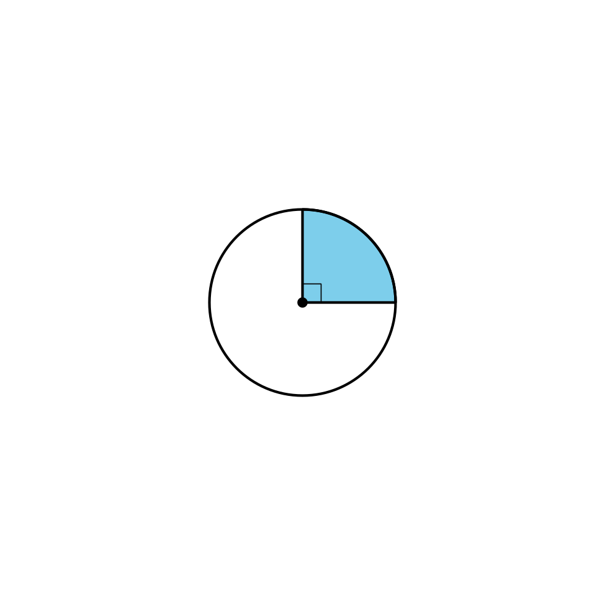
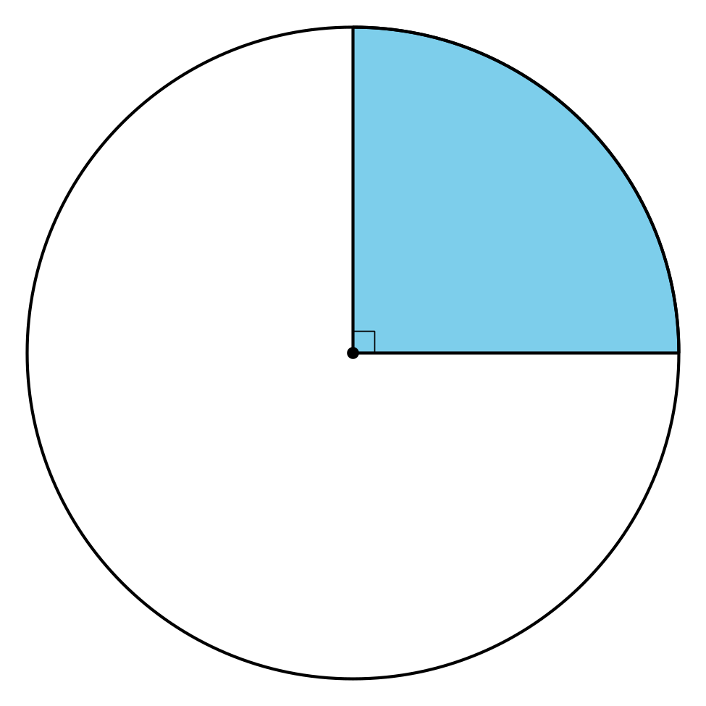
For each part of the dilated image, determine the factor by which it’s changed when compared to the corresponding part of the original circle.
- the area of the sector
- the central angle of the sector
- the radius
- the length of the arc defined by the sector
- the ratio of the circle’s circumference to its diameter

3 Card Sort: Angles, Arcs, and Radii

Student Task Statement
Your teacher will give you a set of cards. Sort the cards into categories of your choosing. Be prepared to explain the meaning of your categories. Then, sort the cards into categories in a different way. Be prepared to explain the meaning of your new categories.
© CC BY 2019 by Illustrative Mathematics®

