Lesson 7: Collect and Represent Data
- Let’s organize data and share with others.

Warm-up: Notice and Wonder: Let’s Get There
What do you notice? What do you wonder?
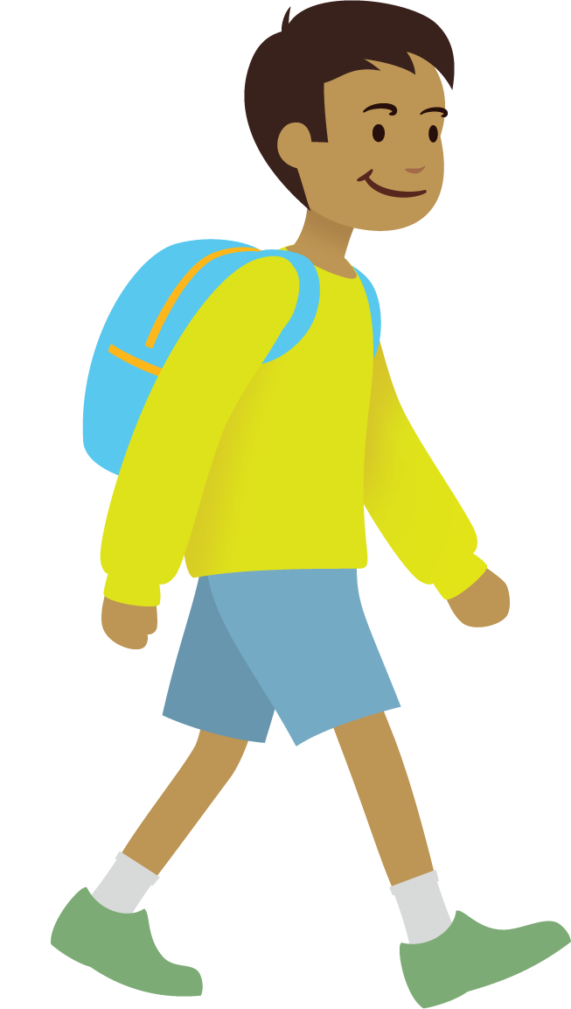
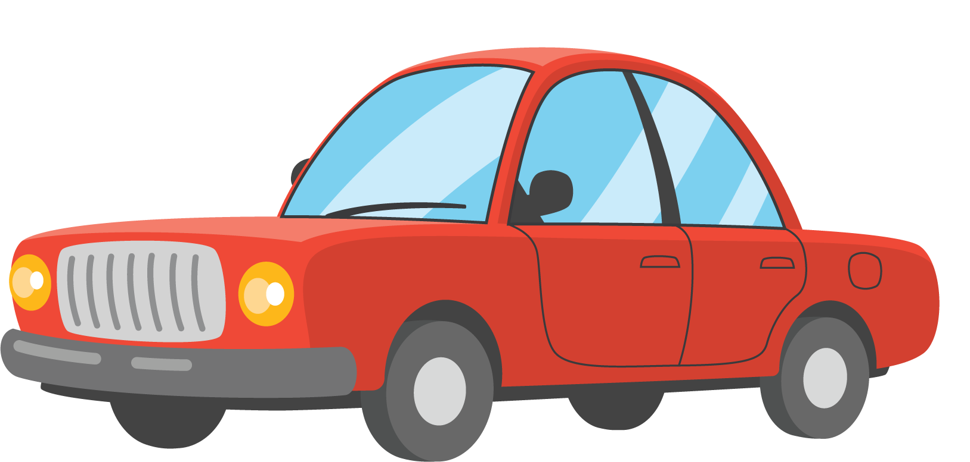
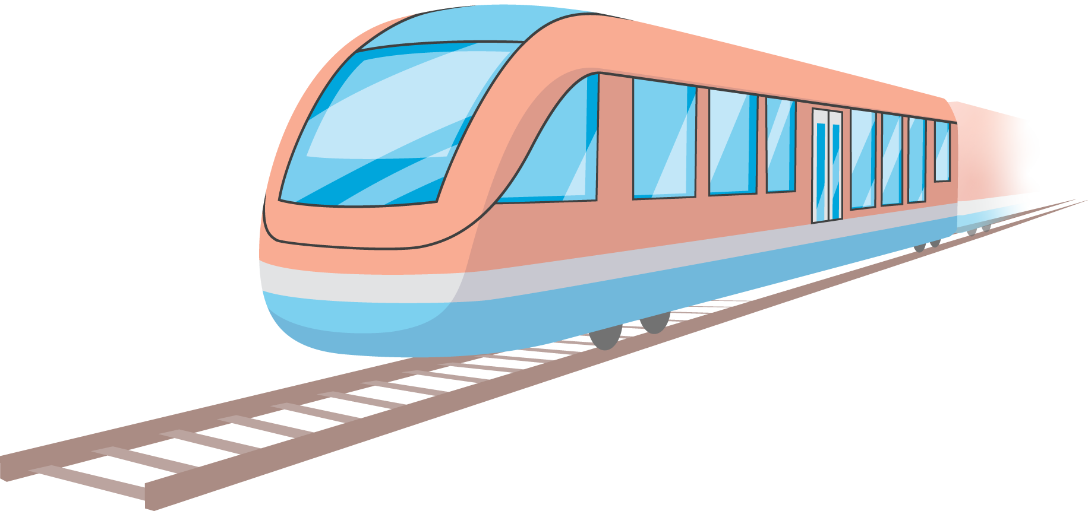

7.1: How Do We Get to School?
Choose the picture that shows how you got to school today.
Write your name on the picture.

7.2: Visual Representations of Data
Organize and represent the data about how our class gets to school.
© CC BY 2021 Illustrative Mathematics®

