Lesson 6: Count Larger Collections
- Let’s organize, count, and show collections.

6.2: Noah Counts a Collection
Noah organized his collection of connecting cubes.
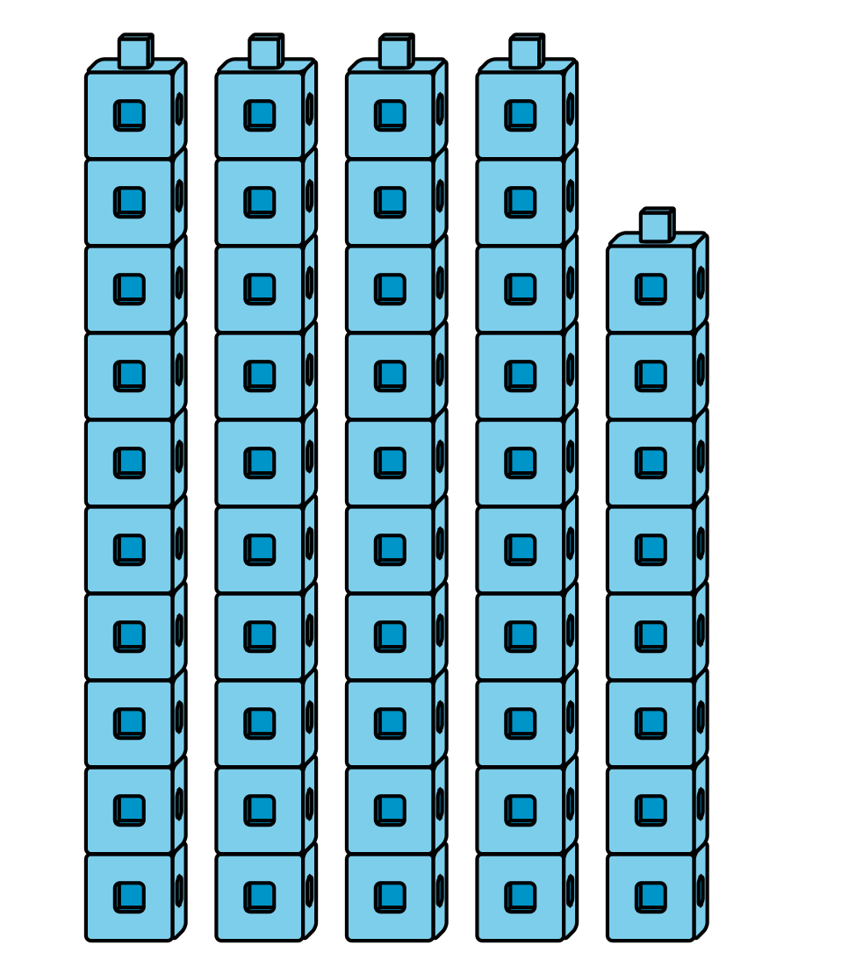
He counts and says there are 50 cubes.
Do you agree or disagree?
Explain how you know:
I ____________________ with Noah because

6.3: Centers: Choice Time
Choose a center.
Check It Off
Five in a Row
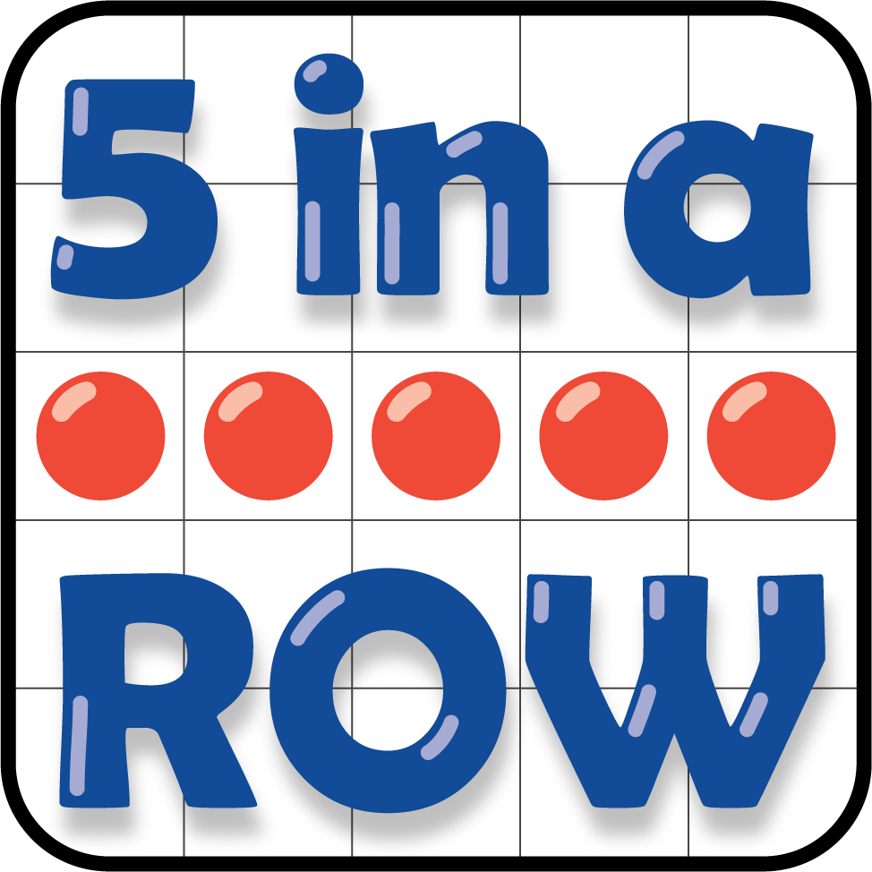
Number Puzzles
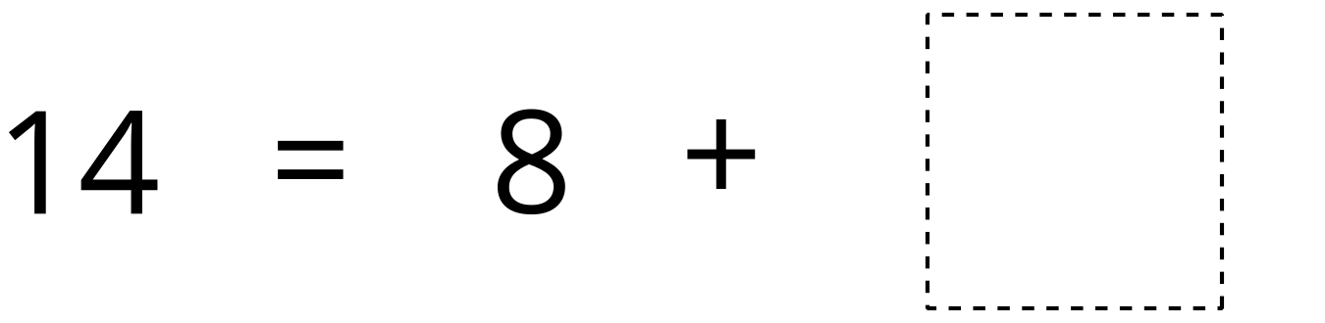
© CC BY 2021 Illustrative Mathematics®

