Unit 6 Lesson 5: Distance To and Distance From

1 Saving Up (Warm up)

Student Task Statement
Kiran is saving up to buy a game for $22. He starts with no money saved and adds $1.50 to his savings each week. Both of these graphs represent the situation.
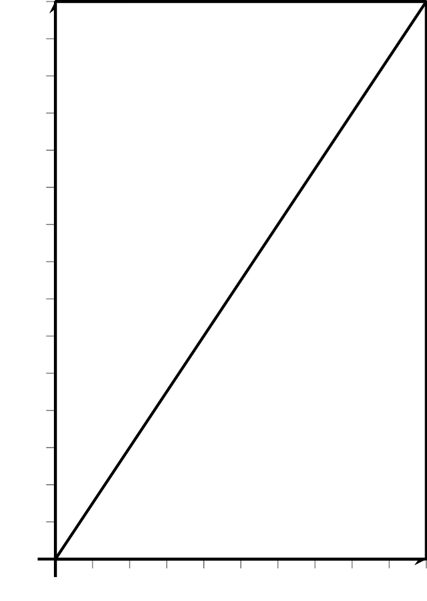
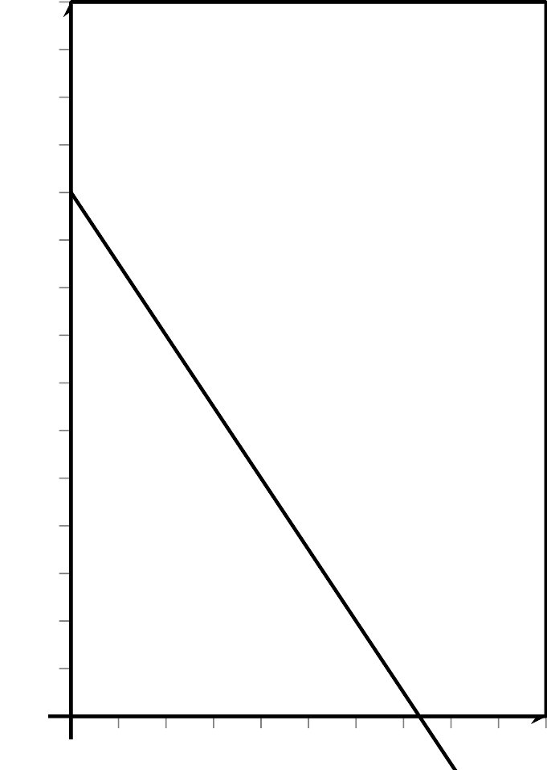
Describe what $x$ and $y$ represent on each graph.

2 A Walk to the Park, or a Walk Away from Home?

Student Task Statement
- A person is walking from home to a park that is 2,473 feet away. They are walking 280 feet per minute.
  - How far away from home are they after 0, 1, 2, 3, 5, $t$ minutes?
- minutes | - 0 | - 1 | - 2 | - 3 | - 5 | - $t$
  - distance from home
  - How far away from the park are they after 0, 1, 2, 3, 5, $t$ minutes?
- minutes | - 0 | - 1 | - 2 | - 3 | - 5 | - $t$
  - distance from park
- Create an equation that relates $t$ to:
  - the distance from home
  - the distance from the park
- Create a rough sketch of a graph of each equation. Label the coordinates of any horizontal or vertical intercepts.
- Which is the closest to the number of minutes it takes the person to reach the park: 6, 8, 9, or 12? Explain how you know.

3 Walking to School

Student Task Statement
- A person walks from home to school. The function $d(t)=250t$ gives the distance from home as a function of time, $t$, in minutes. The school is 4,000 feet from home.
  - How far does the person walk in 30 seconds?
  - Here are two tables representing the person’s walk. How are the tables alike? How are they different?
  - Complete the tables.
- time (minutes) | - 0 | - 1 | - 2 | - 3 | - 4 | - $t$
- distance from home (feet) | - 0 | - 250 | - 500
- time (minutes) | - 0 | - 1 | - 2 | - 3 | - 4 | - $t$
- distance from school (feet) | - 4,000 | - 3,750 | - 3,500
- The square of a number refers to the product of the number and itself. For example, the square of 3 is 9, because $3^{2}=9$. Complete the table showing squares and positive square roots of different numbers.
- $n$ | - 4 | - 8 | - 0.8 |  | - $\frac{1}{10}$ | - 12
- $n^{2}$ | - 16 |  |  | - 81 |  |  | - 1.96 | - 256 | - $\frac{1}{289}$ | - 400
© CC BY 2019 by Illustrative Mathematics®

