Unit 4 Lesson 21: Zeros in the Standard Algorithm

WU Which One Doesn’t Belong: Numbers with 0, 2, and 5 (Warm up)

Student Task Statement
Which one doesn’t belong?
- 2,050
- 2,055
- 205.2
- 20,005

1 What If There is Nothing to Decompose?

Student Task Statement
Here are some numbers you saw earlier. Each number has at least one 0. From each number, 1,436 is being subtracted.
- Make sense of the problems and explain to a partner.
- a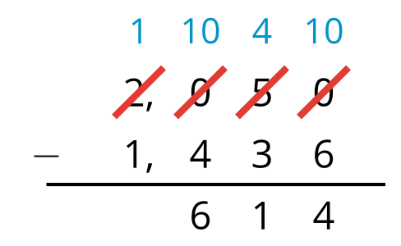
- b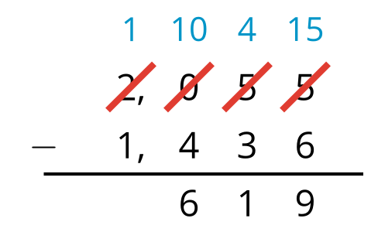
- Use the approach in the first problem to find these two differences:
- a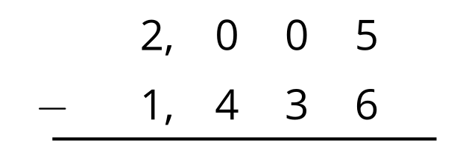
- b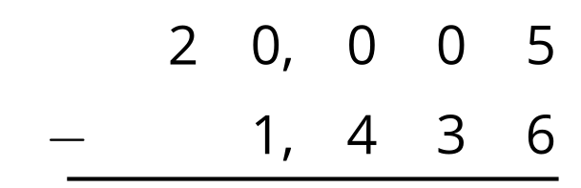
- Find the value of each difference. Be prepared to explain your reasoning. If you get stuck, try subtracting using the expanded form.
- a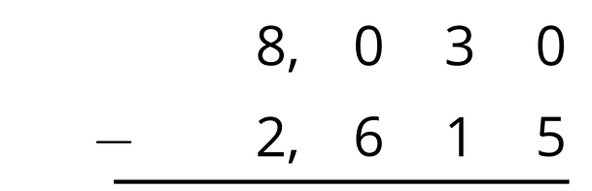
- b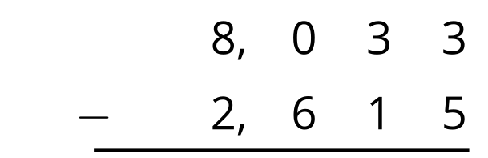
- c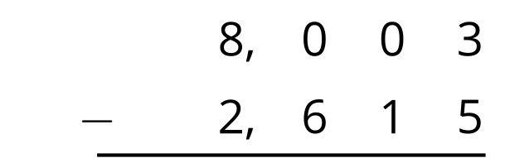
- d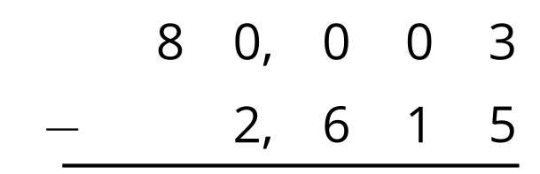

2 What is Your Age?

Student Task Statement
Jada recorded the birth year of some of her maternal grandparents for a family history project.
family member | birth year
grandmother | 1952
grandfather | 1948
great-grandmother | 1930
great-grandfather | 1926
As of this year, what is the age of each family member? Show your reasoning. Use the standard algorithm at least once.

Images for Activity Synthesis
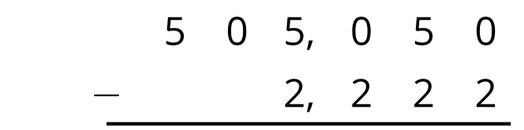
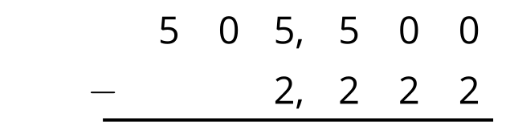
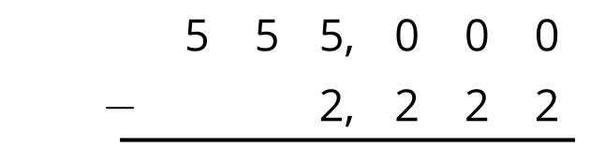
© CC BY 2021 Illustrative Mathematics®

