Lesson 1: Multiples of a Number

Warm-up: Which One Doesn’t Belong: All Kinds of Area
Which one doesn’t belong?
A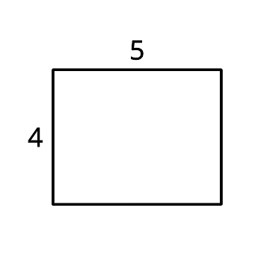
B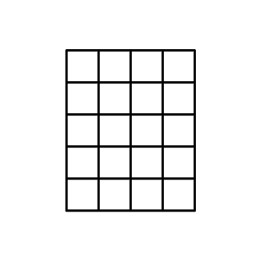
C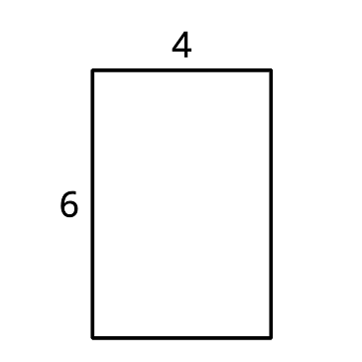
D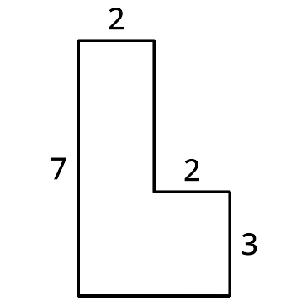

1.1: Build Rectangles and Find Area
- Build 5 different rectangles with each of the given widths. Record the area of each rectangle in the table.
- 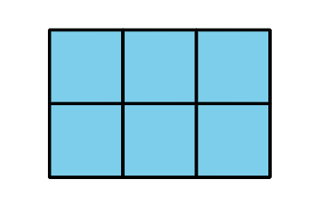
- Discuss with a partner what you notice about the areas in each row of the table.
- Predict the area of another rectangle that has each width. Explain your reasoning.
  - 2 tiles:
  - 3 tiles:
  - 4 tiles:

1.2: What Areas Can You Build?
- Elena is building rectangles with a width of 3 units and an area of 30 square units or less.
  - Build the rectangles Elena could make and draw the rectangles on grid paper. Label the area and the side lengths of each rectangle.
  - What is the area of each rectangle you built?
  - What do you notice about the areas?
- Why is 28 square units not a possible area for a rectangle with a width of 3 units?
- If the area of the rectangle can be more than 30 square units, find 2 other areas it could have. Explain or show your reasoning.
- What is an area that is not possible for a rectangle with a width of 3 units? Explain or show your reasoning.
© CC BY 2021 Illustrative Mathematics®

