## Unit 8 Lesson 12: Edge Lengths and Volumes

### 1 Ordering Squares and Cubes (Warm up)

#### Student Task Statement

Let , , , , , and be positive numbers.

Given these equations, arrange , , , , , and from least to greatest. Explain your reasoning.

### 2 Name That Edge Length!

#### Student Task Statement

Fill in the missing values using the information provided:

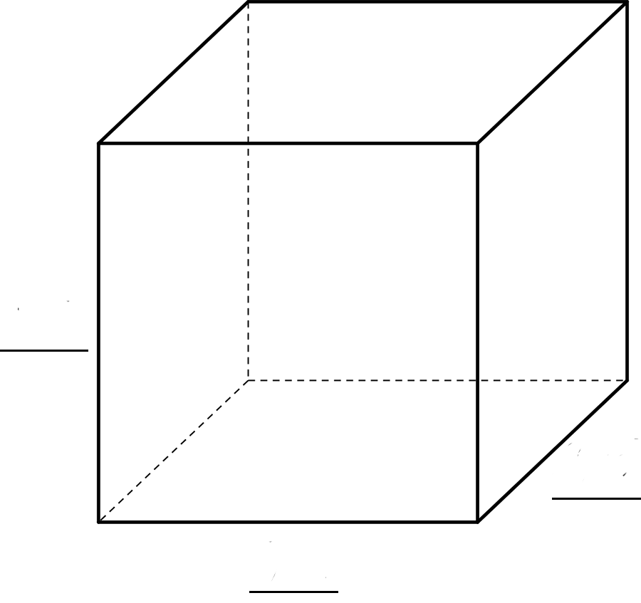

|  |  |  |
| --- | --- | --- |
| sides | volume | volume equation |
|  |  |  |
|  |  |  |
|  |  |  |

### 3 Card Sort: Rooted in the Number Line

#### Student Task Statement

Your teacher will give your group a set of cards. For each card with a letter and value, find the two other cards that match. One shows the location on a number line where the value exists, and the other shows an equation that the value satisfies. Be prepared to explain your reasoning.



© CC BY Open Up Resources. Adaptations CC BY IM.