Unit 5 Lesson 13 Cumulative Practice Problems
- The value of $x$ is $\frac{\text{-}1}{4}$. Order these expressions from least to greatest:
- $x$
- $1−x$
- $x−1$
- $\text{-}1÷x$

- Here are four expressions that have the value $\frac{\text{-}1}{2}$:
- $\frac{\text{-}1}{4}+\left(\frac{\text{-}1}{4}\right)$
- $\frac{1}{2}−1$
- $\text{-}2⋅\frac{1}{4}$
- $\text{-}1÷2$
- Write five expressions: a sum, a difference, a product, a quotient, and one that involves at least two operations that have the value $\frac{\text{-}3}{4}$.
- Find the value of each expression.
  - $\text{-}22+5$
  - $\text{-}22−(\text{-}5)$
  - $(\text{-}22)(\text{-}5)$
  - $\text{-}22÷5$
- The price of an ice cream cone is $3.25, but it costs $3.51 with tax. What is the sales tax rate?
- (From Unit 4, Lesson 10.)
- Two students are both working on the same problem: A box of laundry soap has 25% more soap in its new box. The new box holds 2 kg. How much soap did the old box hold?
  - Here is how Jada set up her double number line.
  - 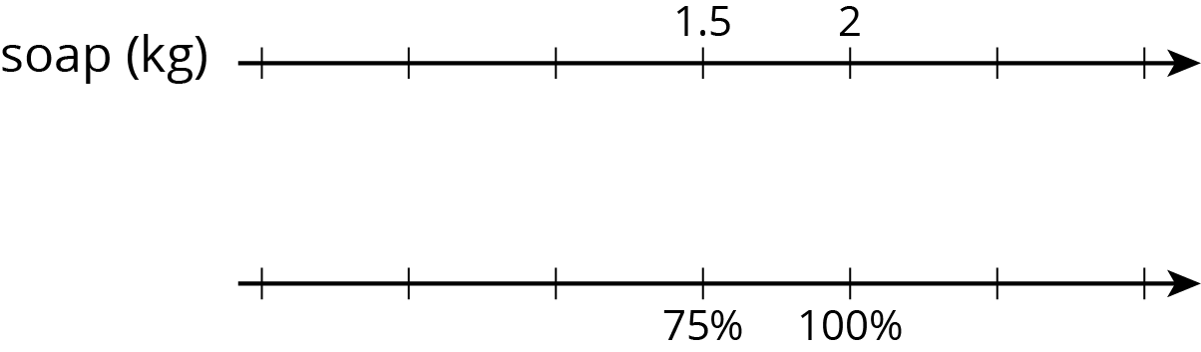
  - Here is how Lin set up her double number line.
- Do you agree with either of them? Explain or show your reasoning.
- (From Unit 4, Lesson 7.)
  - A coffee maker’s directions say to use 2 tablespoons of ground coffee for every 6 ounces of water. How much coffee should you use for 33 ounces of water?
  - A runner is running a 10 km race. It takes her 17.5 minutes to reach the 2.5 km mark. At that rate, how long will it take her to run the whole race?
- (From Unit 4, Lesson 3.)
© CC BY Open Up Resources. Adaptations CC BY IM.

