Lesson 7: Rectángulos y cuadrados

Standards Alignments
Addressing | 5.G.B.3, 5.G.B.4
Building Towards | 5.G.B.3

Teacher-facing Learning Goals
- Explain why a square is also a rectangle.

Student-facing Learning Goals
- Aprendamos más sobre rectángulos y cuadrados.

Lesson Purpose
The purpose of this lesson is for students to understand that a square is also a rectangle.
The purpose of this lesson is to establish a hierarchy of quadrilaterals based on properties of angles and side lengths and to represent that hierarchy using a diagram. Students examine the relationships between different pairs of quadrilaterals, notably squares and rectangles but also squares and rhombuses, and trapezoids and parallelograms. They have worked with explicit examples of these shapes in previous lessons and described their defining attributes. In this lesson they put all of these relationships together to understand relationships between categories (MP7), such as:
- A quadrilateral that is both a rectangle and a rhombus is a square.
- Rhombuses, squares, and rectangles are all parallelograms, but parallelograms don't have to be rhombuses, rectangles, or squares.
Students should have access to straight edges, protractors, and patty paper throughout this lesson.

Access for:

Students with Disabilities
- Action and Expression (Activity 2)

English Learners
- MLR8 (Activity 1)

Instructional Routines
What Do You Know About _____? (Warm-up)

Materials to Copy
- Quadrilateral Clues (groups of 2): Activity 1

Lesson Timeline
Warm-up | 10 min
Activity 1 | 15 min
Activity 2 | 20 min
Lesson Synthesis | 10 min
Cool-down | 5 min

Teacher Reflection Question
As students shared their ideas today, how did you ensure all students’ voices were heard and valued as an important part of the collective learning?

Cool-down
(to be completed at the end of the lesson) 5min
Cuadriláteros en el diagrama de Venn

Standards Alignments
Addressing | 5.G.B.4

Student-facing Task Statement
Dibuja cada figura o escribe su letra en el lugar correcto del diagrama:
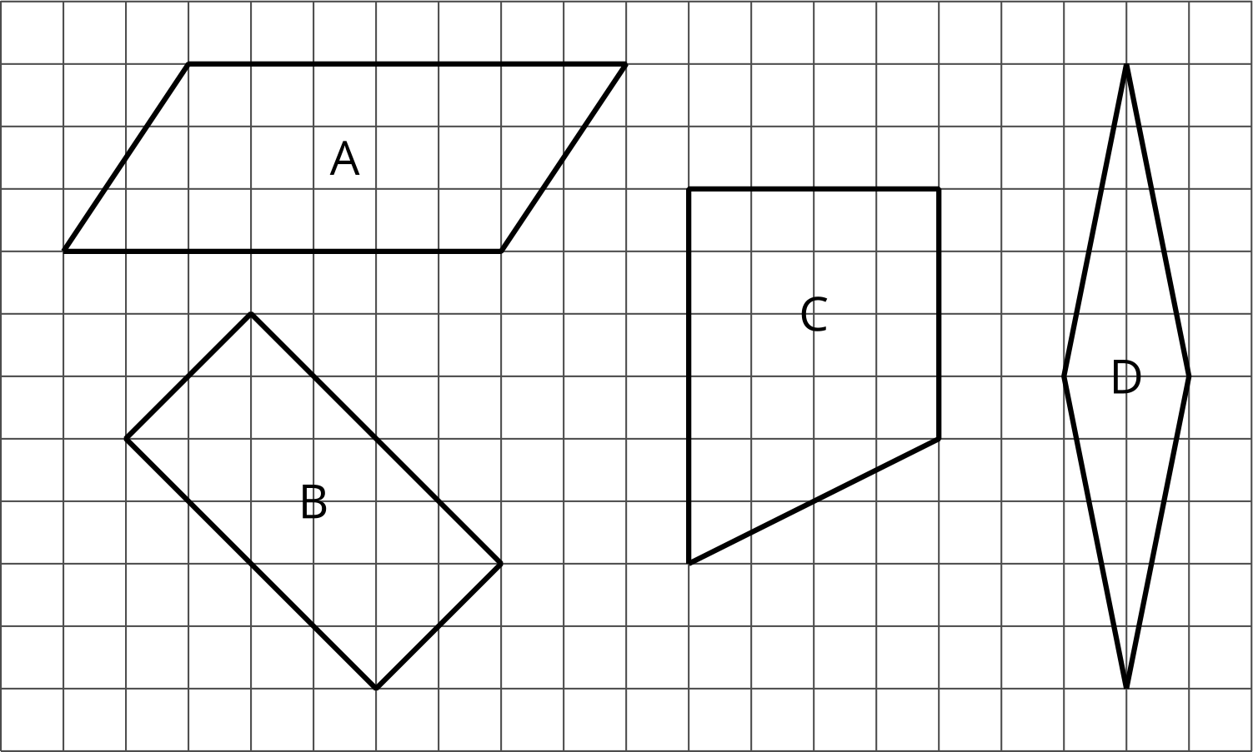
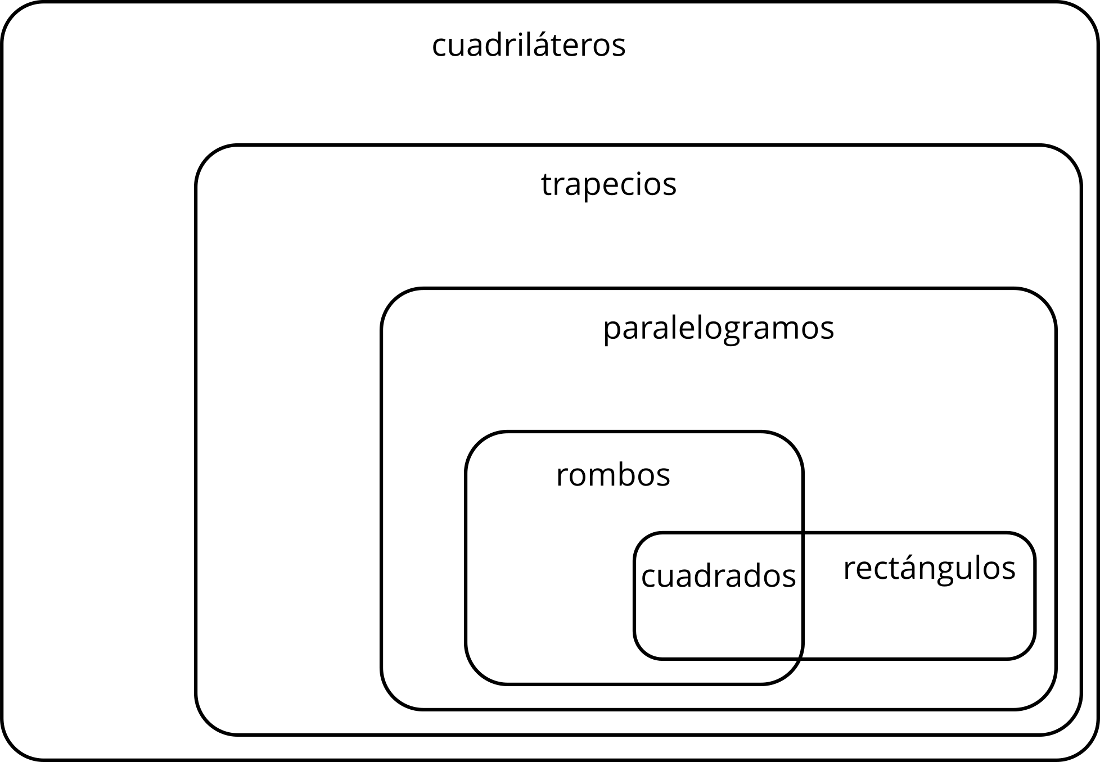

Student Responses
