Lesson 1: Scale Drawings
- Let’s make a scale drawing.

1.1: Is That the Same Hippo?
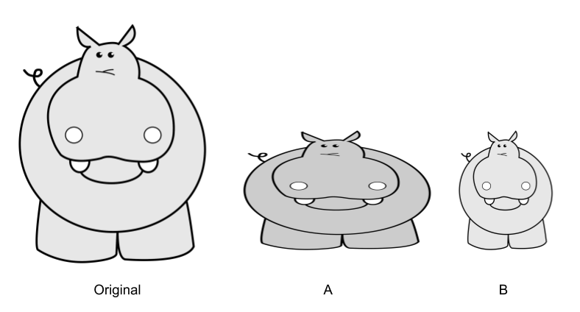
Diego took a picture of a hippo and then edited it. Which is the distorted image? How can you tell?
Is there anything about the pictures you could measure to test whether there’s been a distortion?

1.2: Sketching Stretching
A dilation with center $O$ and positive scale factor $r$ takes a point $P$ along the ray $OP$ to another point whose distance is $r$ times farther away from $O$ than $P$ is. If $r$ is less than 1 then the new point is really closer to $O$, not farther away.
- Dilate $H$ using $C$ as the center and a scale factor of 3. $H$ is 40 mm from $C$.
- Dilate $K$ using $O$ as the center and a scale factor of $\frac{3}{4}$. $K$ is 40 mm from $O$.

1.3: Mini Me
- Dilate the figure using center $P$ and scale factor $\frac{1}{2}$.

- What do you notice? What do you wonder?

Are you ready for more?
- Dilate segment $AB$ using center $P$ by scale factor $\frac{1}{2}$. Label the result $A^{′}B^{′}$.
- Dilate the segment $AB$ using center $Q$ by scale factor $\frac{1}{2}$.
- How does the length of $A^{″}B^{″}$ compare to $A^{′}B$? How would the length of $A^{″}B^{″}$ change if $Q$ was infinitely far away? Explain or show your answer.

Lesson 1 Summary
A scale drawing of an object is a drawing in which all lengths in the drawing correspond to lengths in the object by the same scale. When we scale a figure we need to be sure to scale all of the parts equally or else the image will become distorted.
Creating a scaled copy involves multiplying the lengths in the original figure by a scale factor. The scale factor is the factor by which every length in a original figure is multiplied when you make a scaled copy. A scale factor greater than 1 enlarges an object while a scale factor less than 1 shrinks an object. What would a scale factor equal to 1 do?
For example, segment $BC$ is a scaled copy of segment $DE$ with a scale factor of $\frac{1}{4}$. So $BC=\frac{1}{4}DE$. If $DE=6$, then $BC=\frac{6}{4}$ or 1.5.
To perform a dilation, we need a center of dilation, a scale factor, and something to dilate. A dilation with center $A$ and positive scale factor $k$ takes a point $D$ along the ray $AD$ to another point whose distance is $k$ times farther away from $A$ than $D$ is.
Segment $FG$ is a dilation of segment $DE$ using center $A$ and a scale factor of 3. So $FA=3⋅DA$. If $DA=15$, then $FA=45$.
© CC BY 2019 by Illustrative Mathematics®

