Lesson 15: Features of Trigonometric Graphs (Part 1)
- Let’s compare graphs and equations of trigonometric functions.

15.1: Notice and Wonder: Musical Notes
Here are pictures of sound waves for two different musical notes:
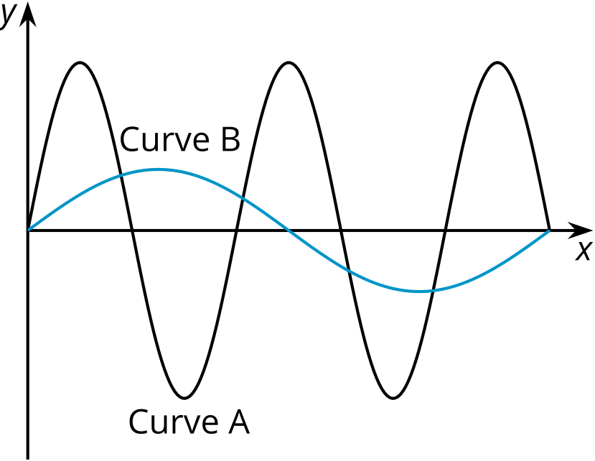
What do you notice? What do you wonder?

15.2: Equations and Graphs
Match each equation with its graph. More than 1 equation can match the same graph.
Equations:
- $y=\text{-}cos\left(θ\right)$
- $y=2sin\left(θ\right)−3$
- $y=cos\left(θ+\frac{π}{2}\right)$
- $y=3sin\left(θ\right)−2$
- $y=sin\left(θ−\frac{π}{2}\right)$
- $y=sin\left(θ+π\right)$

A
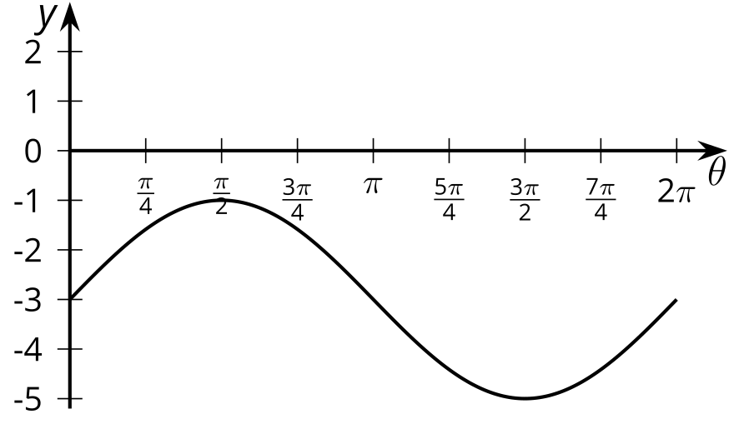

B
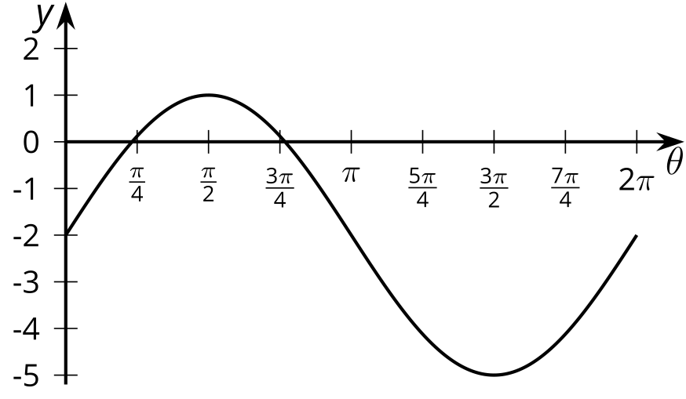

C
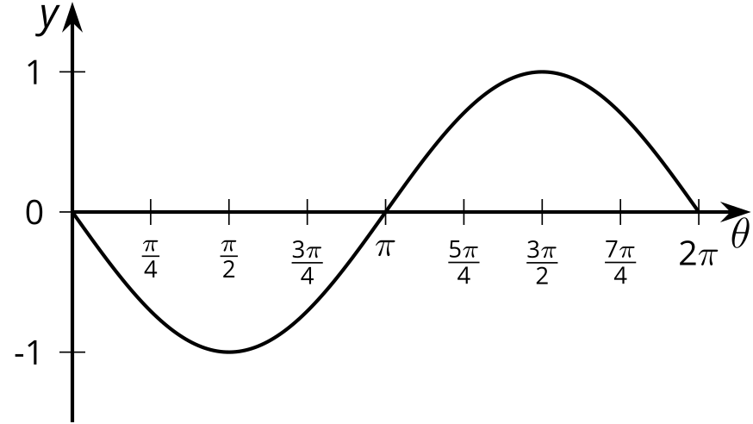

D
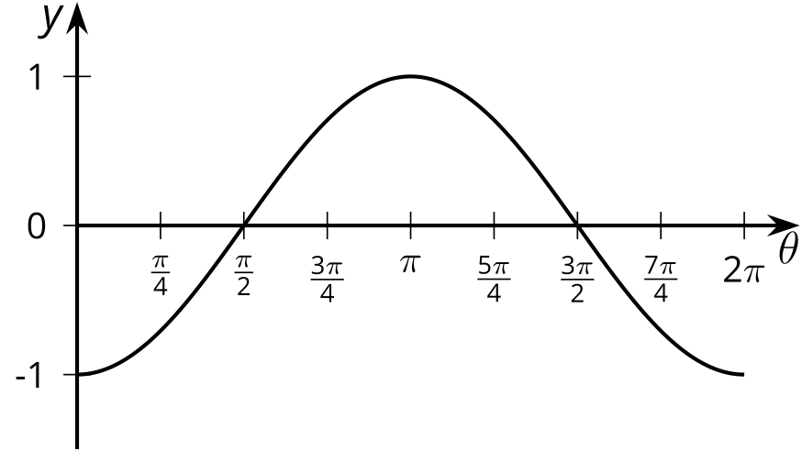

Are you ready for more?
- Find an equation for this graph using the sine function.
- Find another equation for the same graph using a cosine function.
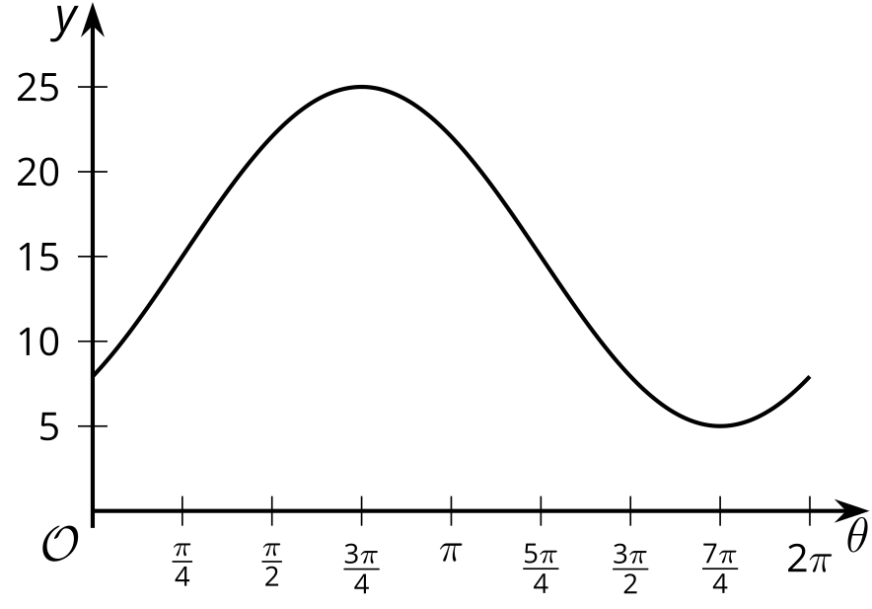

15.3: Double the Sine
- Complete the table of values for the expression $sin\left(2θ\right)$
- $θ$ | - 0 | - $\frac{π}{12}$ | - $\frac{π}{6}$ | - $\frac{π}{4}$ | - $\frac{π}{2}$ | - $\frac{3π}{4}$ | - $π$ | - $\frac{5π}{4}$ | - $\frac{3π}{2}$ | - $\frac{7π}{4}$ | - $2π$
- $sin\left(2θ\right)$
- Plot the values and sketch a graph of the equation $y=sin\left(2θ\right)$. How does the graph of $y=sin\left(2θ\right)$ compare to the graph of $y=sin\left(θ\right)$?
- 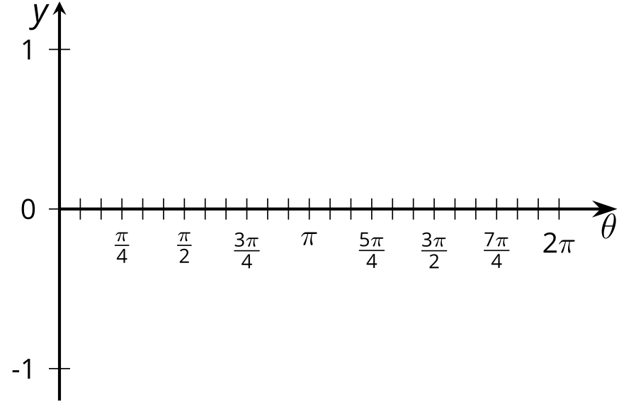
- Predict what the graph of $y=cos\left(4θ\right)$ will look like and make a sketch. Explain your reasoning.

Lesson 15 Summary
We can find the amplitude and midline of a trigonometric function using the graph or from an equation. For example, let’s look at the function given by the equation $y=3cos\left(θ+\frac{π}{4}\right)+2$. We can see that the midline of this function is 2 because of the vertical translation up by 2. This means the horizontal line $y=2$ goes through the middle of the graph. The amplitude of the function is 3. This means the maximum value it takes is 5, 3 more than the midline value, and the minimum value it takes is -1, 3 less than the midline value. The horizontal translation is $\frac{π}{4}$ to the left, so instead of having, for example, a minimum at $π$, the minimum is at $\frac{3π}{4}$. Here is what the graph looks like:
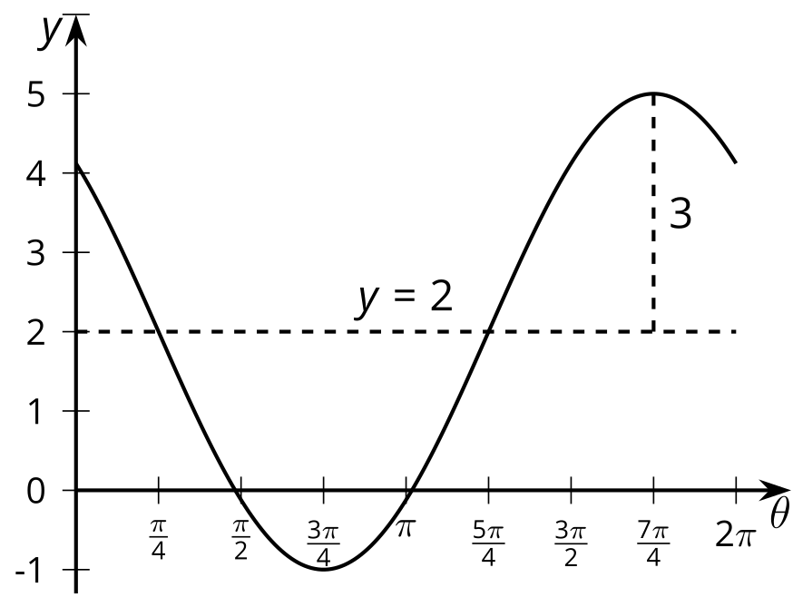
Another type of transformation is one that affects the period and that is when a horizontal scale factor is used. For example, let's look at the equation $y=cos\left(2θ\right)$ where the variable $θ$ is multiplied by a number. Here, 2 is the scale factor affecting $θ$. When $θ=0$, we have $2θ=0$ so the graph of this cosine equation starts at $\left(0,1\right)$, just like the graph of $y=cos\left(θ\right)$. When $x=π$, we have $2θ=2π$ so the graph of $y=cos\left(2θ\right)$ goes through two full periods in the same horizontal span it takes $y=cos\left(θ\right)$ to complete one full period, as shown in their graphs.
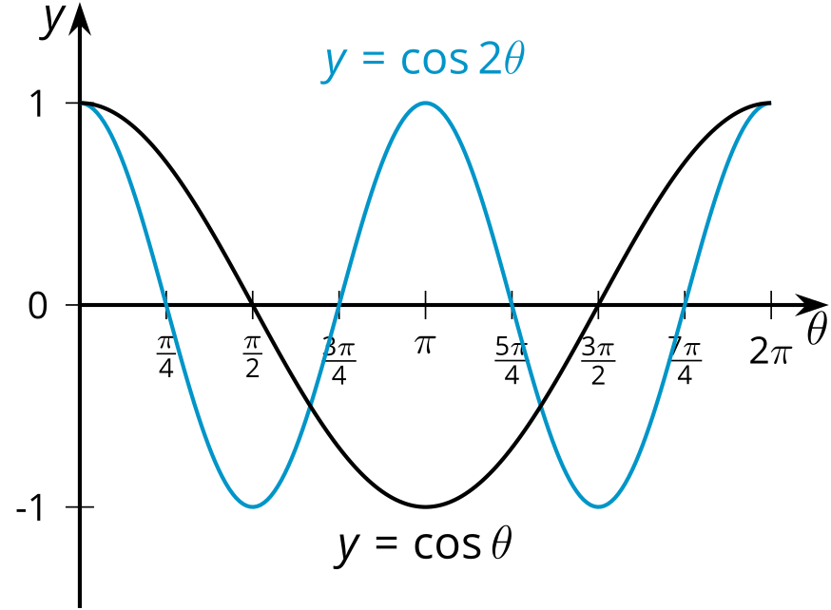
Notice that the graph of $y=cos\left(2θ\right)$ has the same general shape as the graph of $y=cos\left(θ\right)$ (same midline and amplitude) but the waves are compressed together. And what if we wanted to give the graph of cosine a stretched appearance? Then we could use a horizontal scale factor between 0 and 1. For example, the graph of $y=cos\left(\frac{θ}{6}\right)$ has a period of $12π$.
© CC BY 2019 by Illustrative Mathematics®

