Unit 7 Lesson 11: A New Way to Measure Angles

1 A One-Unit Radius (Warm up)

Student Task Statement
A circle has radius 1 unit. Find the length of the arc defined by each of these central angles. Give your answers in terms of $π$.
- 180 degrees
- 45 degrees
- 270 degrees
- 225 degrees
- 360 degrees

2 A Constant Ratio

Student Task Statement
Diego and Lin are looking at 2 circles.
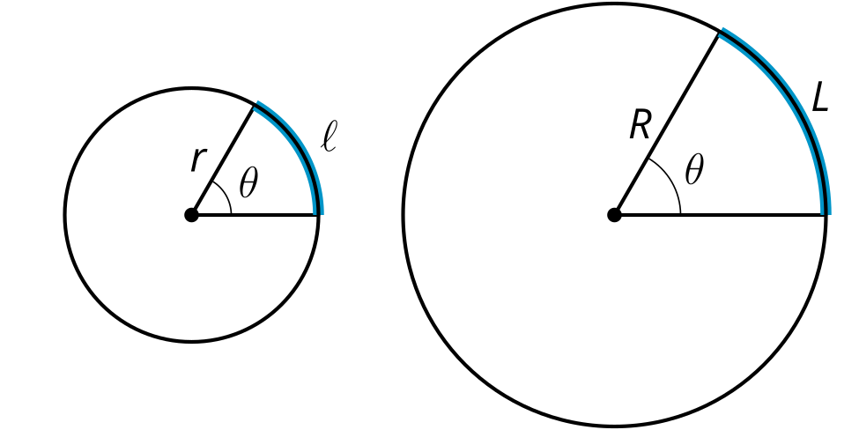
Diego says, “It seems like for a given central angle, the arc length is proportional to the radius. That is, the ratio $\frac{ℓ}{r}$ has the same value as the ratio $\frac{L}{R}$ because they have the same central angle measure. Can we prove that this is true?”
Lin says, “The big circle is a dilation of the small circle. If $k$ is the scale factor, then $R=kr$.”
Diego says, “The arc length in the small circle is $ℓ=\frac{θ}{360}⋅2πr$. In the large circle, it’s $L=\frac{θ}{360}⋅2πR$. We can rewrite that as $L=\frac{θ}{360}⋅2πrk$. So $L=kℓ$.”
Lin says, “Okay, from here I can show that $\frac{ℓ}{r}$ and $\frac{L}{R}$ are equivalent.”
- How does Lin know that the big circle is a dilation of the small circle?
- How does Lin know that $R=kr$?
- Why could Diego write $ℓ=\frac{θ}{360}⋅2πr$?
- When Diego says that $L=kℓ$, what does that mean in words?
- Why could Diego say that $L=kℓ$?
- How can Lin show that $\frac{ℓ}{r}=\frac{L}{R}$?

Activity Synthesis
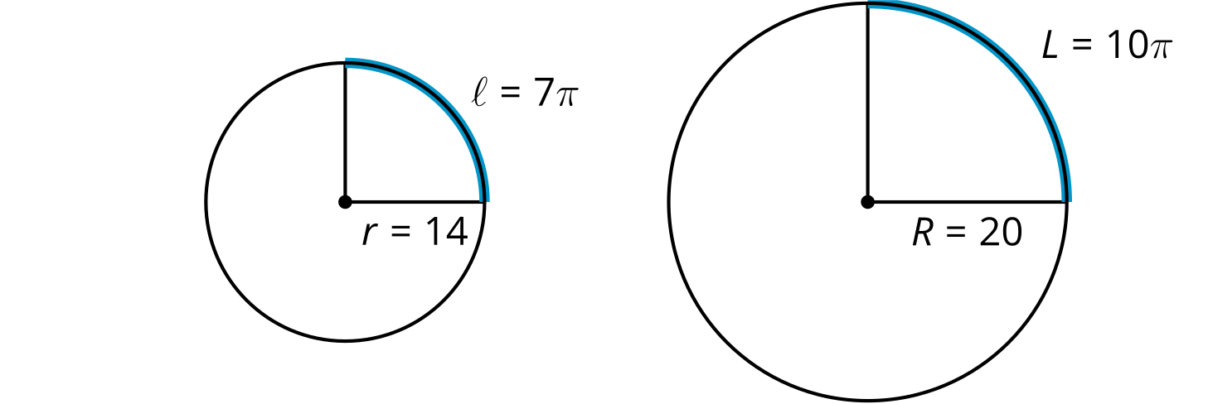

3 Defining Radians

Student Task Statement
Suppose we have a circle that has a central angle. The radian measure of the angle is the ratio of the length of the arc defined by the angle to the circle’s radius. That is, $θ=\frac{\text{arc length}}{\text{radius}}$.
- The image shows a circle with radius 1 unit.
- 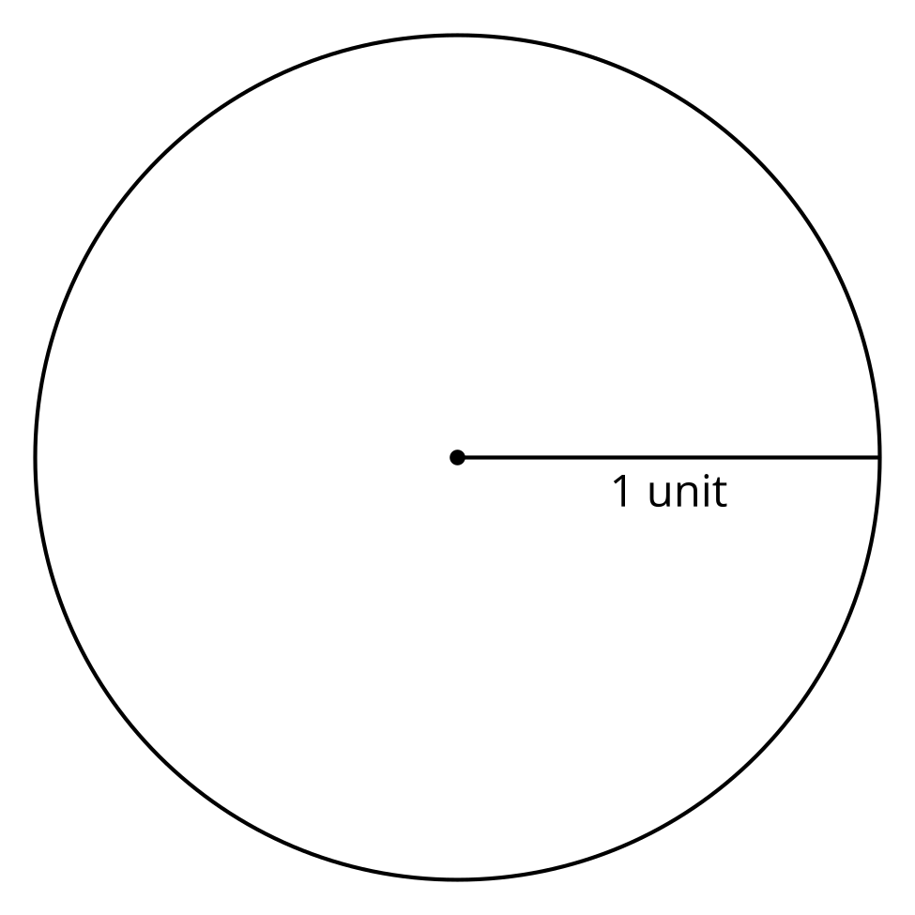
  - Cut a piece of string that is the length of the radius of this circle.
  - Use the string to mark an arc on the circle that is the same length as the radius.
  - Draw the central angle defined by the arc.
  - Use the definition of radian to calculate the radian measure of the central angle you drew.
- Draw a 180 degree central angle (a diameter) in the circle. Use your 1-unit piece of string to measure the approximate length of the arc defined by this angle.
- Calculate the radian measure of the 180 degree angle. Give your answer both in terms of $π$ and as a decimal rounded to the nearest hundredth.
- Calculate the radian measure of a 360 degree angle.

Images for Activity Synthesis
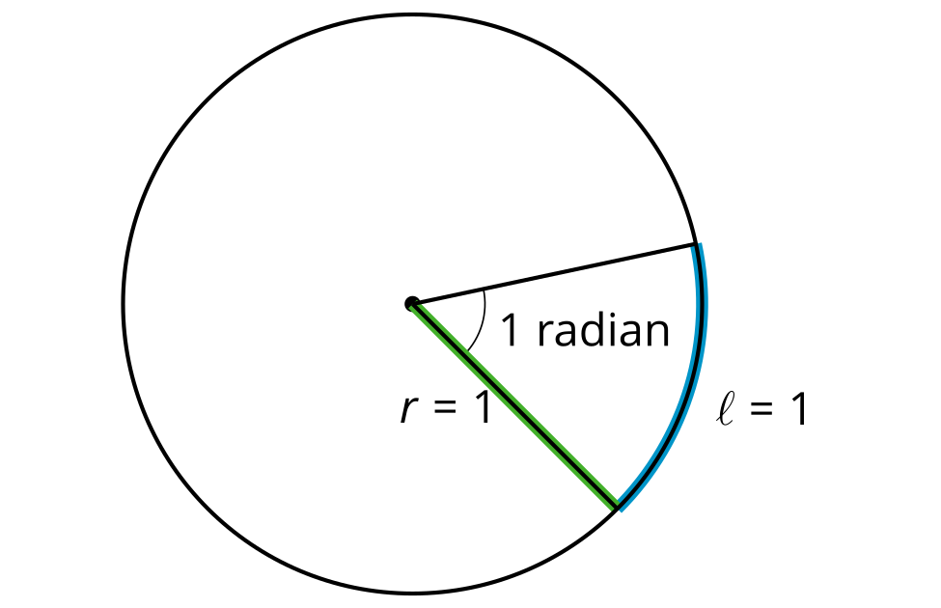
© CC BY 2019 by Illustrative Mathematics®

