Lesson 8: Interpret Picture Graphs
- Let’s answer questions based on picture graphs.

Warm-up: How Many Do You See: Dots within 10
How many do you see? How do you see them?

8.1: Veggies People Love
Clare asked a group of kids, “What veggies do you love?” Their responses are shown in this picture graph.
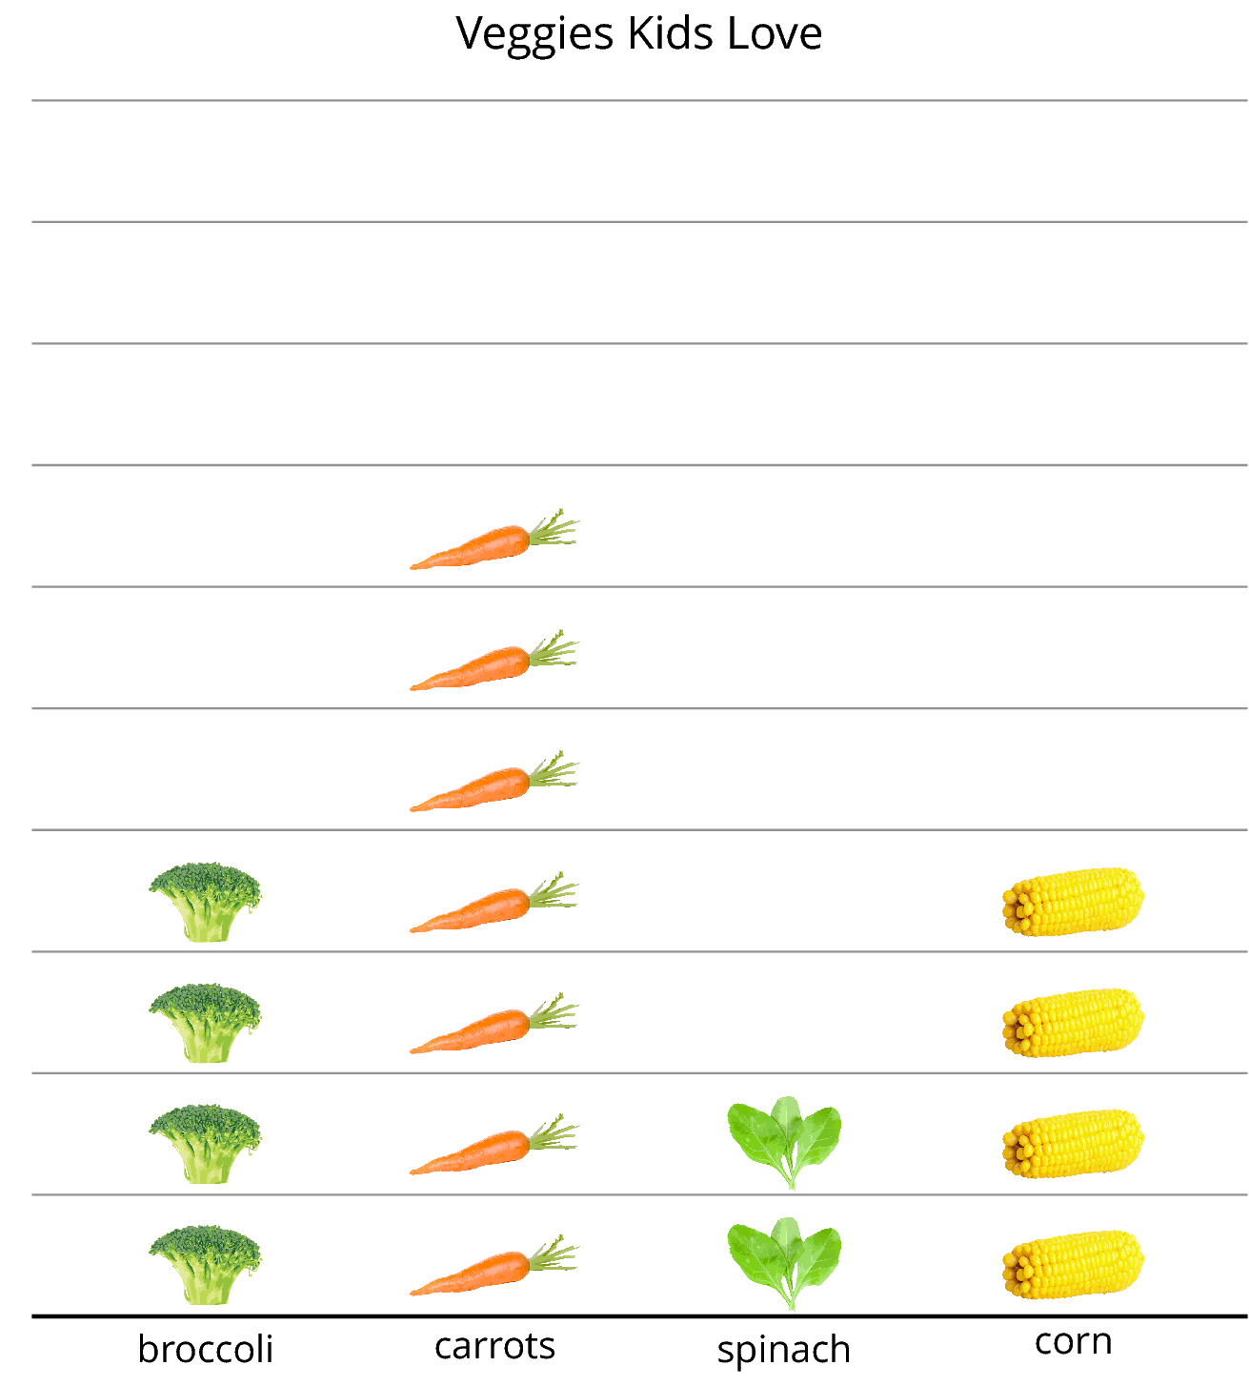
What can you learn about the veggies kids love from Clare’s picture graph?
A group of adults were asked, “What veggies do you love?” Their responses are shown in this picture graph.
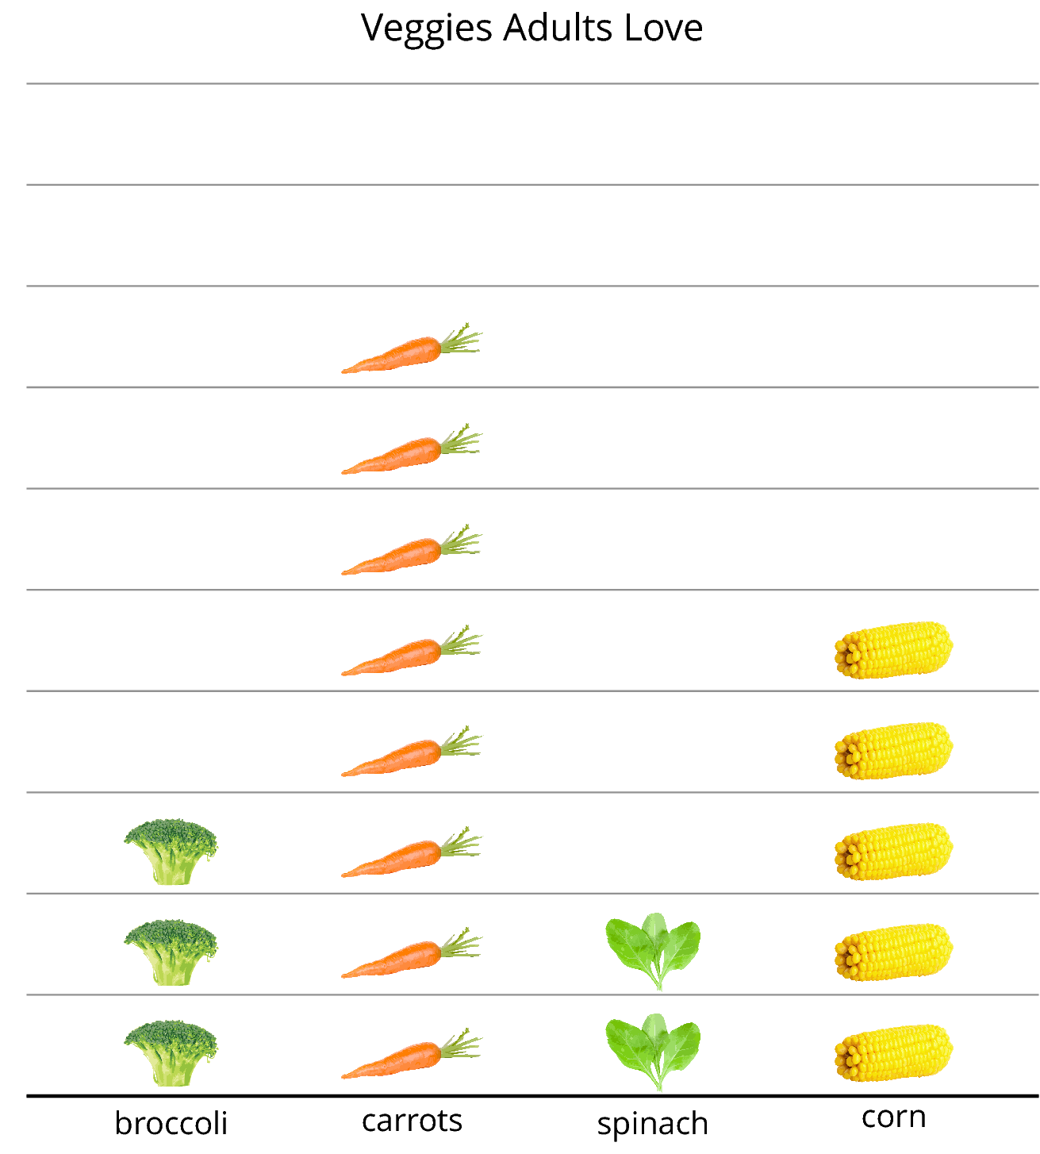
Answer the questions based on the graph.
- How many adults like spinach?
- What is the total number of adults who like carrots or corn? Show your thinking using drawings, numbers, or words.
- Write one fact you learned about the veggies adults love based on the data represented in the picture graph.

8.2: Answer Questions
A group of kids were asked, “What foods do you love to eat?” Their responses are shown in this picture graph.
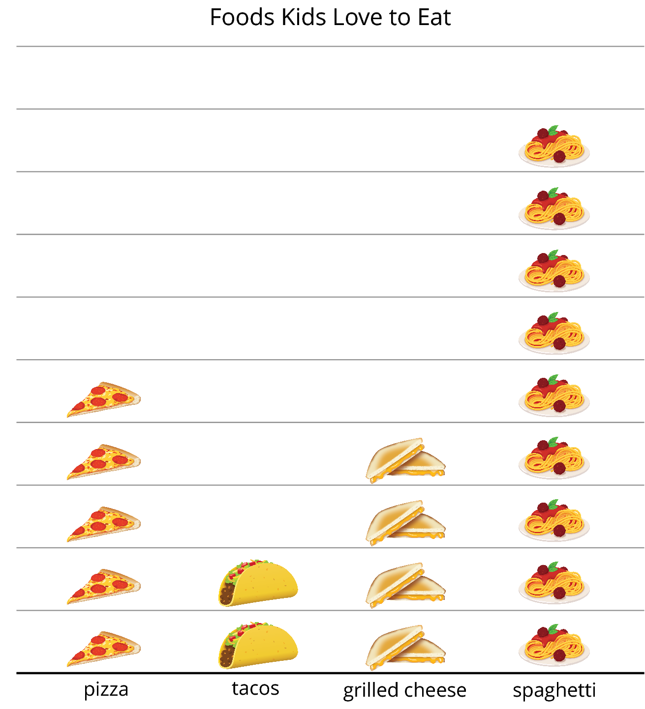
- Circle the 4 questions that can be answered using the graph.
  - How many kids chose pizza?
  - How many chose tacos or grilled cheese?
  - Why did so many kids choose spaghetti?
  - How many more kids chose pizza than tacos?
  - What is the total number of kids who chose spaghetti or pizza?
- Answer each question you circled.
© CC BY 2021 Illustrative Mathematics®

