Lesson 11: Use Factors to Find Equivalent Fractions
- Let’s find equivalent fractions by working with numerators and denominators.

Warm-up: Which One Doesn’t Belong: Four Representations
Which one doesn't belong?
- 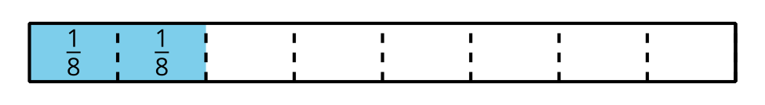
- $\frac{1}{4}$

11.1: The Other Way Around
- Andre drew a number line and marked a point on it. Label the point with the fraction it represents.
- To find other fractions that the point represents, Andre made copies of the number line. He drew darker marks on some of the existing tick marks.
- Label the darker tick marks Andre made on each number line.
- Kiran wrote the same fractions for the points but used a different strategy, as shown. Analyze his reasoning.
- $\frac{8 ÷ 4}{12 ÷ 4}=\frac{2}{3}$
- $\frac{8 ÷ 2}{12 ÷ 2}=\frac{4}{6}$
- How do you think Andre’s and Kiran’s strategies are related?
- Try using Kiran’s strategy to find one or more fractions that are equivalent to $\frac{10}{12}$ and $\frac{18}{12}$.

11.2: How Would You Find Them?
Find at least two fractions that are equivalent to each fraction. Show your reasoning.
- $\frac{16}{8}$
- $\frac{40}{10}$
- $\frac{7}{6}$
- $\frac{90}{100}$
- $\frac{5}{4}$

11.3: Card Sort: Fractions Galore
Your teacher will give you a set of cards. Find as many sets of equivalent fractions as you can. Be prepared to explain or show your reasoning.
Record the sets of equivalent fractions here.
Record fractions that do not have an equivalent fraction here.

Section Summary
Section Summary
In this section, we learned to identify and write equivalent fractions. We placed fractions on number lines and saw that two fractions that occupy the same spot on a number line are equivalent.
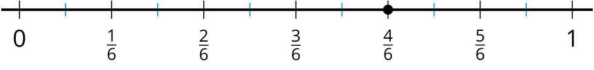
We also looked at strategies for finding equivalent fractions and learned that multiplying or dividing the numerator and denominator by the same number will result in an equivalent fraction. Here are some examples:
$\frac{1 × 2}{5 × 2}=\frac{2}{10}$
$\frac{1 × 4}{5 × 4}=\frac{4}{20}$
$\frac{1}{5}$ is equivalent to $\frac{2}{10}$ and $\frac{4}{20}$.
$\frac{8 ÷ 2}{12 ÷ 2}=\frac{4}{6}$
$\frac{8 ÷ 4}{12 ÷ 4}=\frac{2}{3}$
$\frac{8}{12}$ is equivalent to $\frac{4}{6}$ and $\frac{2}{3}$.
© CC BY 2021 Illustrative Mathematics®

