Unit 6 Lesson 6: Graphs of Situations that Change

1 Notice and Wonder: The Draining Tank (Warm up)

Student Task Statement
A water tank is draining at a constant rate.
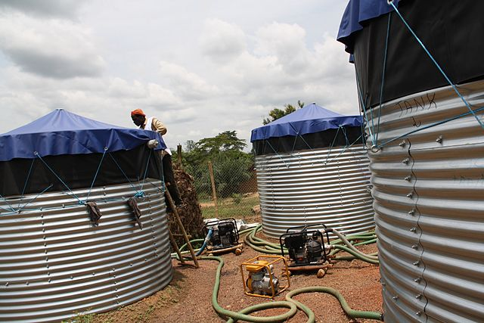
What do you notice? What do you wonder?

2 Identifying Important Points

Student Task Statement
A tank has 50 gallons of water and drains at a constant rate of 2 gallons per minute. Here is a graph representing the situation:
- Label each axis to show what it represents. Be sure to include units.
- Complete the table.
- $t$ | - 0 | - 1 | - 2 | - 3 | - 10 | - 20 | - $t$
- $v(t)$
- Use the expression in terms of $t$ from the table to write a function modeling this situation.
- Use graphing technology to graph your function. Practice setting the graphing window so that you can see both intercepts, and using graphing technology to see the coordinates of different points on your graph.
- What is a reasonable domain for this function, based on the situation it models?

3 Three Situations

Student Task Statement
- Create a graph of each function using graphing technology. Make a rough sketch of each graph. On each graph, label the coordinates of any intercepts.
  - $a(x)=4+\text{-}3x+50$
  - $b(x)=10(x−0.5)+17$
  - $c(x)=81−\frac{1}{3}x$
  - $d(x)=8x−x^{2}$
- Function $d$ has a maximum point. Can you find the coordinates of this point?
- Here are some situations. For each situation:
  - Write an equation representing the situation. If you get stuck, consider making a table of values, thinking about what type of function it is, or thinking about the initial value and rate of change or growth factor. Be sure to explain the meaning of any variables you use.
  - Sketch a graph representing each situation. Label the coordinates of any intercepts or other important points.
- A person has $128 saved, and adds $4 to their savings per week.
- A tank has 128 gallons of water, and drains at a constant rate of 4 gallons per minute.
- A patient is given 128 milligrams of a medication, and half of the medication leaves the patient’s bloodstream every hour.
© CC BY 2019 by Illustrative Mathematics®

