Unit 4 Lesson 22: Solve Problems Involving Large Numbers

WU True or False: Sums and Differences (Warm up)

Student Task Statement
Decide if each statement is true or false. Be prepared to explain your reasoning.
- $7,​000+3,​000=10,​000$
- $7,​180+3,​920=10,​100$
- $423,​450−42,​345=105$
- $400,​000−99,​999=311,​111$

1 The Fundraiser

Student Task Statement
A school’s track teams raised $41,560 from fundraisers and concession sales.
In the fall, the teams paid $3,180 for uniforms, $1,425 in entry fees for track meets, and $18,790 in travel costs.
In the spring, the teams paid $10,475 in equipment replacement, $1,160 for competition expenses, and $912 for awards and trophies.
- Was the amount collected enough to cover all the payments? Explain or show how you know.
- If the amount collected was enough, how much money did the track teams have left after paying all the expenses? If it was not enough, how much did the track teams overspend? Explain or show how you know.

2 The Least and the Greatest of Them All

Student Task Statement
Your teacher will give you and your partner a set of 10 cards, each with a number between 0 and 9. Shuffle the cards and put them face down.
- Draw 3 cards. Use all 3 cards to form two different numbers that would give:
  - the greatest possible sum
  - 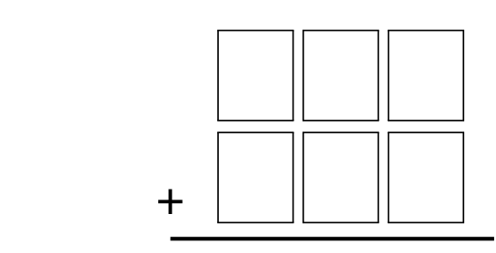
  - the least possible sum
  - the greatest possible difference
  - the least possible difference
- Shuffle the cards and draw 4 cards. Use them to form two different numbers that would give:
  - the greatest possible sum
  - 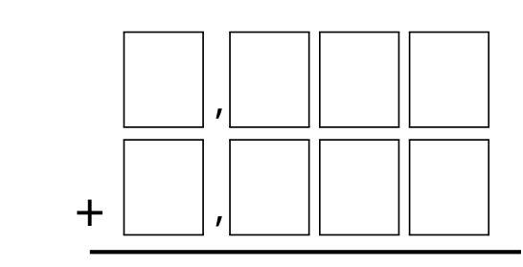
  - the least possible sum
  - the greatest possible difference
  - the least possible difference
© CC BY 2021 Illustrative Mathematics®

