Unit 3 Lesson 18: Using Long Division

1 Using Base-Ten Diagrams to Calculate Quotients (Warm up)

Student Task Statement
Elena used base-ten diagrams to find $372÷3$. She started by representing 372.
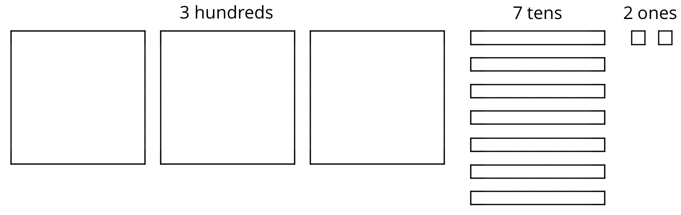
She made 3 groups, each with 1 hundred. Then, she put the tens and ones in each of the 3 groups. Here is her diagram for $372÷3$.
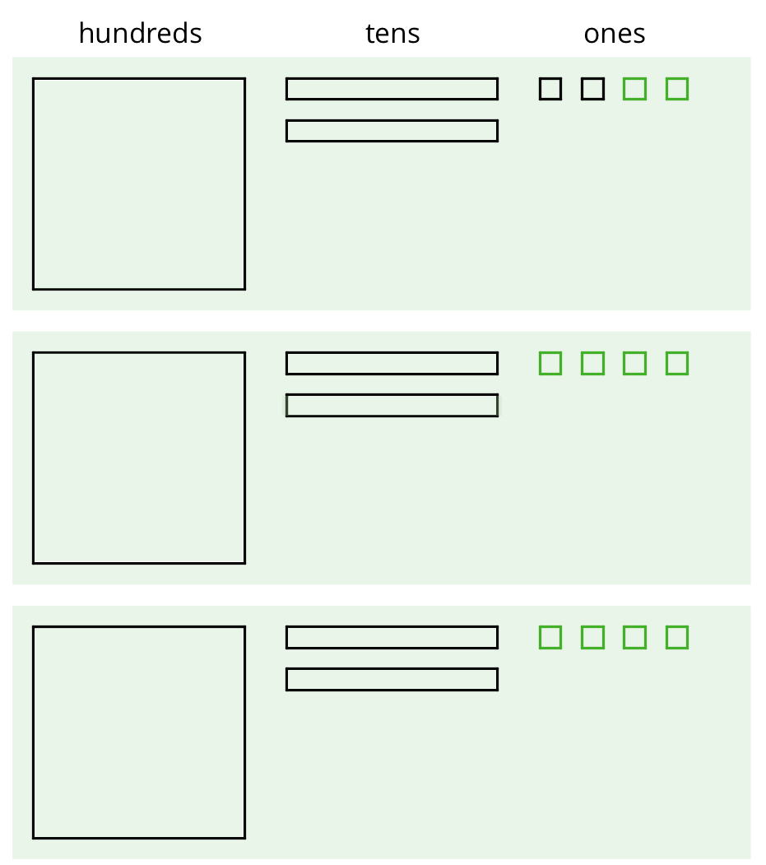
Discuss with a partner:
- Elena’s diagram for 372 has 7 tens. The one for $372÷3$ has only 6 tens. Why?
- Where did the extra ones (small squares) come from?

2 Using the Partial Quotients Method to Calculate Quotients

Images for Launch
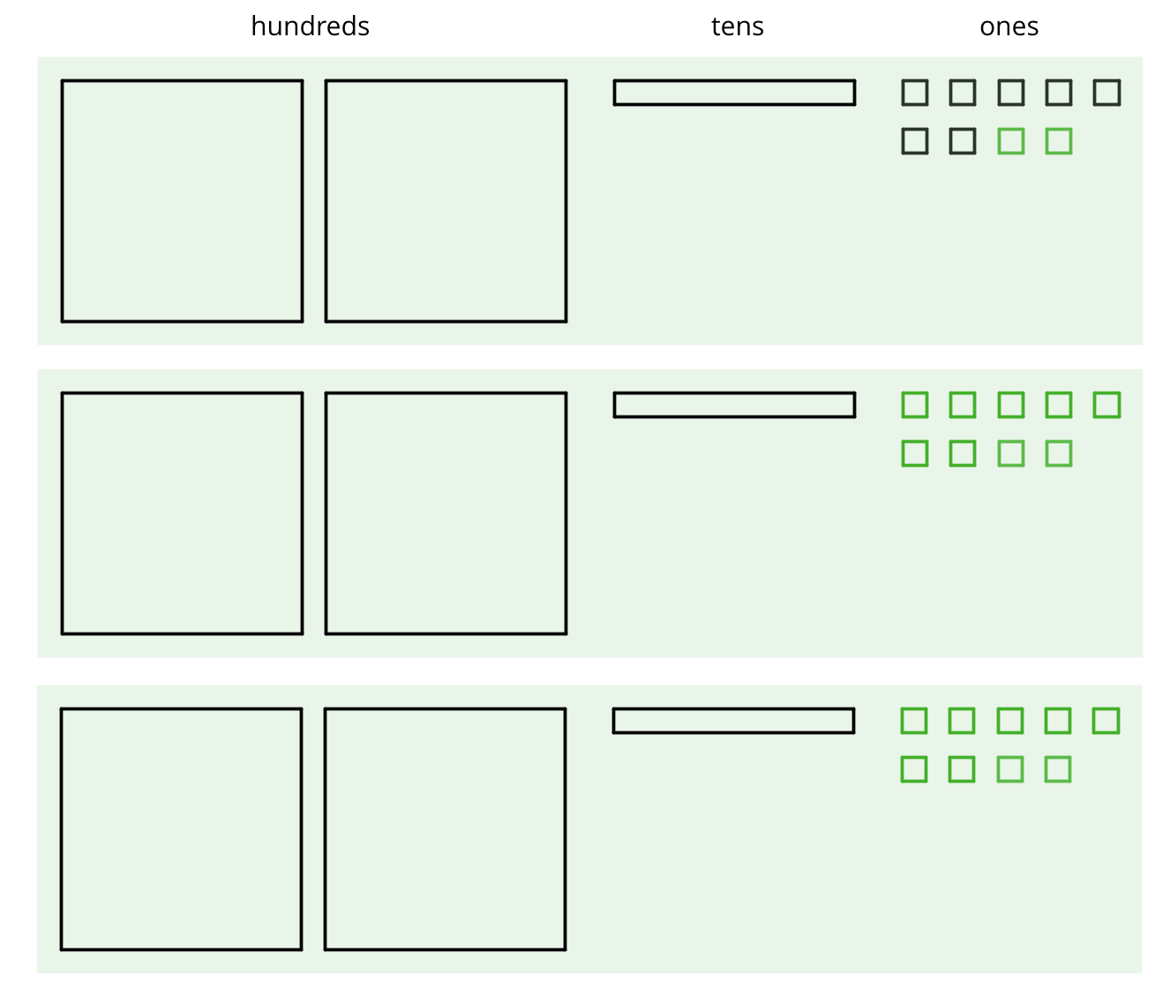

Student Task Statement
- Andre calculated $657÷3$ using a method that was different from Elena’s.
- 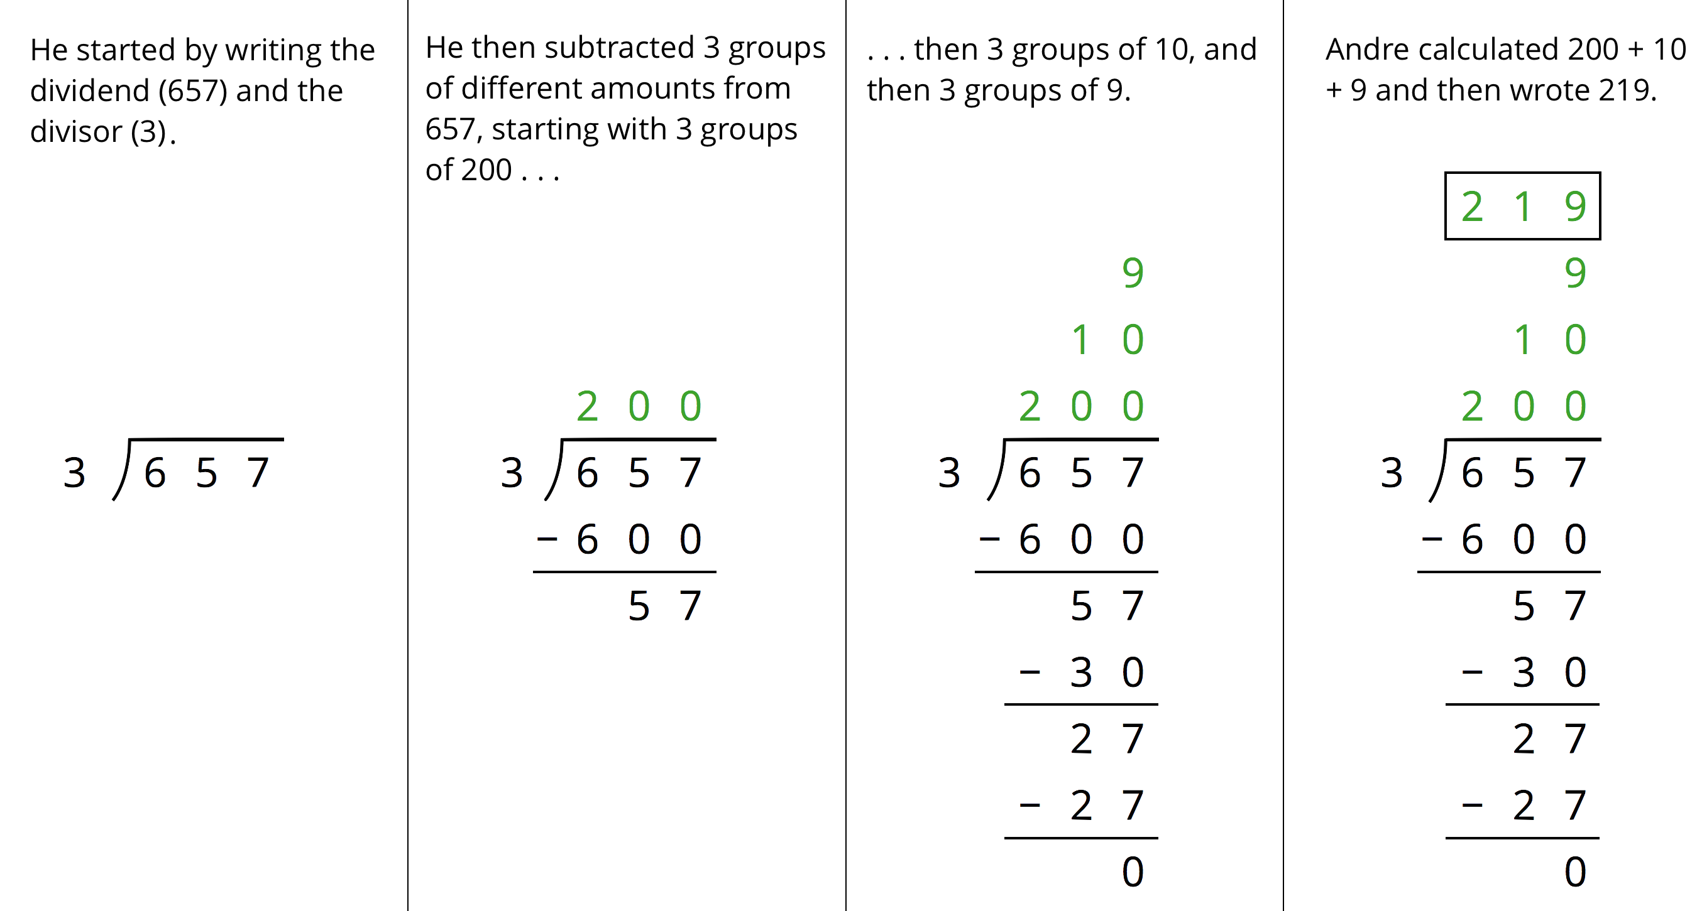
  - Andre subtracted 600 from 657. What does the 600 represent?
  - Andre wrote 10 above the 200, and then subtracted 30 from 57. How is the 30 related to the 10?
  - What do the numbers 200, 10, and 9 represent?
  - What is the meaning of the 0 at the bottom of Andre’s work?
- How might Andre calculate $896÷4$? Explain or show your reasoning.

3 Lin Uses Long Division

Student Task Statement
Lin has a method of calculating quotients that is different from Elena’s method and Andre’s method. Here is how she found the quotient of $657÷3$:
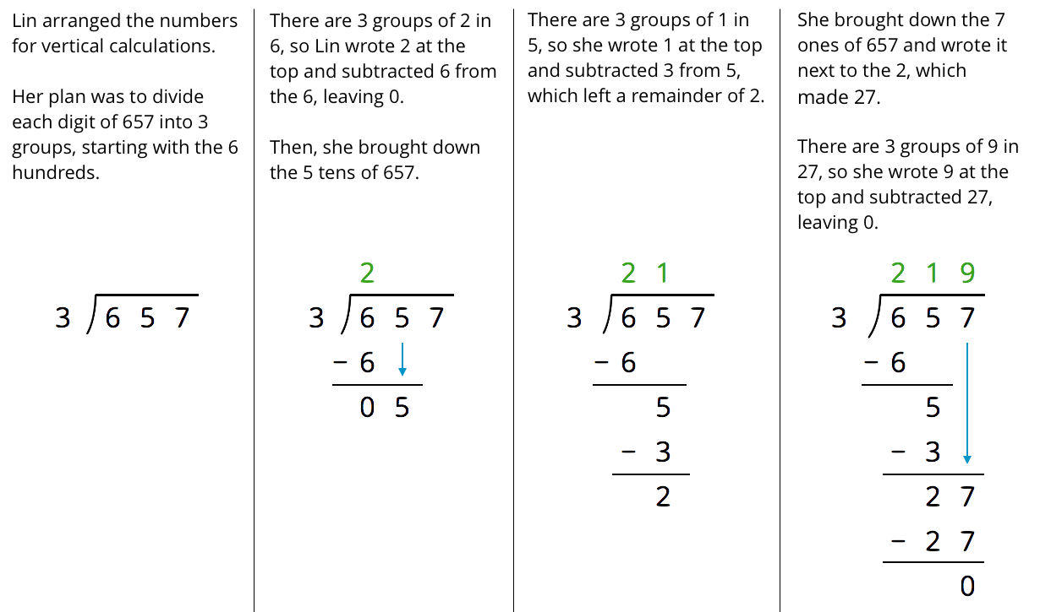
- Discuss with your partner how Lin’s method is similar to and different from drawing base-ten diagrams or using the partial quotients method.
  - Lin subtracted $3⋅2,$ then $3⋅1$, and lastly $3⋅9$. Earlier, Andre subtracted $3⋅200,$ then $3⋅10$, and lastly $3⋅9$. Why did they have the same quotient?
  - In the third step, why do you think Lin wrote the 7 next to the remainder of 2 rather than adding 7 and 2 to get 9?
- Lin’s method is called long division. Use this method to find the following quotients. Check your answer by multiplying it by the divisor.
  - $846÷3$
  - $1,​816÷4$
  - $768÷12$

Activity Synthesis
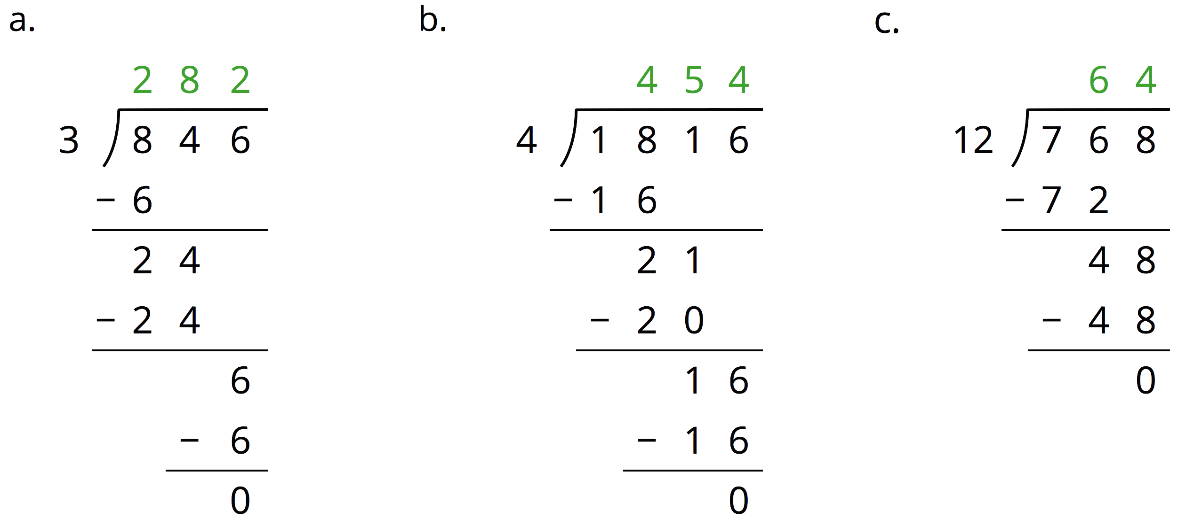

4 Dividing Whole Numbers (Optional)

Student Task Statement
- Find each quotient.
  - $633÷3$
  - $1001÷7$
  - $2996÷14$
- Here is Priya’s calculation of $906÷3$.
- 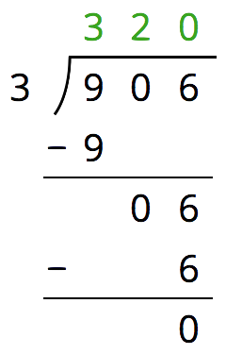
  - Priya wrote 320 for the value of $906÷3$. Check her answer by multiplying it by 3. What product do you get and what does it tell you about Priya’s answer?
  - Describe Priya’s mistake, then show the correct calculation and answer.
© CC BY Open Up Resources. Adaptations CC BY IM.

