Unit 6 Lesson 6: Distinguishing between Two Types of Situations

1 Which One Doesn’t Belong: Seeing Structure (Warm up)

Student Task Statement
Which equation doesn’t belong?
$4\left(x+3\right)=9$
$4⋅x+12=9$
$4+3x=9$
$9=12+4x$

2 Card Sort: Categories of Equations

Student Task Statement
Your teacher will give you a set of cards that show equations. Sort the cards into 2 categories of your choosing. Be prepared to explain the meaning of your categories. Then, sort the cards into 2 categories in a different way. Be prepared to explain the meaning of your new categories.

3 Even More Situations, Diagrams, and Equations

Student Task Statement
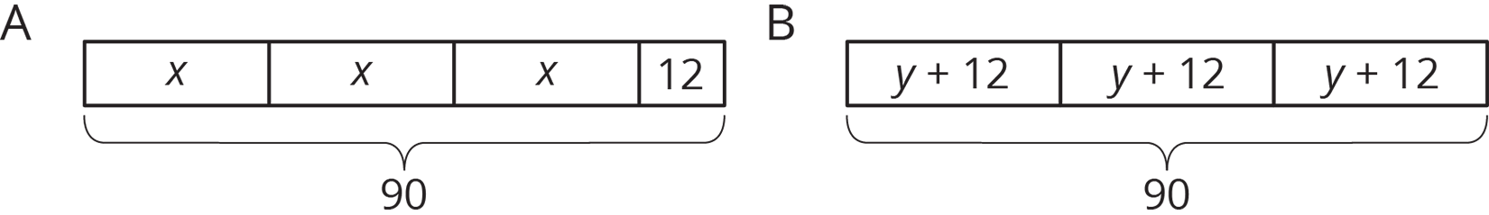
Story 1: Lin had 90 flyers to hang up around the school. She gave 12 flyers to each of three volunteers. Then she took the remaining flyers and divided them up equally between the three volunteers.
Story 2: Lin had 90 flyers to hang up around the school. After giving the same number of flyers to each of three volunteers, she had 12 left to hang up by herself.
- Which diagram goes with which story? Be prepared to explain your reasoning.
- In each diagram, what part of the story does the variable represent?
- Write an equation corresponding to each story. If you get stuck, use the diagram.
- Find the value of the variable in the story.
© CC BY Open Up Resources. Adaptations CC BY IM.

