Lesson 11: Share Story Problems
- Let’s share and solve our story problems.

Warm-up: Number Talk: Add and Subtract 2 and 3
Find the value of each expression.
- $3−2$
- $3+2$
- $4−2$
- $4−3$

Section Summary
Section Summary
In this section, we explored our school community.
We created number books to show important things from our school.
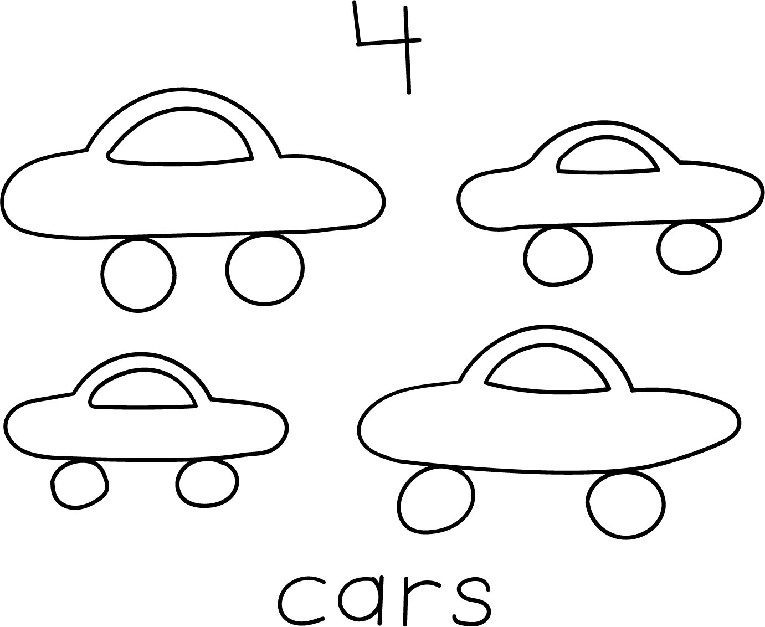
We asked questions about our school and used tools to answer the questions.
We told story problems about our school.
There are 5 pictures on one side of the hallway.
There are 3 pictures on the other side of the hallway.
How many pictures are there in the hallway?
$5+3=8$
There are 8 pictures.
© CC BY 2021 Illustrative Mathematics®

