Unit 6 Lesson 4: Evaluating Quadratic and Exponential Functions

1 Math Talk: Exponents (Warm up)

Student Task Statement
Evaluate mentally.
$4^{2}$
$2^{4}$
$2^{6}$
$4^{3}$

2 Evaluating and Describing Functions

Student Task Statement
- Different students are evaluating two expressions, $3⋅6^{x}$ and $5^{x}$. Analyze their work, describe any errors made, and then evaluate each expression correctly.
 | - Noah’s work | - Mai’s work | - corrected work
- Evaluate $5^{x}$ when $x$ is 6. | - $5^{x}$  - $5^{6}$  - 30 | - $5^{x}$  - $5^{6}$  - $6⋅6⋅6⋅6⋅6$  - 7,776
- Evaluate $3⋅6^{x}$ when $x$ is 2. | - $3⋅6^{x}$  - $3⋅6^{2}$  - $3⋅12$  - 36 | - $3⋅6^{x}$  - $3⋅6^{2}$  - ${18}^{2}$  - 324
- Here are three functions. For each function:
  - Complete the table of values.
  - Sketch a graph.
  - Decide whether each function is linear, quadratic, or exponential, and be prepared to explain how you know.
- $f\left(x\right)=3⋅2^{x}$
- $x$ | - -1 | - 0 | - 1 | - 2 | - 3 | - 5
- $f\left(x\right)$

- 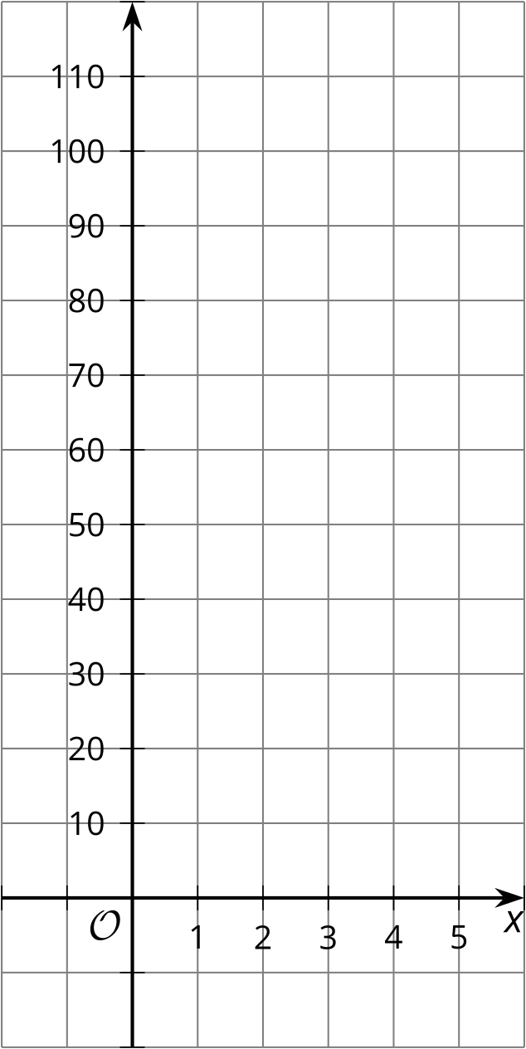
- $g\left(x\right)=3⋅x^{2}$
- $x$ | - -1 | - 0 | - 1 | - 2 | - 3 | - 5
- $g\left(x\right)$

- $h\left(x\right)=3⋅2x$
- $x$ | - -1 | - 0 | - 1 | - 2 | - 3 | - 5
- $h\left(x\right)$

3 Evaluating Exponential and Quadratic Expressions

Student Task Statement
For each row, you and your partner will each evaluate an expression. You should each get the same answer in each row. If you disagree, work to reach agreement.
row | Partner A | PartnerB
1 | $4⋅2^{x}$ when $x$ is 3 | $2⋅2^{x}$ when $x$ is 4
2 | $19+x^{2}$ when $x$ is 9 | $4⋅x^{2}$ when $x$ is 5
3 | $16⋅2^{x}$ when $x$ is 0 | $2⋅2^{x}$ when $x$ is 3
4 | $\frac{1}{2}⋅2^{x}$ when $x$ is 4 | $x^{2}−1$ when $x$ is 3
5 | $x^{2}+1$ when $x$ is 7 | $18+2^{x}$ when $x$ is 5
6 | $4+2^{x}$ when $x$ is 4 | $\frac{1}{5}x^{2}$ when $x$ is 10
7 | $0.1x^{2}$ when $x$ is 6 | $0.4x^{2}$ when $x$ is 3
8 | $45⋅x^{2}$ when $x$ is $\frac{1}{3}$ | $10⋅2^{x}$ when $x$ is -1
9 | $x^{2}$ when $x$ is -4 | $64x^{2}$ when $x$ is $\frac{1}{2}$
10 | $\text{-}2x^{2}$ when $x$ is 3 | $\text{-}2x^{2}$ when $x$ is -3

© CC BY 2019 by Illustrative Mathematics®

