Lesson 8: Different Representations of Tens and Ones
- Let’s think about how two-digit numbers can be shown.

Warm-up: Estimation Exploration: How Many?
- How many do you see?
- 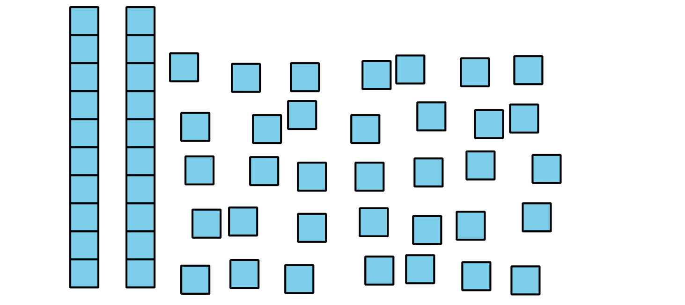
- Record an estimate that is:
- too low | - about right | - too high
- How many do you see?
- 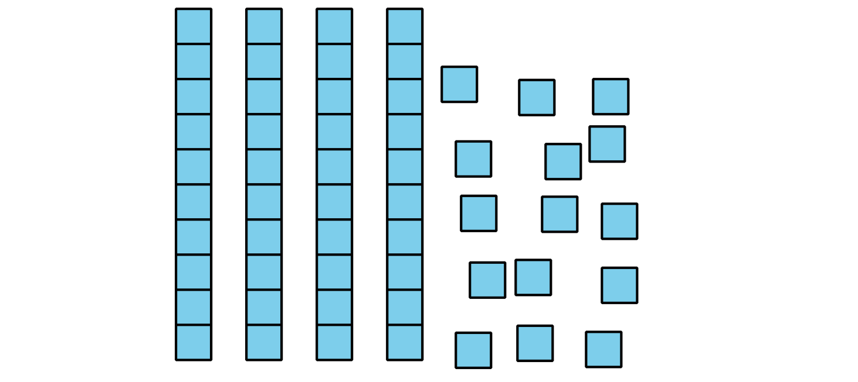
- Record an estimate that is:
- too low | - about right | - too high

8.1: Compare Representations of a Collection
Each student counted and showed a collection.
- Clare drew
- 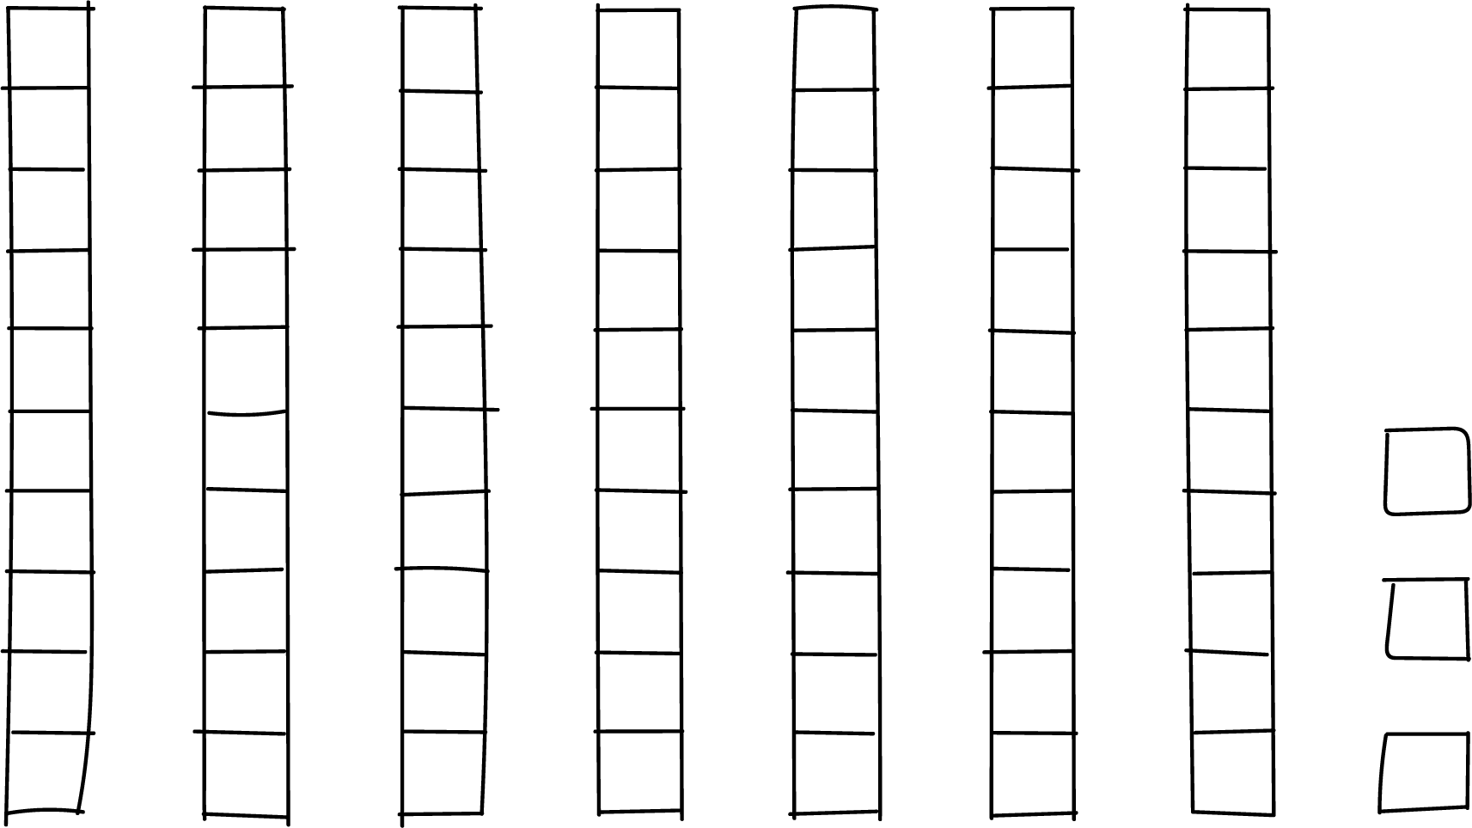
- Han drew
- 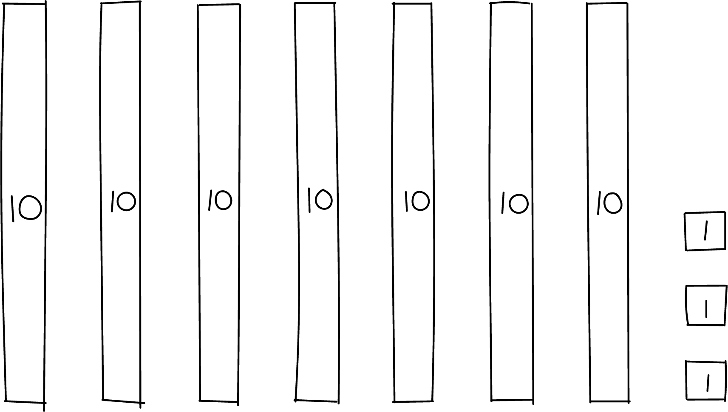
- Kiran wrote 3 ones and 7 tens.
- Priya wrote $70+3$.
Did the students count the same number of objects?
How do you know?
Show your thinking using drawings, numbers, or words.

8.2: Card Sort: Base-ten Representations
Your teacher will give you a set of cards that show different representations of a two-digit number. Find the cards that match. Be ready to explain your reasoning.
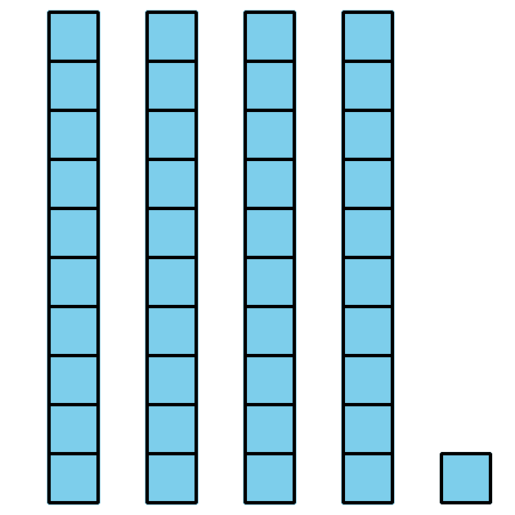
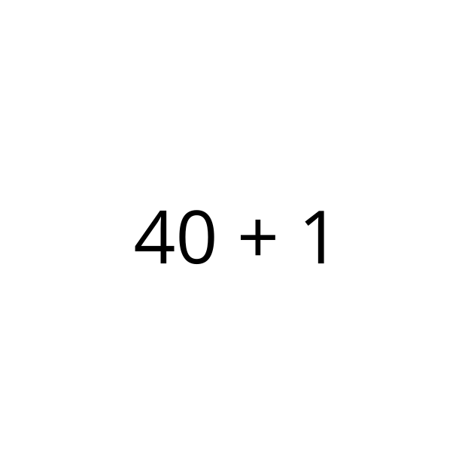
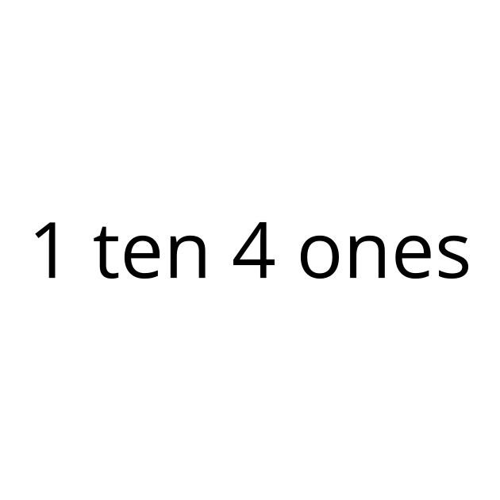
© CC BY 2021 Illustrative Mathematics®

