Unit 1 Lesson 16: Arrange Objects Into Arrays

WU Notice and Wonder: Eggs (Warm up)

Student Task Statement
What do you notice? What do you wonder?
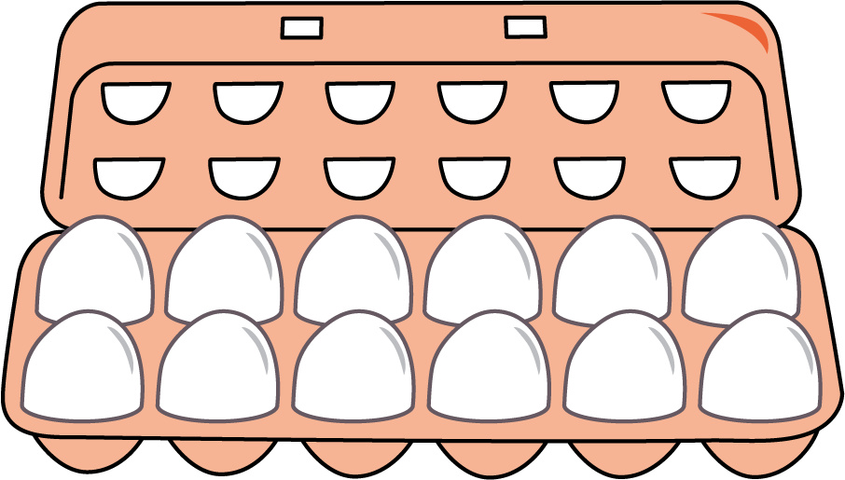

1 Compare Equal Groups and Arrays

Student Task Statement
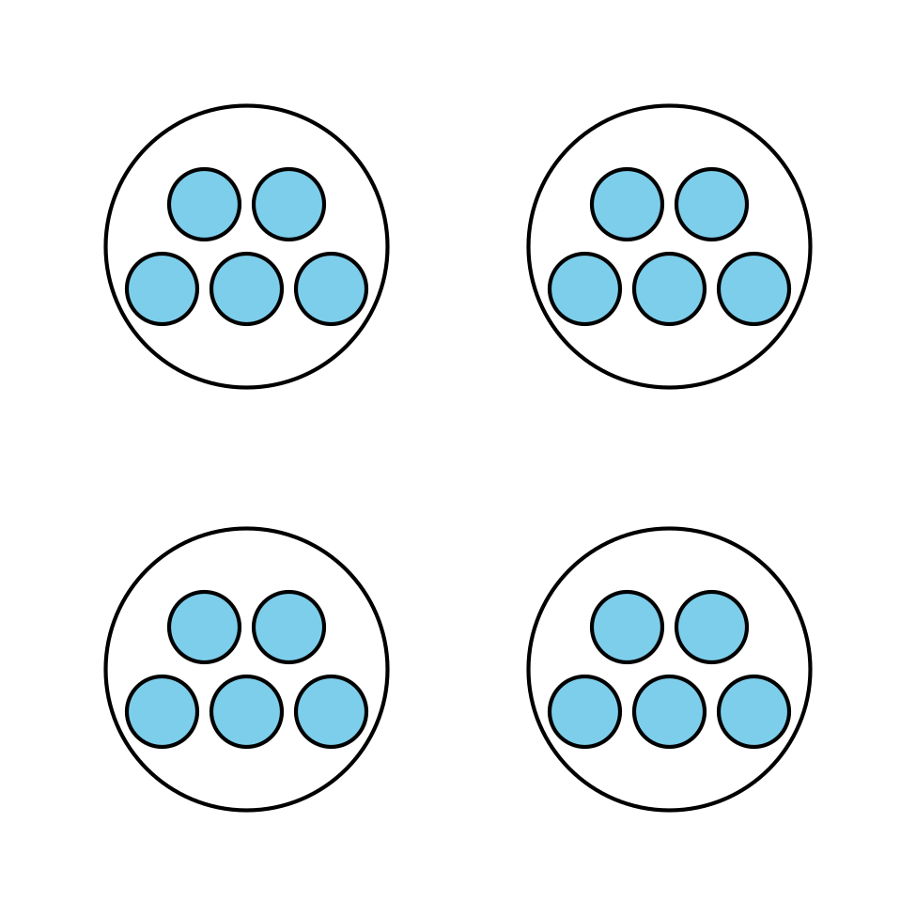
- How does arranging the dots into an array affect how you see the number?
- Noah says he sees equal groups in the drawing with 4 circles and 5 dots in each circle, but says there are no equal groups in the array. Do you agree with Noah? Explain your reasoning.

2 Arrange Into Arrays

Student Task Statement
- Use cubes to make 6 groups of 5.
  - Arrange them into an array.
  - Explain or show how the array is related to equal groups.
- Count out 20 cubes.
  - Arrange them into as many arrays as you can.
  - Explain or show how each array is related to equal groups.
- Count out 24 cubes.
  - Arrange them into as many arrays as you can.
  - Explain or show how each array is related to equal groups.
© CC BY 2021 Illustrative Mathematics®

