Unit 4 Lesson 1 Cumulative Practice Problems
- A rectangle has a height to width ratio of $3:4.5$. Give two examples of dimensions for rectangles that could be scaled versions of this rectangle.
- One rectangle measures 2 units by 7 units. A second rectangle measures 11 units by 37 units. Are these two figures scaled versions of each other? If so, find the scale factor. If not, briefly explain why.
- Ants have 6 legs. Elena and Andre write equations showing the proportional relationship between the number of ants, $a$, to the number of ant legs $l$. Elena writes $a=6⋅l$ and Andre writes $l=\frac{1}{6}⋅a$. Do you agree with either of the equations? Explain your reasoning.
- (From Unit 2, Lesson 5.)
- On the grid, draw a scaled copy of quadrilateral ABCD with a scale factor $\frac{2}{3}$.
- 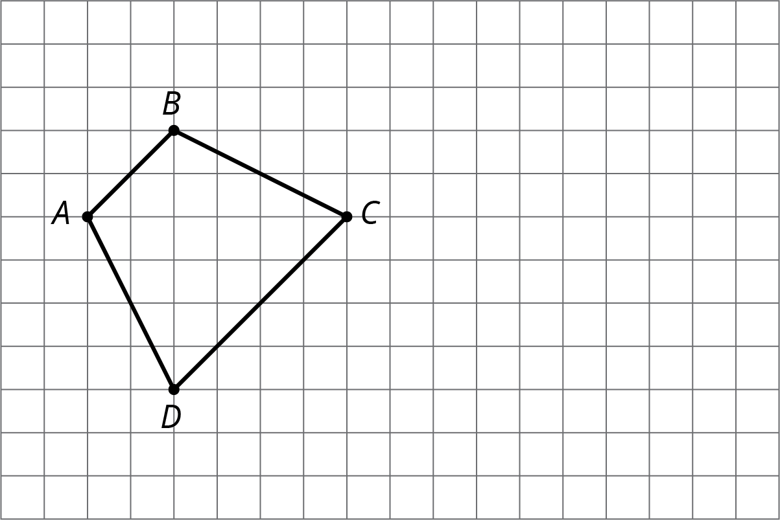
- (From Unit 1, Lesson 4.)
- Solve each equation mentally.
  - $\frac{5}{2}⋅x=1$
  - $x⋅\frac{7}{3}=1$
  - $1÷\frac{11}{2}=x$
- (From Unit 1, Lesson 5.)
- Lin has a scale model of a modern train. The model is created at a scale of 1 to 48.
  - The height of the model train is 102 millimeters. What is the actual height of the train in meters? Explain your reasoning.
  - On the scale model, the distance between the wheels on the left and the wheels on the right is $1\frac{1}{4}$ inches. The state of Wyoming has old railroad tracks that are 4.5 feet apart. Can the modern train travel on those tracks? Explain your reasoning.
- (From Unit 1, Lesson 11.)
© CC BY Open Up Resources. Adaptations CC BY IM.

