Unit 4 Lesson 10: Explore Multiplication Strategies with Rectangles

How Many Do You See: Squares (Warm up)

Student Task Statement
How many do you see? How do you see them?
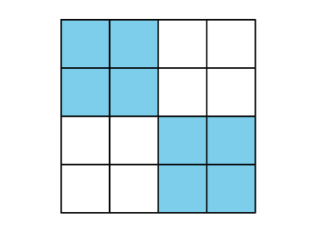
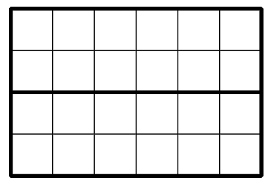
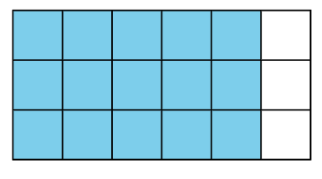

1 From Diagrams to Expressions

Student Task Statement
Andre and Elena are finding the area of this rectangle.
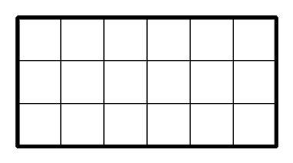
Andre writes $6×3$.
He marks the rectangle like this:
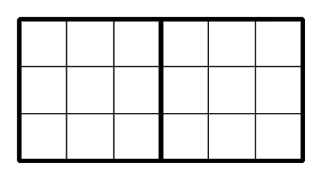
He then writes:
$2×(3×3)$
$2×9=18$
Elena writes $3×6$.
She marks the rectangle like this:
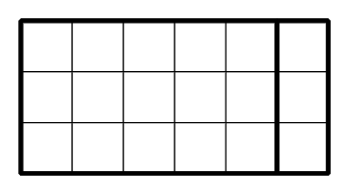
She then writes:
$3×(5+1)$
$(3×5)+(3×1)$
$15+3$
18
- Discuss with a partner:
  - How are Andre and Elena’s strategies alike? How are they different?
  - How are the numbers in Andre’s expressions related to his diagram?
  - How are the numbers in Elena’s expressions related to her diagram?
- Here is another rectangle.
- Its area can be found by finding $4×9$.
- 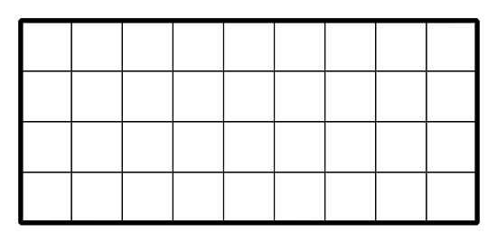
  - Mark or shade the rectangle in a way that would help you find its area.
  - Write one or more expressions that can represent your work on the diagram and show how you find the area.

2 From Expressions to Diagrams

Student Task Statement
Here are some rectangles and expressions that show how three students saw the area of the rectangles.
Noah
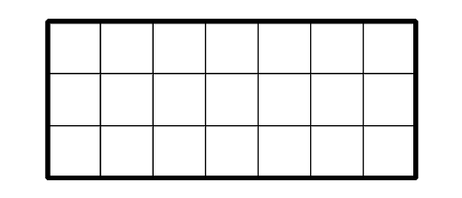
$(5×3)+(2×3)$
Priya
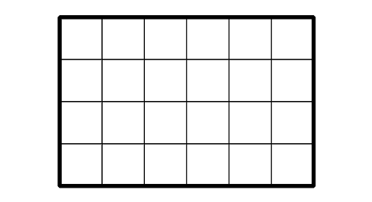
$2×(2×6)$
Tyler
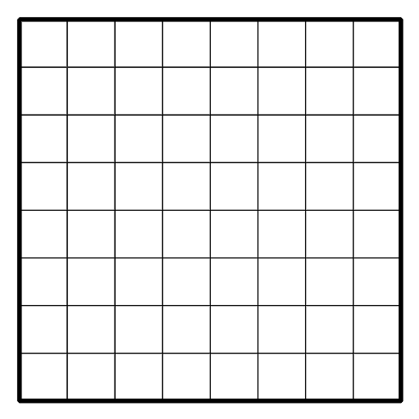
$(5×8)+(3×8)$
For each rectangle:
- Name the two factors that can be multiplied to find its area.
- Mark or shade each rectangle to show how each student saw the area. Be prepared to explain your reasoning.
© CC BY 2021 Illustrative Mathematics®

