Unit 4 Lesson 11: Multiplication Strategies on Ungridded Rectangles

Which One Doesn’t Belong: Multiplication in Many Forms (Warm up)

Student Task Statement
Which one doesn’t belong?
A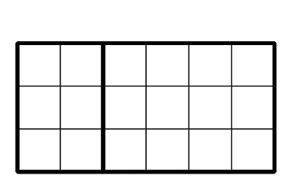
B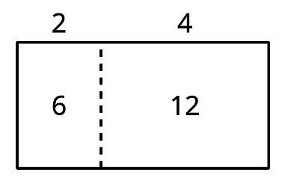
C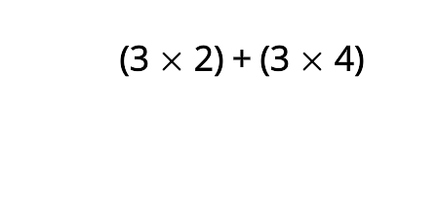
D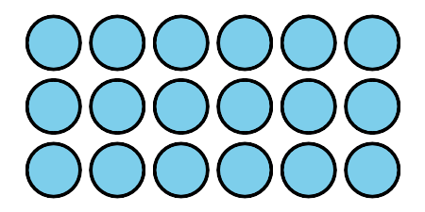

1 Mark, then Express

Student Task Statement
For each rectangle:
- Mark or shade each rectangle to show a strategy for finding its area.
- Write one or more expressions that can represent how you find the area.
A
B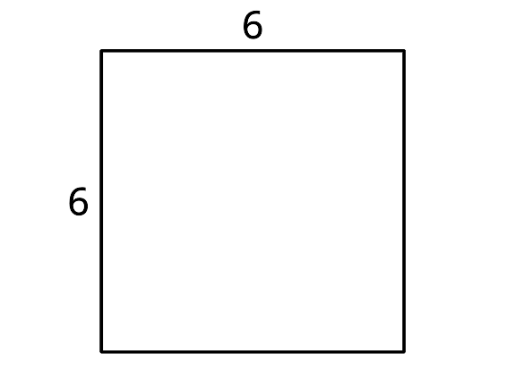
C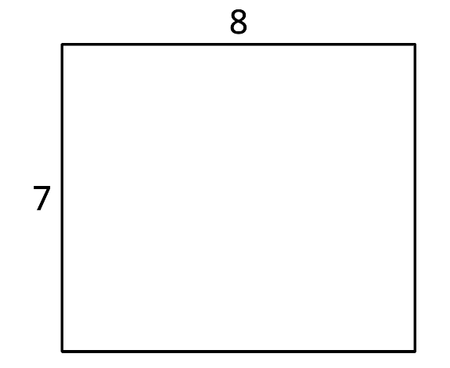

2 Card Sort: Different Expressions, Same Rectangle

Student Task Statement
Your teacher will give you a set of cards with expressions that represent areas of rectangles.
Sort the expressions into groups so that the expressions in each group can represent the area of the same rectangle. Be prepared to explain your reasoning.
You can draw rectangles if you find them helpful.
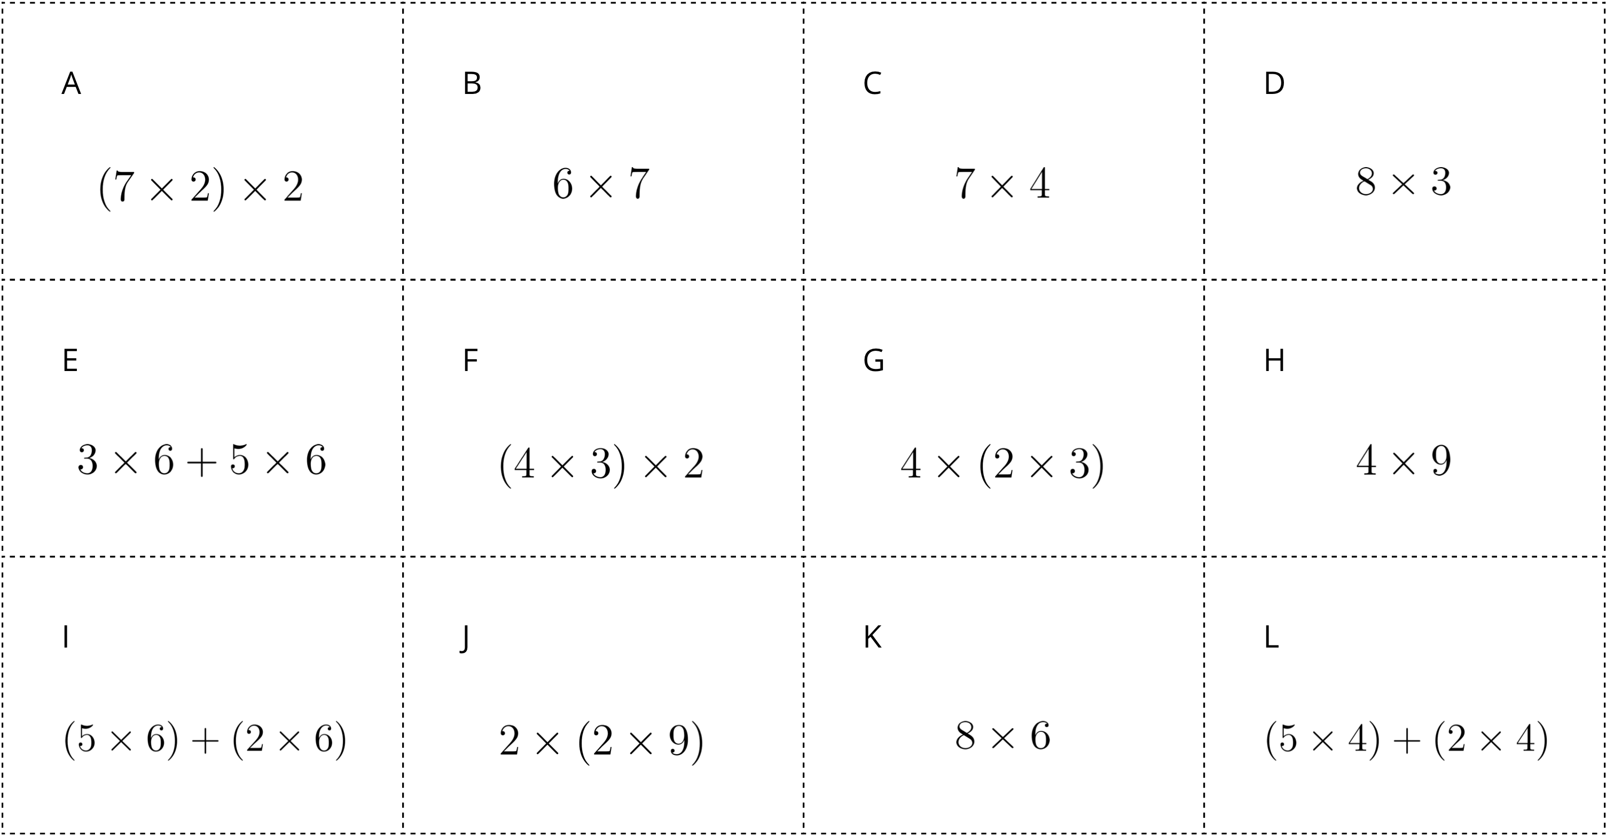

Activity Synthesis
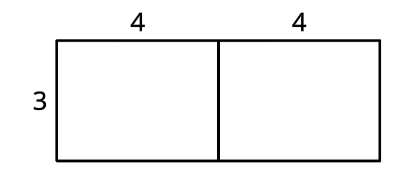
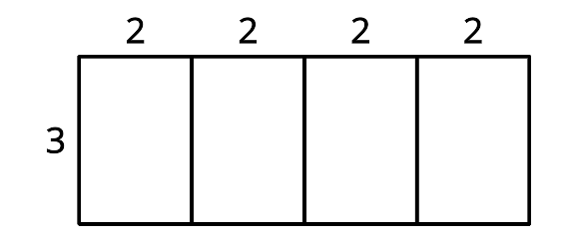
© CC BY 2021 Illustrative Mathematics®

