Lesson 1 Practice Problems
- Reflect triangle $ABC$ over the line $x=\text{-}3$.
- Translate the image by the directed line segment from $\left(0,0\right)$ to $\left(4,1\right)$.
- What are the coordinates of the vertices in the final image?
- 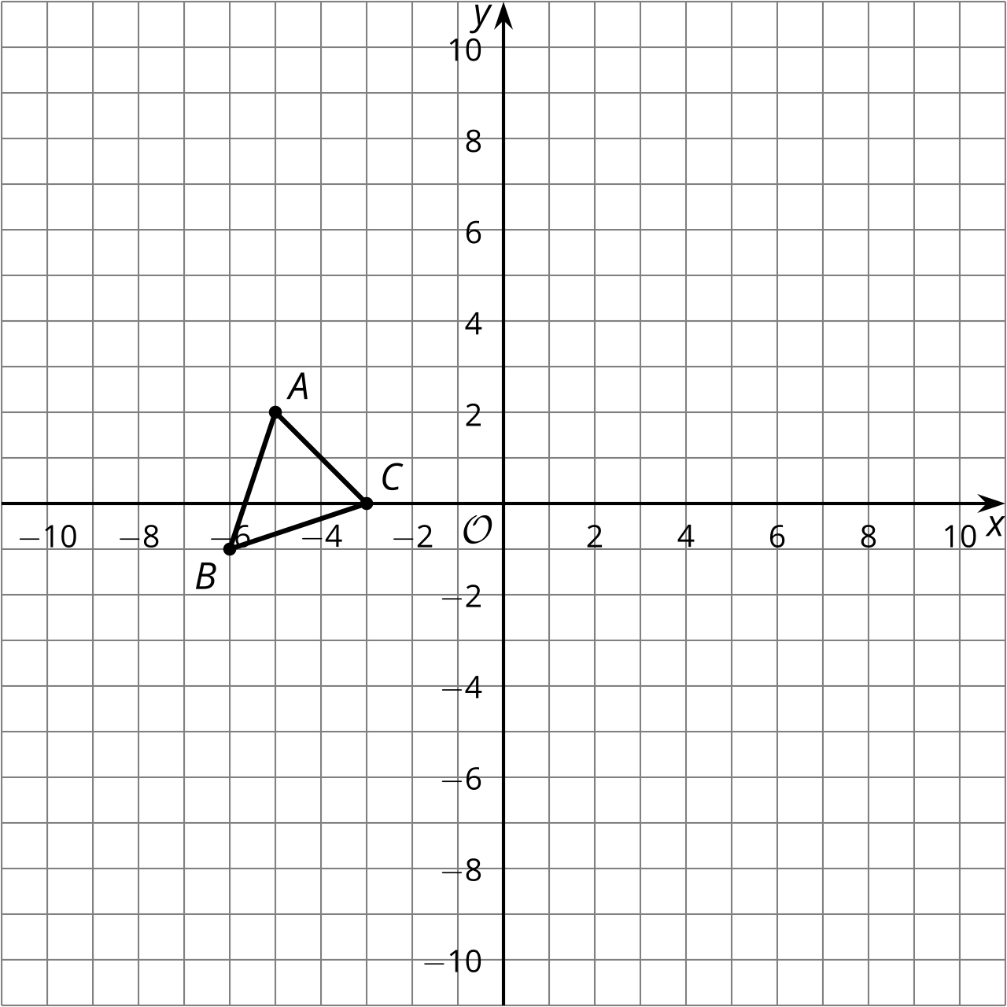
- Three line segments form the letter N. Rotate the letter N counterclockwise around the midpoint of segment $BC$ by 180 degrees. Describe the result.
- 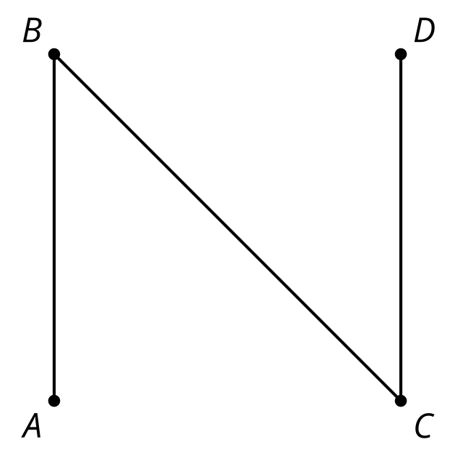
- (From Unit 1, Lesson 14.)
- Triangle $ABC$ has coordinates $A=\left(1,3\right),B=\left(2,0\right),$ and $C=\left(4,1\right).$ The image of this triangle after a sequence of transformations is triangle $A^{′}B^{′}C^{′}$ where $A^{′}=\left(\text{-}5,\text{-}3\right),B^{′}=\left(\text{-}4,0\right),$ and $C^{′}=\left(\text{-}2,\text{-}1\right).$
- Write a sequence of transformations that takes triangle $ABC$ to triangle $A^{′}B^{′}C^{′}$.
- 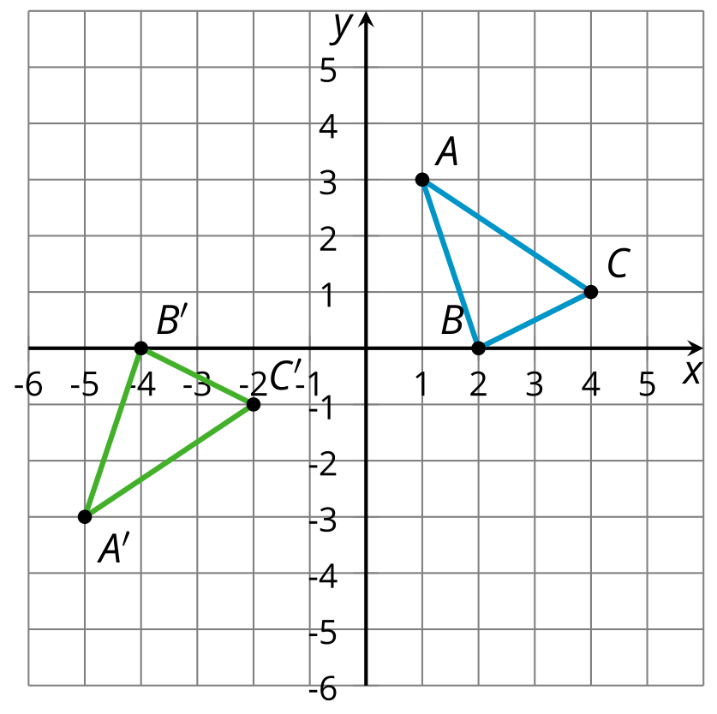
- Prove triangle $ABC$ is congruent to triangle $DEF$.
- 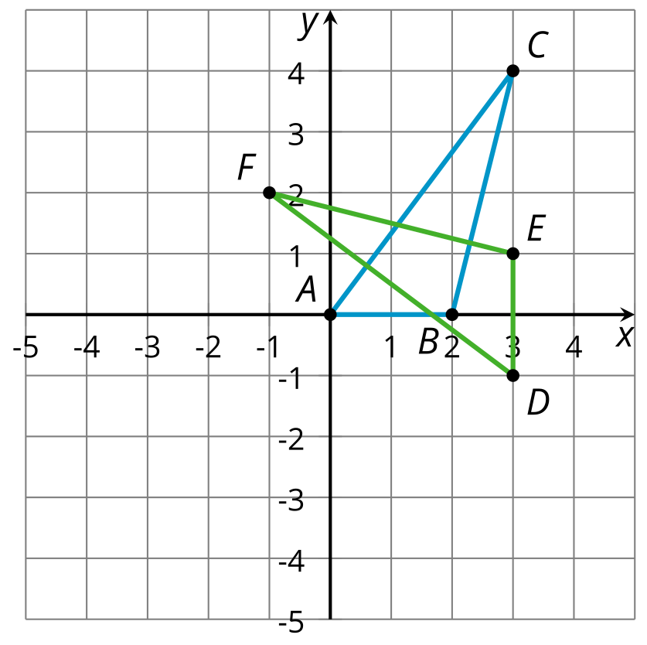

- The density of water is 1 gram per cm³. An object floats in water if its density is less than water’s density, and it sinks if its density is greater than water’s. Will a 1.17 gram diamond in the shape of a pyramid whose base has area 2 cm² and whose height is 0.5 centimeters sink or float? Explain your reasoning.
- (From Unit 5, Lesson 17.)
- Technology required. An oblique cylinder with a base of radius 2 units is shown. The top of the cylinder can be obtained by translating the base by the directed line segment $AB$ which has length 16 units. The segment $AB$ forms a ${30}^{∘}$ angle with the plane of the base. What is the volume of the cylinder?
- 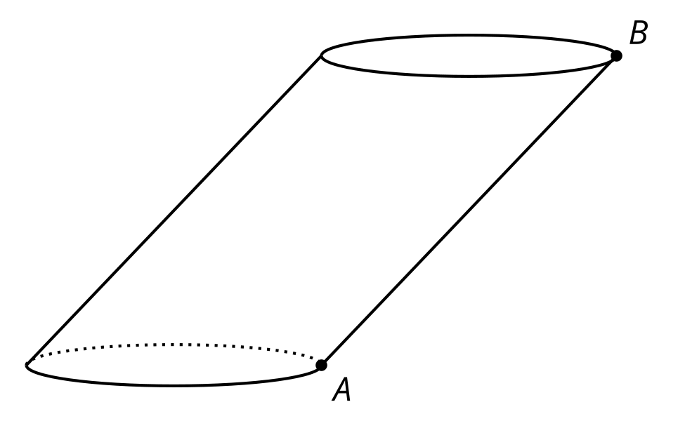
- (From Unit 5, Lesson 11.)
- This design began from the construction of an equilateral triangle. Record at least 3 rigid transformations (rotation, reflection, translation) you see in the design.
- 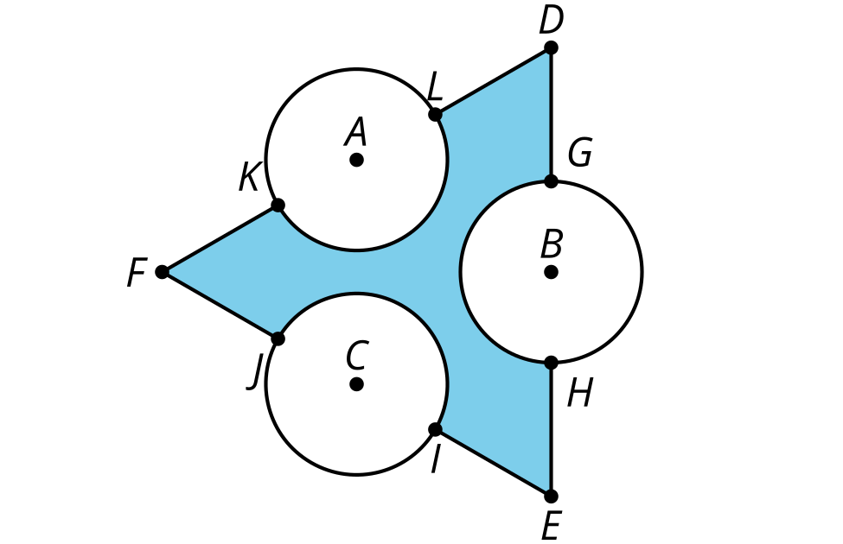
- (From Unit 1, Lesson 22.)
© CC BY 2019 by Illustrative Mathematics®

