Lesson 10: Write Two-digit Numbers
- Let’s write two-digit numbers.

Warm-up: Notice and Wonder: Same Digit, Different Place
What do you notice?
What do you wonder?
A
7
B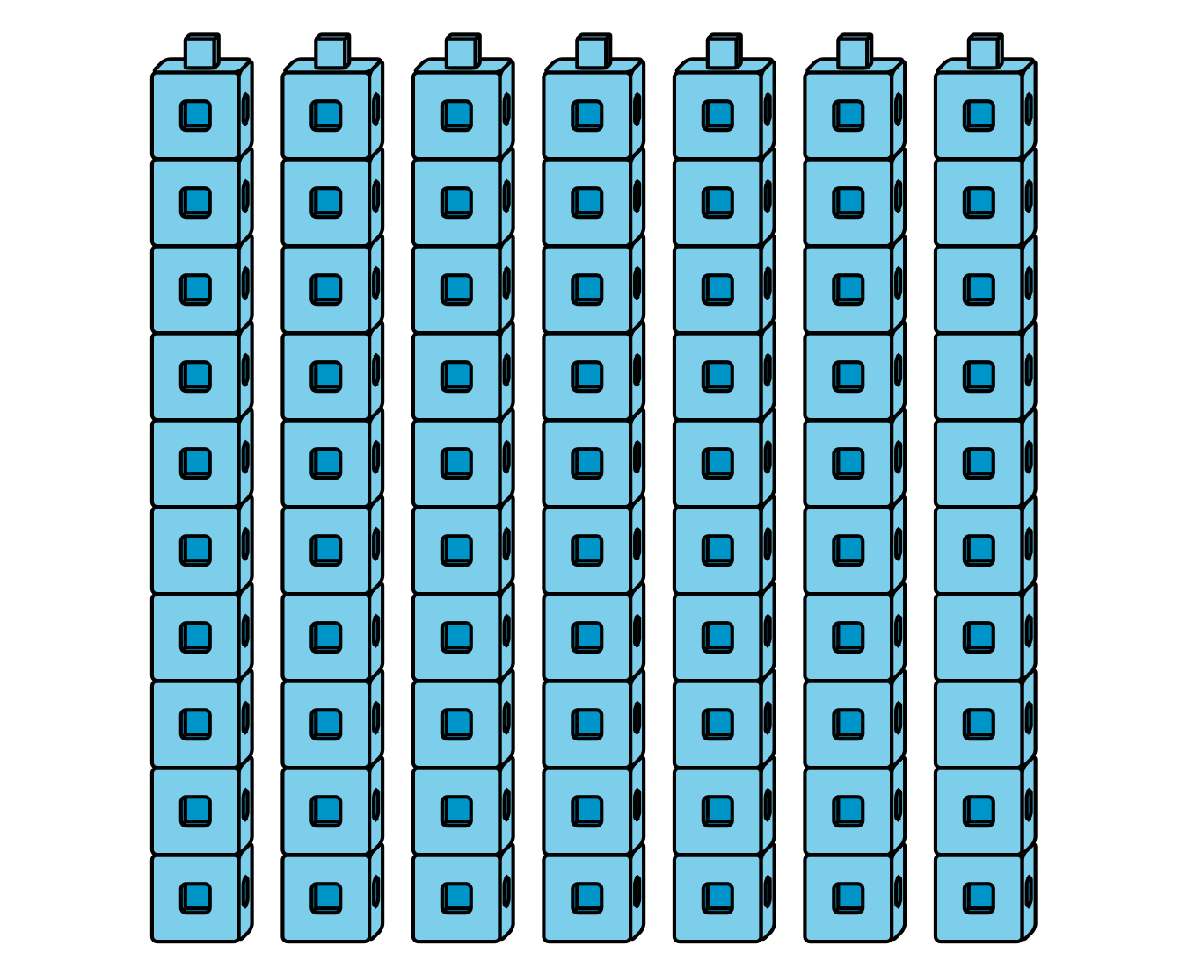
70
C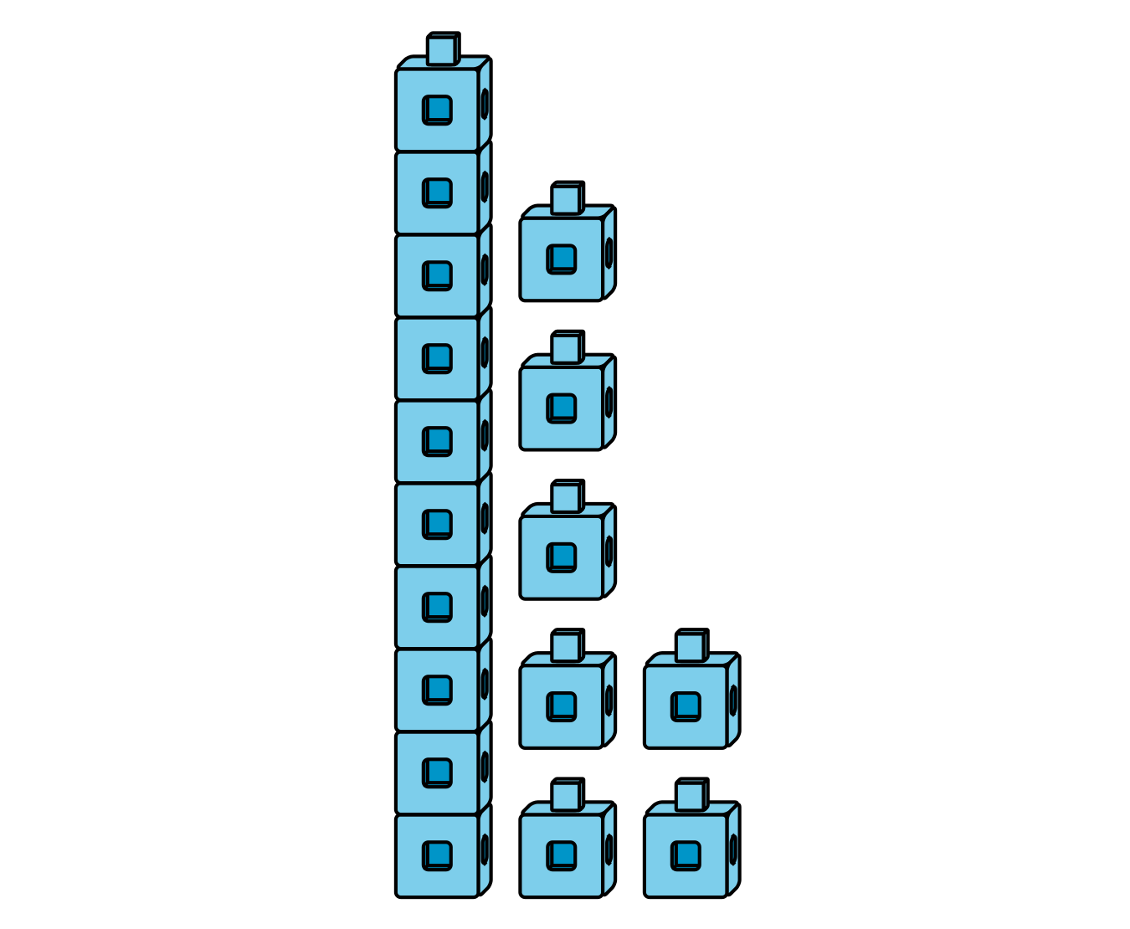
17
D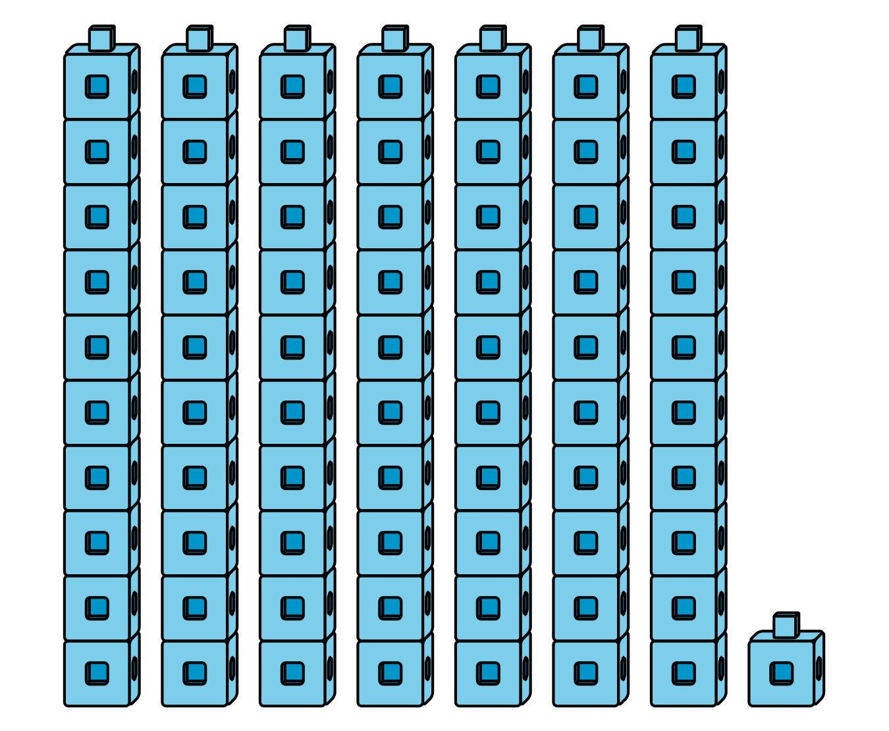
71

10.1: Write Numbers to Match Base-Ten Representations
Write the number that matches each representation.
- 1 ten 4 ones
- Number: ____________

- 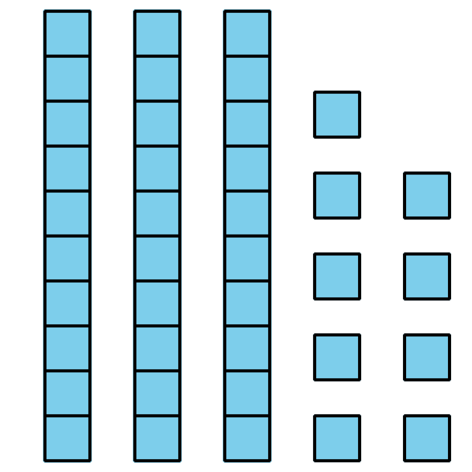
- Number: ____________
- 9 tens
- Number: ____________
- $20+5$
- Number: ____________

- 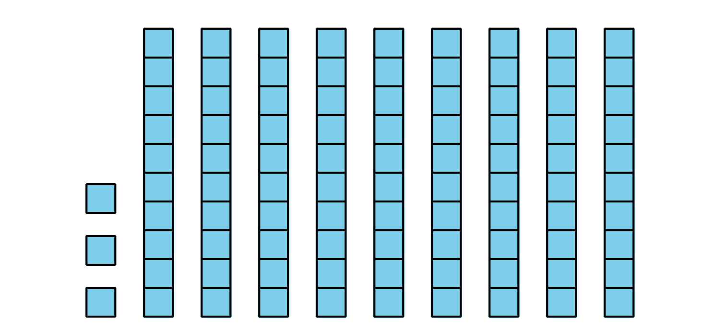
- Number: ____________
- $7+40$
- Number: ____________
- 2 ones 8 tens
- Number: ____________

- 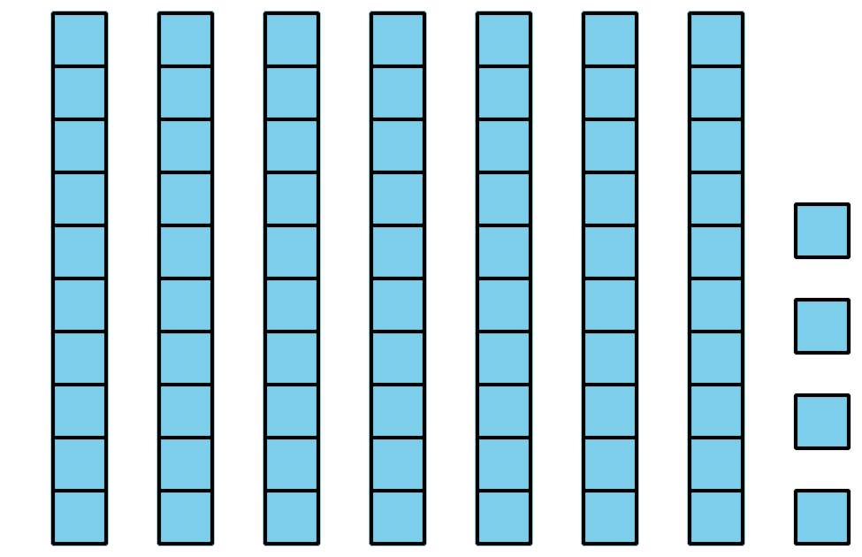
- Number: ____________
- $1+40$
- Number: ____________

- Number: ____________
© CC BY 2021 Illustrative Mathematics®

