Unit 1 Lesson 18: Represent Arrays with Expressions

WU How Many Do You See: An Array of Shapes (Warm up)

Student Task Statement
How many do you see? How do you see them?
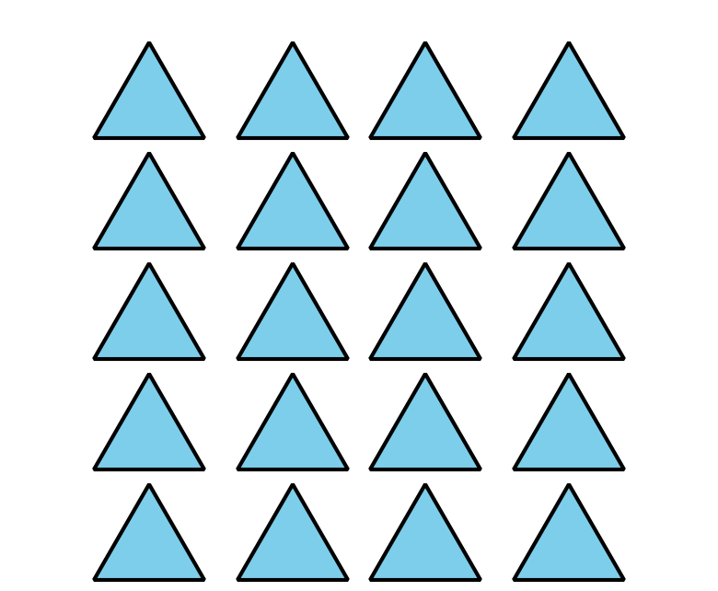

1 Represent Array Situations

Student Task Statement
Use objects or drawings to represent each situation with an array.
- There are 3 rows of chairs. Each row has 5 chairs.
- There are 4 rows of cars. Each row has 5 cars in it.
- There are 2 rows of eggs. Each row has 6 eggs.
- There are 2 teams of students lined up. Each team has 10 students.
Write a multiplication expression to represent each situation.

2 Connect Arrays to Expressions

Student Task Statement
Draw an array for each multiplication expression. Be prepared to share your reasoning.
- $2×3$
- $5×2$
- $4×4$
© CC BY 2021 Illustrative Mathematics®

