Lesson 11: Patrones y pares ordenados

Standards Alignments
Addressing | 5.OA.B.3
Building Towards | 5.G.A.1

Teacher-facing Learning Goals
- Form ordered pairs consisting of corresponding terms from two patterns and graph the ordered pairs on a coordinate grid.

Student-facing Learning Goals
- Grafiquemos patrones en la cuadrícula de coordenadas.

Lesson Purpose
The purpose of this lesson is for students to represent corresponding terms in two patterns on the coordinate grid.
The purpose of this lesson is to continue to analyze the relationship between two patterns by plotting corresponding numbers on the coordinate grid. After generating patterns in previous lessons, students now make ordered pairs from those numbers and plot them on the coordinate grid. They observe patterns and interpret the meaning of points on the coordinate grid in terms of generating rules.

Access for:

Students with Disabilities
- Action and Expression (Activity 1)

English Learners
- MLR8 (Activity 1)

Instructional Routines
Notice and Wonder (Warm-up)

Lesson Timeline
Warm-up | 10 min
Activity 1 | 20 min
Activity 2 | 15 min
Lesson Synthesis | 10 min
Cool-down | 5 min

Teacher Reflection Question
What strategy did most students use in their work today?

Cool-down
(to be completed at the end of the lesson) 5min
2 reglas

Standards Alignments
Addressing | 5.OA.B.3

Student-facing Task Statement
- Completa los patrones de las reglas.
 | - A | - B | - C | - D
- Regla 1: empezar en 0 y siempre sumar 3.
- Regla 2: empezar en 0 y siempre sumar 6.
- ¿Qué relaciones observas entre los términos correspondientes en los dos patrones?
- Ubica y marca los puntos en la cuadrícula de coordenadas.
- 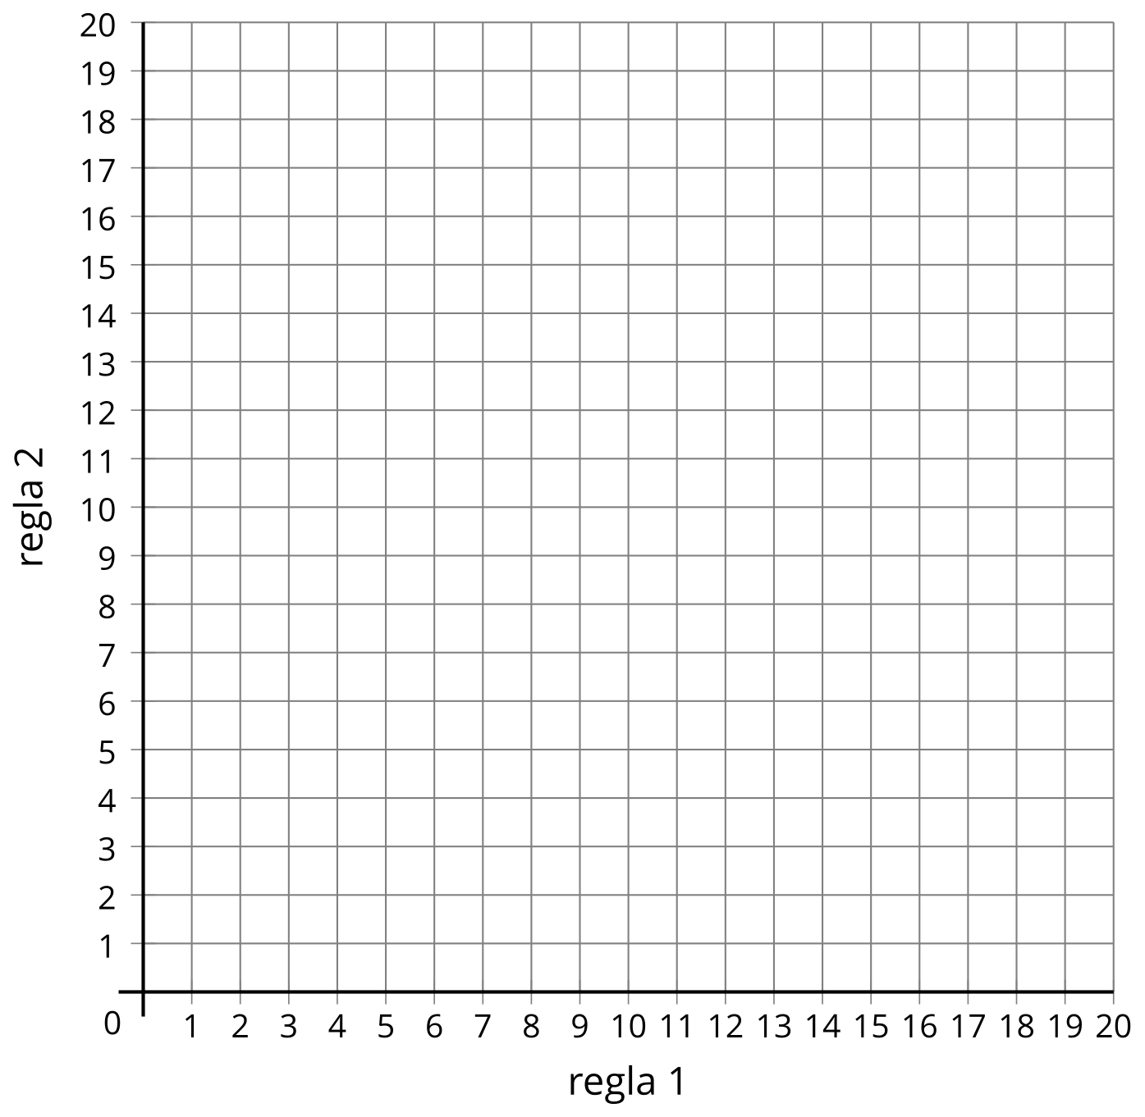

Student Responses
 | - A | - B | - C | - D
- Rule 1: Start at 0. Add 3. | - 0 | - 3 | - 6 | - 9
- Rule 2: Start at 0. Add 6. | - 0 | - 6 | - 12 | - 18
- The numbers with rule 2 are twice as large as the corresponding numbers with rule 1. The numbers with rule 1 are $\frac{1}{2}$ the corresponding numbers with rule 2.

- 