Lesson 14: Sort and Color Expressions and Images within 5
- Let’s practice adding and subtracting.

14.1: Owl Color
Color each section.
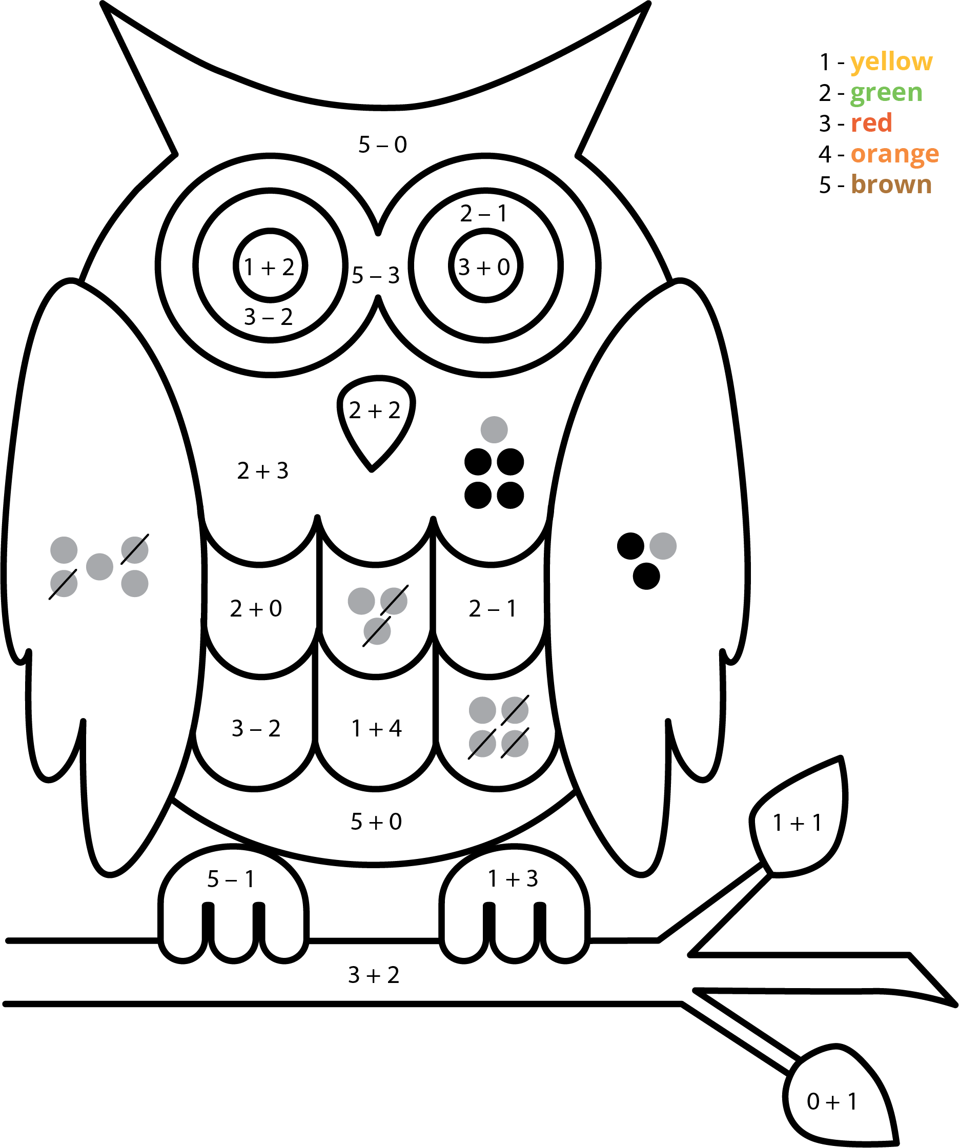

14.3: Centers: Choice Time
Choose a center.
5-frames
Roll and Add
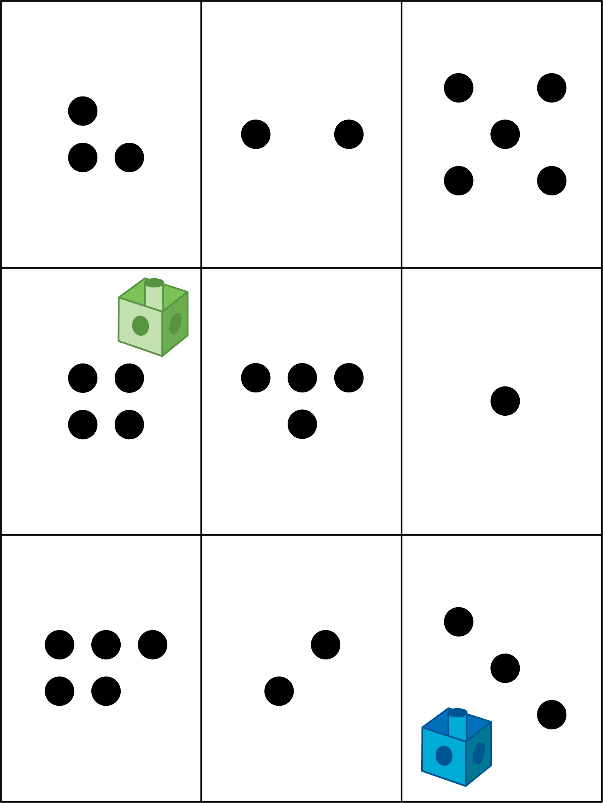
Bingo
Geoblocks
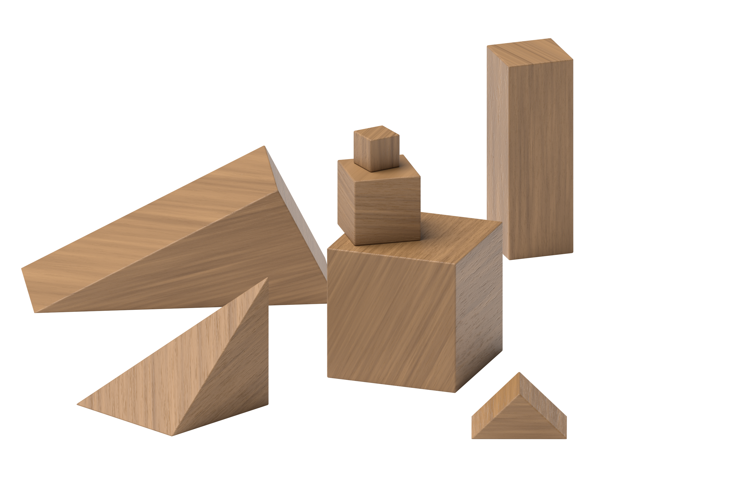
Find the Value of Expressions
© CC BY 2021 Illustrative Mathematics®

