Lesson 12: Center Day 2
- Let’s sort a collection and make graphs to represent it.

Warm-up: Number Talk: Differences
Find the value of each expression mentally.
- $17−7$
- $17−9$
- $15−5$
- $15−8$

12.2: Centers Choice Time
Choose a center.
What's Behind My Back?
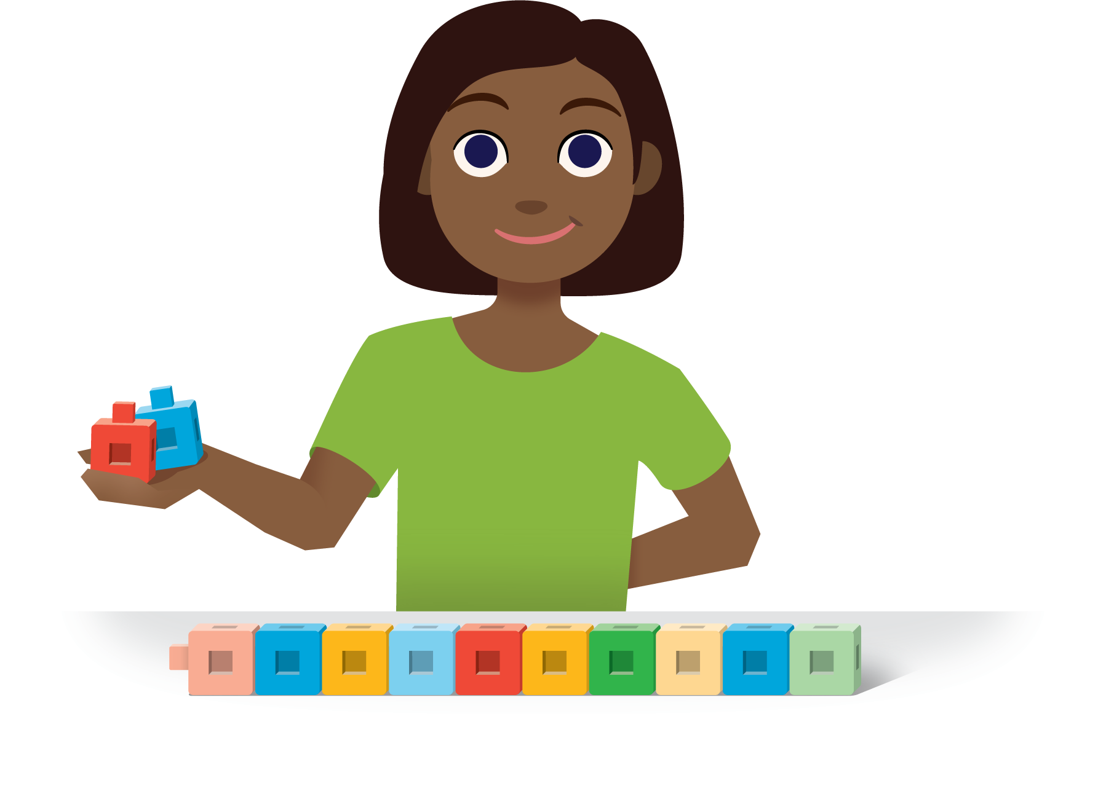
How Close?
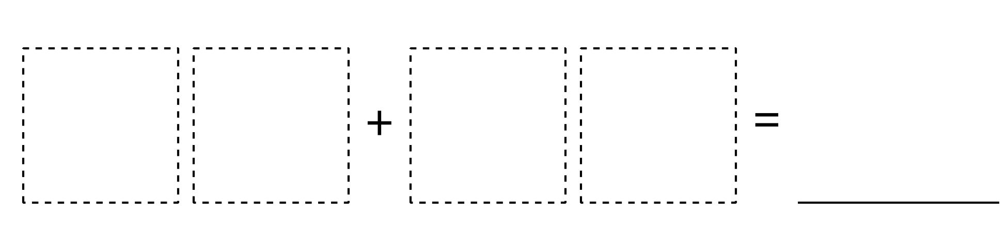
Number Puzzles
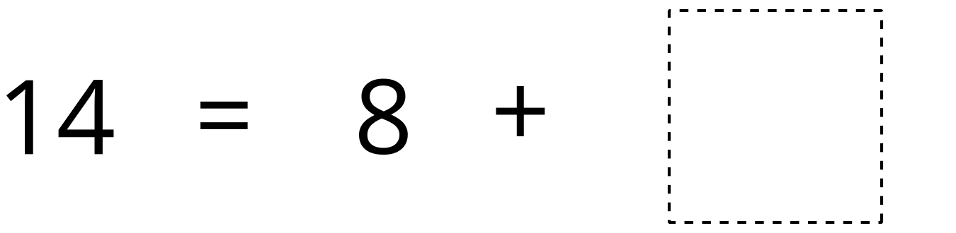
© CC BY 2021 Illustrative Mathematics®

