Lesson 3: Division Situation Drawings

Standards Alignments
Addressing | 3.NBT.A.2, 3.OA.A.2

Teacher-facing Learning Goals
- Interpret and relate drawings and descriptions of division situations.
- Understand that a division situation may involve finding an unknown number of groups or finding an unknown number of objects in each group.

Student-facing Learning Goals
- Let’s represent division situations with drawings.

Lesson Purpose
The purpose of this lesson is for students to interpret descriptions or drawings of division situations and recognize whether they involve finding an unknown number of groups or finding an unknown number of objects in each group.
Students see the two types of division situations side-by-side in this lesson. They understand that division is finding the number in each group or the size of each group and can match division situations to drawings. Students learn that the same drawing can match either type of division situation. This is because the drawings represent the end result after division has occurred. From the drawing, we cannot tell whether the number of groups or the number of objects in each group was known. The division symbol, $÷$, is introduced in the lesson synthesis.

Access for:

Students with Disabilities
- Engagement (Activity 3)

English Learners
- MLR8 (Activity 3)

Instructional Routines
MLR1 Stronger and Clearer Each Time (Activity 2), Number Talk (Warm-up)

Lesson Timeline
Warm-up | 10 min
Activity 1 | 10 min
Activity 2 | 10 min
Activity 3 | 15 min
Lesson Synthesis | 10 min
Cool-down | 5 min

Teacher Reflection Question
How are students leveraging the drawings they used for multiplication to solve division problems?

Cool-down
(to be completed at the end of the lesson) 5min
Party Favors

Standards Alignments
Addressing | 3.OA.A.2

Student-facing Task Statement
Clare has 48 markers. She puts 8 markers into each goodie bag for her birthday party. How many bags will she use?
Which drawing matches the situation? Explain your reasoning.
A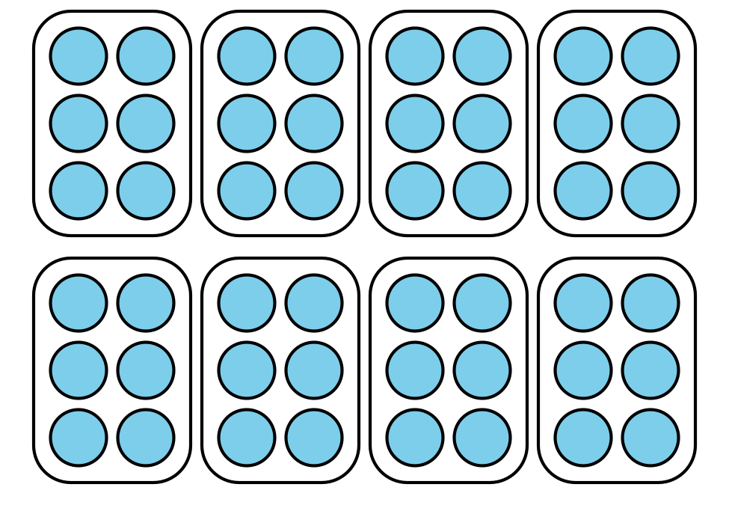
B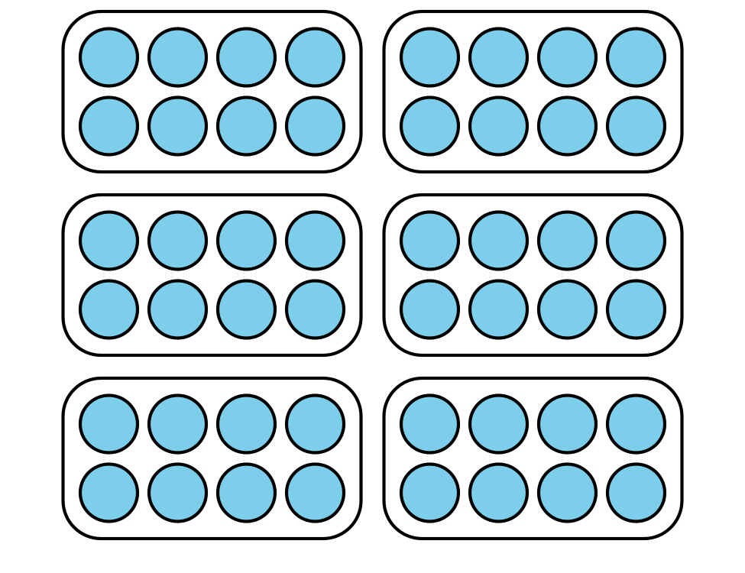

Student Responses
Sample response: Drawing B matches the situation because it shows 8 markers in each bag. After the 48 markers are put into groups of 8, there will be 6 bags.

