Lesson 11: Add Tens to Two-digit Numbers
- Let’s add tens to two-digit numbers.

Warm-up: True or False: Tens and Ones
Decide if each statement is true or false.
Be prepared to explain your reasoning.
- $80+5=5+80$
- $70+1=80+1$
- $20+6=6+30$

11.1: Add Two-digit Numbers and Tens
Find the number that makes each equation true.
Show your thinking using drawings, numbers, or words.
- 37+20=aaaiaaai
- 60+23=aaaiaaai
- 48+50=aaaiaaai
- aaaiaaai=54+20
- 30+65=aaaiaaai
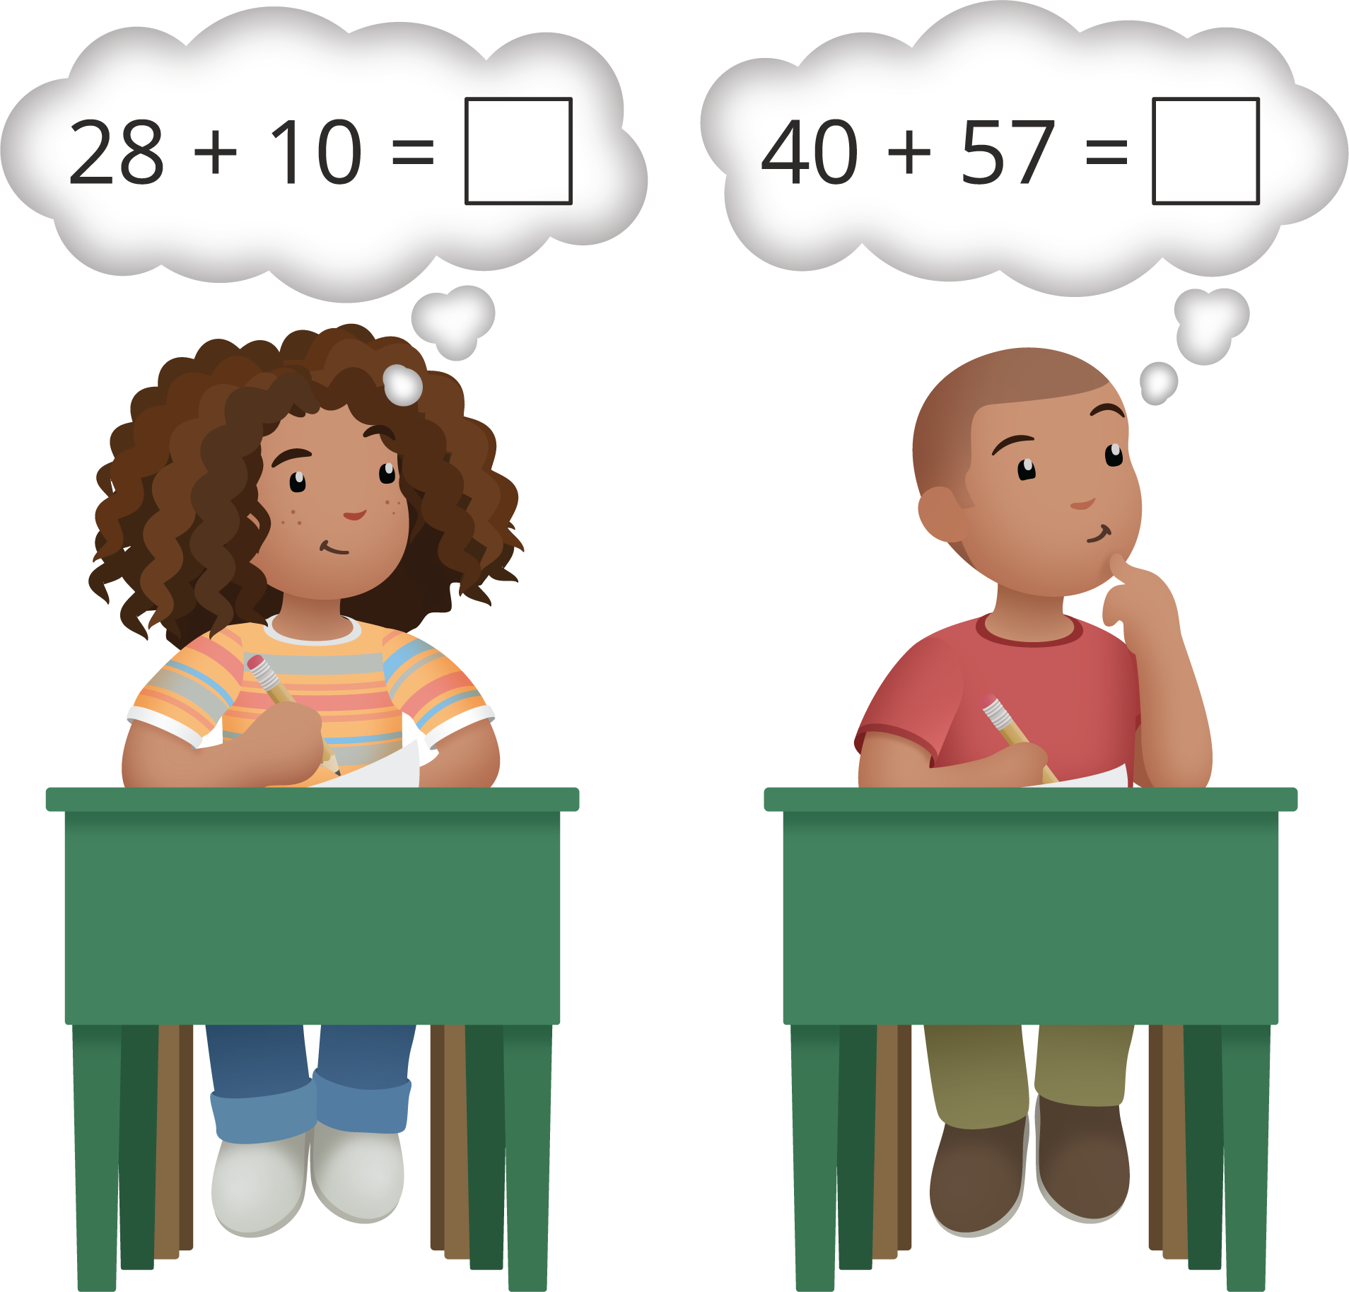

11.2: The Missing Digit
- This equation is true.
- 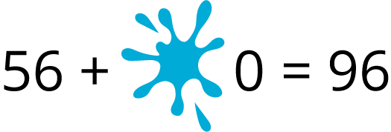
- What digit is under the smudge?
Show your thinking using drawings, numbers, or words.
- This equation is not true.
- Show why it is not true using drawings, numbers, or words.

Section Summary
Section Summary
We learned that two-digit numbers are made up of tens and ones.
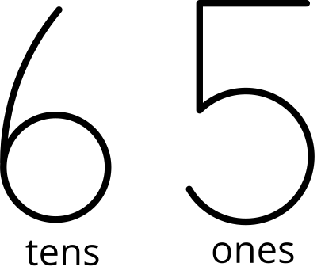
We represented two-digit numbers in many different ways.
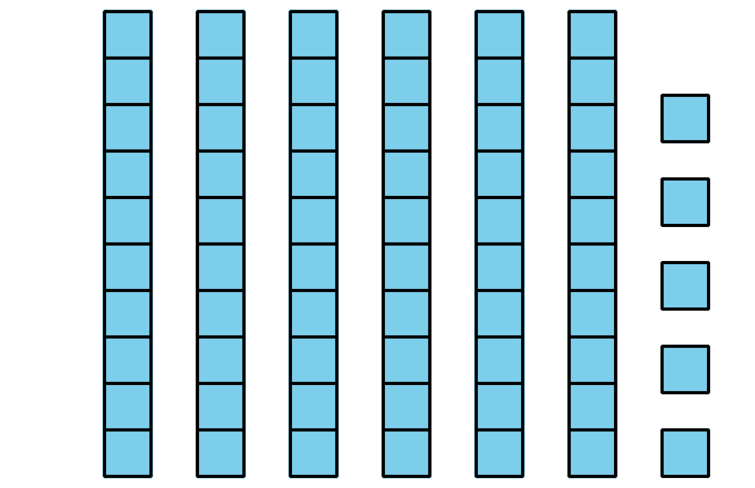
6 tens and 5 ones
$60+5$
65
We added two-digit numbers by thinking about counting on by 10 or adding more tens.
$42+50=\boxed{92}$
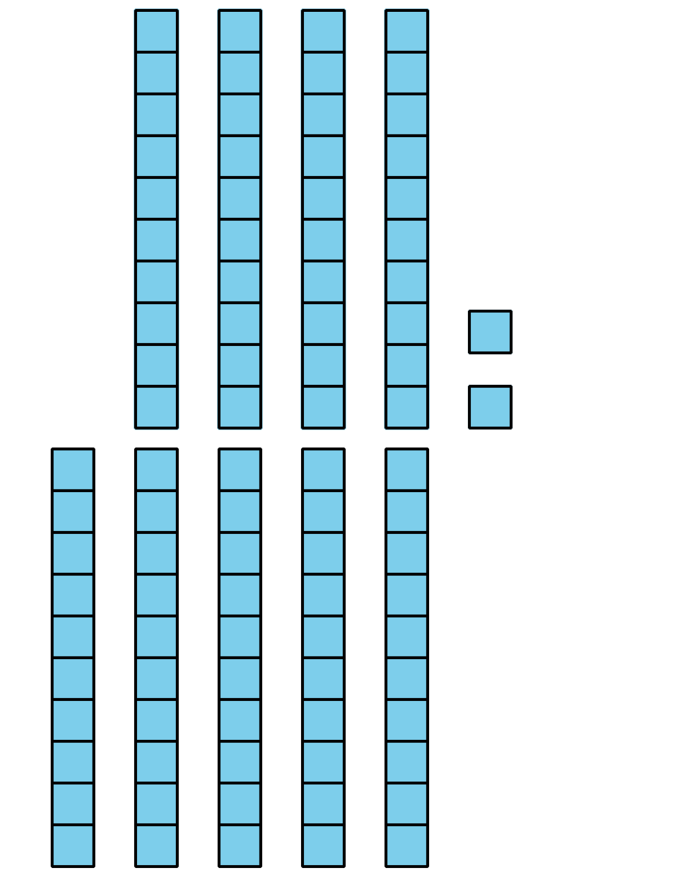
© CC BY 2021 Illustrative Mathematics®

