Unit 8 Lesson 14: Decimal Representations of Rational Numbers

1 Notice and Wonder: Shaded Bars (Warm up)

Student Task Statement
What do you notice? What do you wonder?
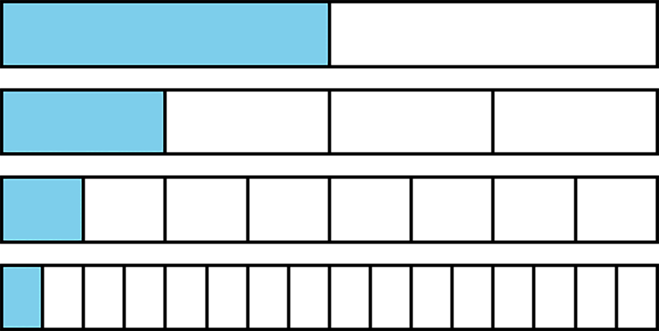

2 Halving the Length (Optional)

Student Task Statement
Here is a number line from 0 to 1.
- Mark the midpoint between 0 and 1. What is the decimal representation of that number?
- Mark the midpoint between 0 and the newest point. What is the decimal representation of that number?
- Repeat step two. How did you find the value of this number?
- Describe how the value of the midpoints you have added to the number line keep changing as you find more. How do the decimal representations change?

3 Recalculating Rational Numbers

Student Task Statement
- Rational numbers are fractions and their opposites. All of these numbers are rational numbers. Show that they are rational by writing them in the form $\frac{a}{b}$ or $\text{-}\frac{a}{b}$.
  - 0.2
  - $\text{-}\sqrt{4}$
  - 0.333
  - $\sqrt[3]{1000}$
  - -1.000001
  - $\sqrt{\frac{1}{9}}$
- All rational numbers have decimal representations, too. Find the decimal representation of each of these rational numbers.
  - $\frac{3}{8}$
  - $\frac{7}{5}$
  - $\frac{999}{1000}$
  - $\frac{111}{2}$
  - $\sqrt[3]{\frac{1}{8}}$

Activity Synthesis
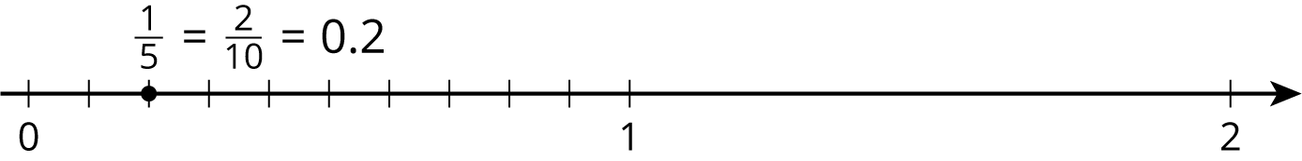

4 Zooming In On $\frac{2}{11}$

Student Task Statement
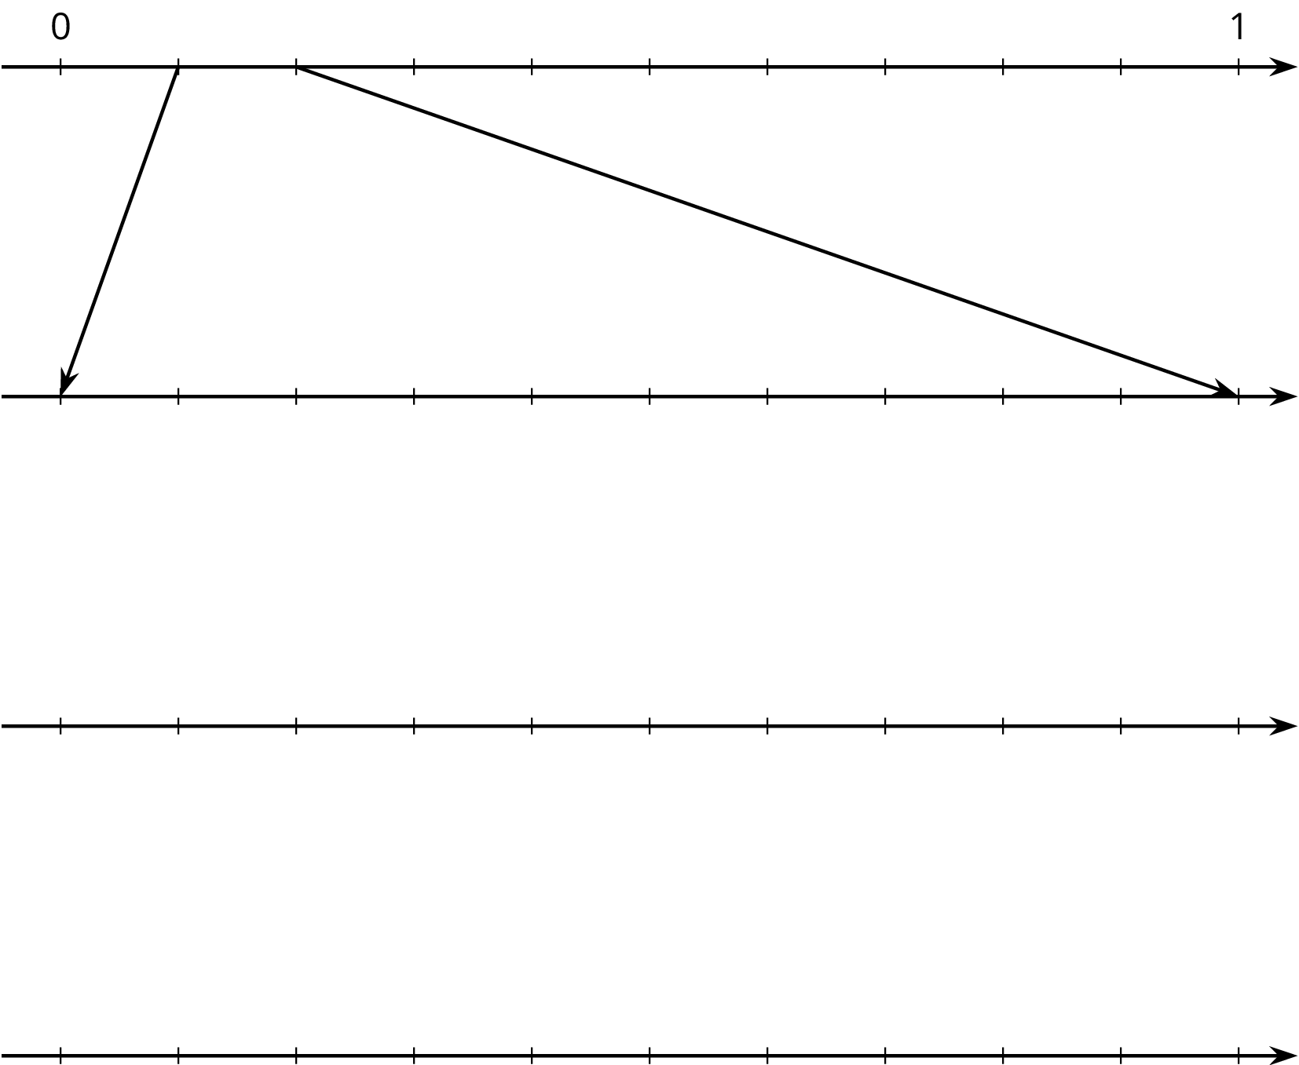
- On the topmost number line, label the tick marks. Next, find the first decimal place of $\frac{2}{11}$ using long division and estimate where $\frac{2}{11}$ should be placed on the top number line.
- Label the tick marks of the second number line. Find the next decimal place of $\frac{2}{11}$ by continuing the long division and estimate where $\frac{2}{11}$ should be placed on the second number line. Add arrows from the second to the third number line to zoom in on the location of $\frac{2}{11}$.
- Repeat the earlier step for the remaining number lines.
- What do you think the decimal expansion of $\frac{2}{11}$ is?
© CC BY Open Up Resources. Adaptations CC BY IM.

