Lesson 2 Practice Problems
- A square has an area of 81 square feet. Select all the expressions that equal the side length of this square, in feet.
  - $\frac{81}{2}$
  - $\sqrt{81}$
  - 9
  - $\sqrt{9}$
  - 3
- Write the exact value of the side length, in units, of a square whose area in square units is:
  - 36
  - 37
  - $\frac{100}{9}$
  - $\frac{2}{5}$
  - 0.0001
  - 0.11
- Square A is smaller than Square B. Square B is smaller than Square C.
- The three squares’ side lengths are $\sqrt{26}$, 4.2, and $\sqrt{11}$.
- 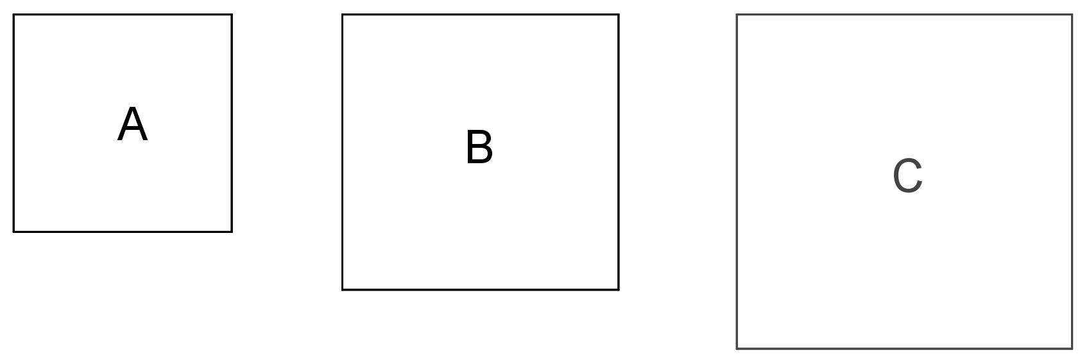
- What is the side length of Square A? Square B? Square C? Explain how you know.
- Find the area of a square if its side length is:
  - $\frac{1}{5}$ cm
  - $\frac{3}{7}$ units
  - $\frac{11}{8}$ inches
  - 0.1 meters
  - 3.5 cm
- (From Unit 8, Lesson 1.)
- Here is a table showing the areas of the seven largest countries.
  - How much larger is Russia than Canada?
  - The Asian countries on this list are Russia, China, and India. The American countries are Canada, the United States, and Brazil. Which has the greater total area: the three Asian countries, or the three American countries?
- country | - area (in km²)
- Russia | - $1.71×{10}^{7}$
- Canada | - $9.98×{10}^{6}$
- China | - $9.60×{10}^{6}$
- United States | - $9.53×{10}^{6}$
- Brazil | - $8.52×{10}^{6}$
- Australia | - $6.79×{10}^{6}$
- India | - $3.29×{10}^{6}$
- (From Unit 7, Lesson 15.)
- Select all the expressions that are equivalent to ${10}^{\text{-}6}$.
  - $\frac{1}{1000000}$
  - $\frac{\text{-}1}{1000000}$
  - $\frac{1}{{10}^{6}}$
  - ${10}^{8}⋅{10}^{\text{-}2}$
  - ${\left(\frac{1}{10}\right)}^{6}$
  - $\frac{1}{10⋅10⋅10⋅10⋅10⋅10}$
- (From Unit 7, Lesson 5.)
© CC BY Open Up Resources. Adaptations CC BY IM.

