Unit 2 Lesson 3 Cumulative Practice Problems
- A recipe for 1 batch of spice mix says, “Combine 3 teaspoons of mustard seeds, 5 teaspoons of chili powder, and 1 teaspoon of salt.” How many batches are represented by the diagram? Explain or show your reasoning.
- 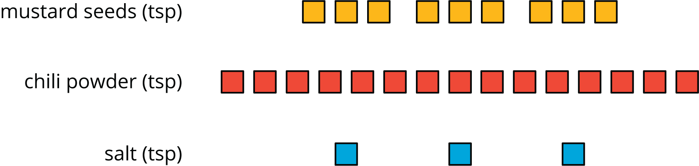

- Priya makes chocolate milk by mixing 2 cups of milk and 5 tablespoons of cocoa powder. Draw a diagram that clearly represents two batches of her chocolate milk.
- In a recipe for fizzy grape juice, the ratio of cups of sparkling water to cups of grape juice concentrate is 3 to 1.
  - Find two more ratios of cups of sparkling water to cups of juice concentrate that would make a mixture that tastes the same as this recipe.
  - Describe another mixture of sparkling water and grape juice that would taste different than this recipe.
- Write the missing number under each tick mark on the number line.
- 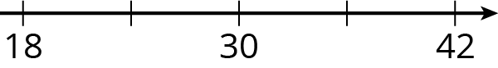
- (From Unit 2, Lesson 1.)
- At the kennel, there are 6 dogs for every 5 cats.
  - The ratio of dogs to cats is ______ to ______.
  - The ratio of cats to dogs is ______ to ______.
  - For every ______ dogs there are ______ cats.
  - The ratio of cats to dogs is ______ : ______.
- (From Unit 2, Lesson 1.)
- Elena has 80 unit cubes. What is the volume of the largest cube she can build with them?
- (From Unit 1, Lesson 17.)
- Fill in the blanks to make each equation true.
  - $3⋅\frac{1}{3}=\text{_______}$
  - $10⋅\frac{1}{10}=\text{_______}$
  - $19⋅\frac{1}{19}=\text{_______}$
  - $a⋅\frac{1}{a}=\text{_______}$
(As long as $a$ does not equal 0.)
  - $5⋅\text{_______}=1$
  - $17⋅\text{_______}=1$
  - $b⋅\text{_______}=1$
- (From Unit 2, Lesson 1.)
© CC BY Open Up Resources. Adaptations CC BY IM.

