Unit 4 Lesson 13: Solve Problems With Equal Groups

Estimation Exploration: Multiply Teens (Warm up)

Student Task Statement
$4×18$
Record an estimate that is:
too low | about right | too high

1 Problems with Teen Numbers

Student Task Statement
Solve each problem. Show your thinking using objects, a drawing, or a diagram.
- A seller at a farmers market has 7 dozen eggs when they close for the day. How many eggs does the seller have?
- At the farmers market there’s a space for performers to play music with some chairs for people to sit and listen. There are 5 rows of chairs and each row has 15 chairs. How many chairs are there?
- A booth at a farmers market has a table top that has lengths of 4 feet and 16 feet. What is the area of the table top?
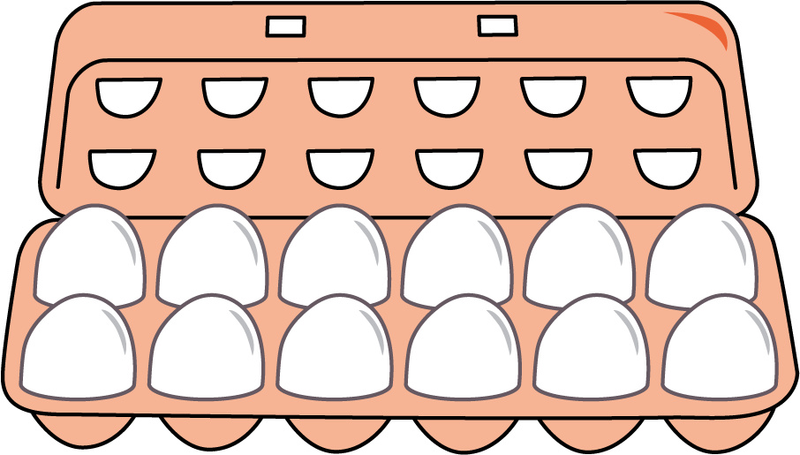

2 Gallery Walk: Problems with Teen Numbers

Student Task Statement
As you visit the posters with your partner, discuss what is the same and what is different about the thinking shown on each poster.
© CC BY 2021 Illustrative Mathematics®

