Unit 3 Lesson 7: The Correlation Coefficient

1 Which One Doesn’t Belong: Linear Models (Warm up)

Student Task Statement
Which one doesn’t belong?

A
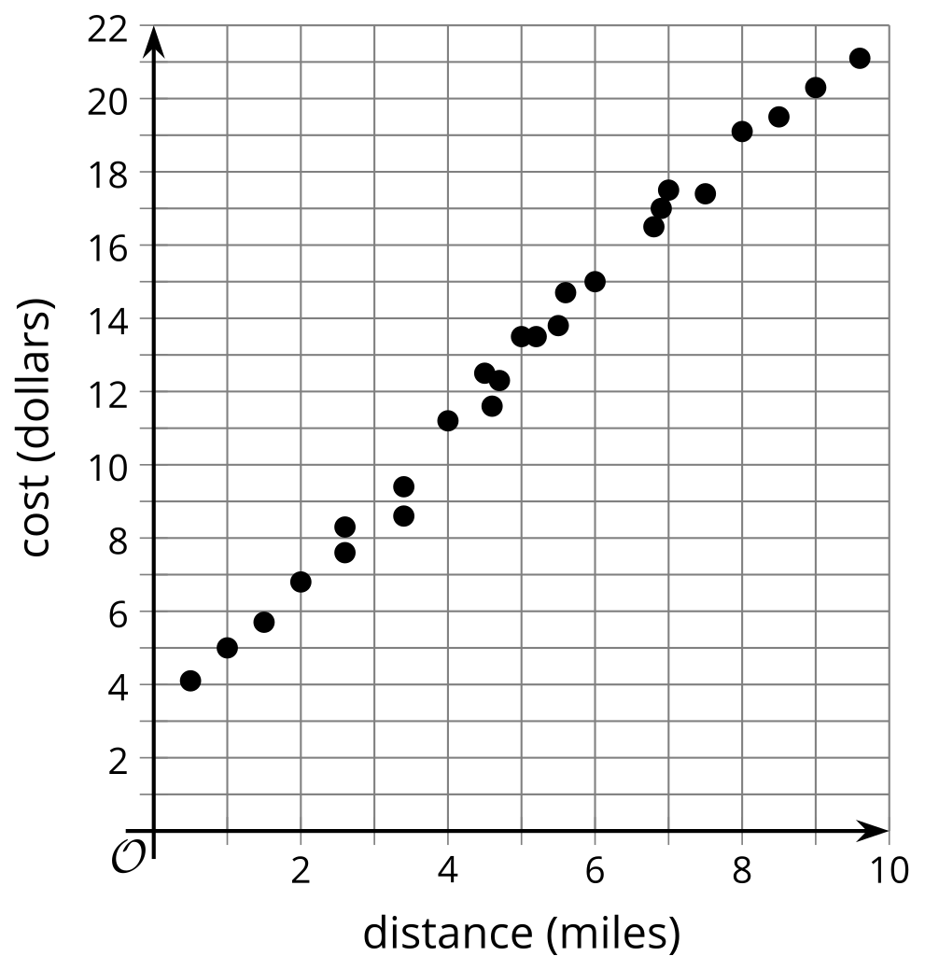

B
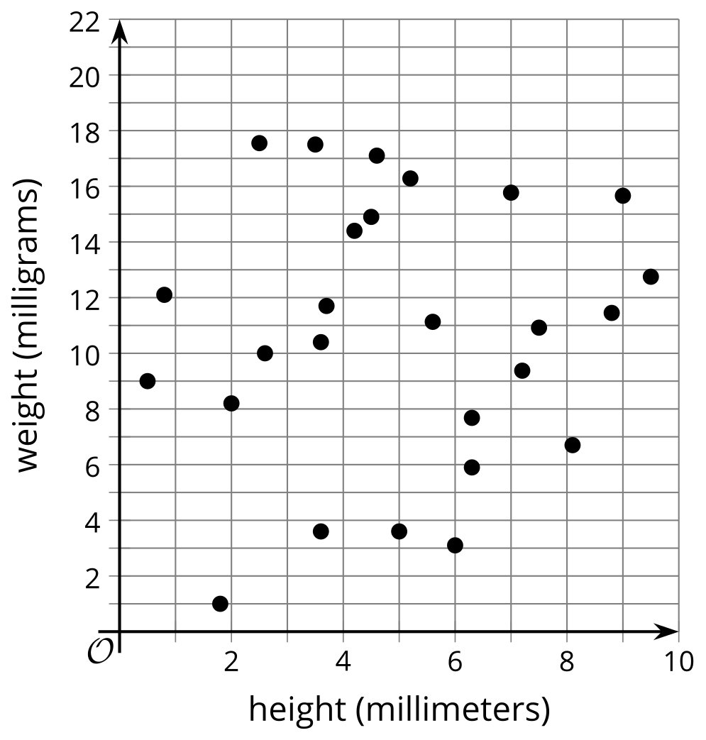

C
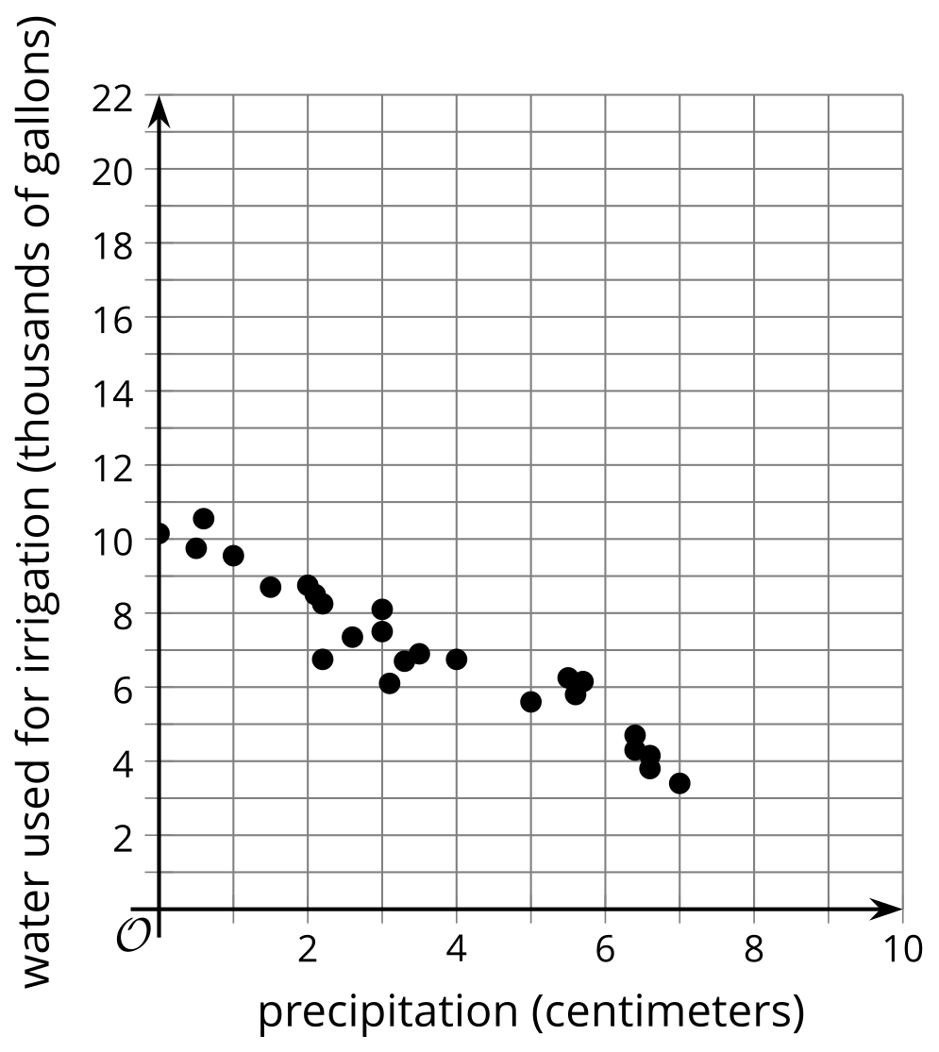

D
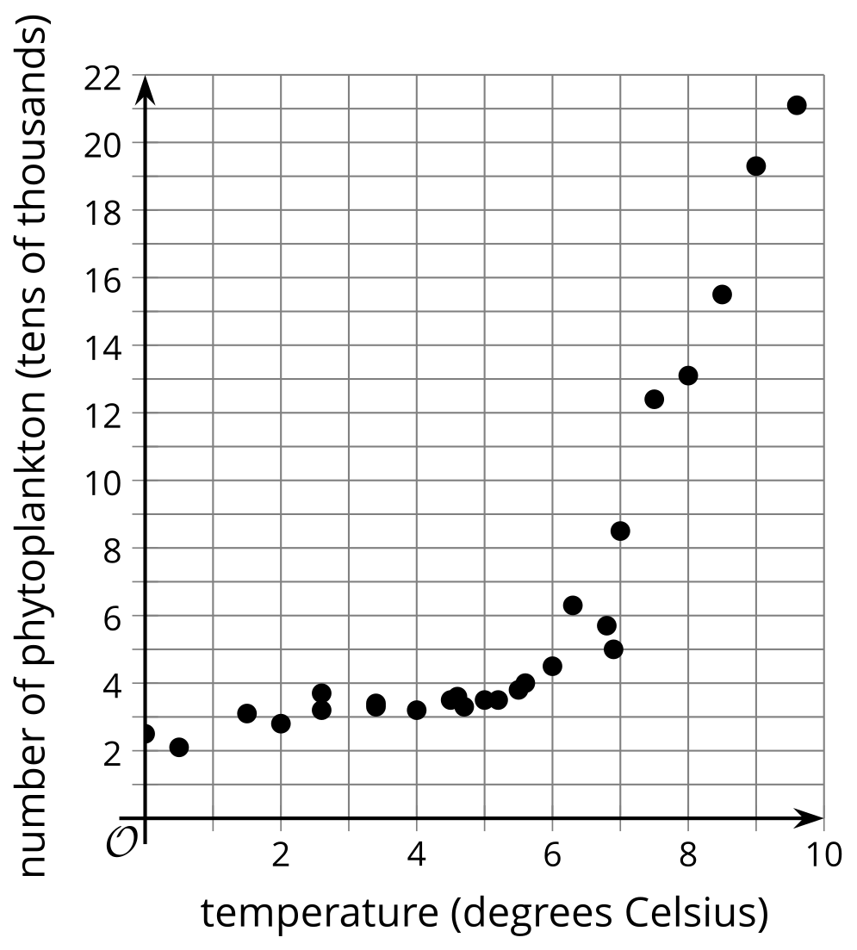

2 Card Sort: Scatter Plot Fit

Student Task Statement
Your teacher will give you a set of cards that show scatter plots of data. Sort the cards into 2 categories of your choosing. Be prepared to explain the meaning of your categories. Then, sort the cards into 2 categories in a different way. Be prepared to explain the meaning of your new categories.

Activity Synthesis

A: $y=\text{-}0.83x−1.85,r=\text{-}0.61$
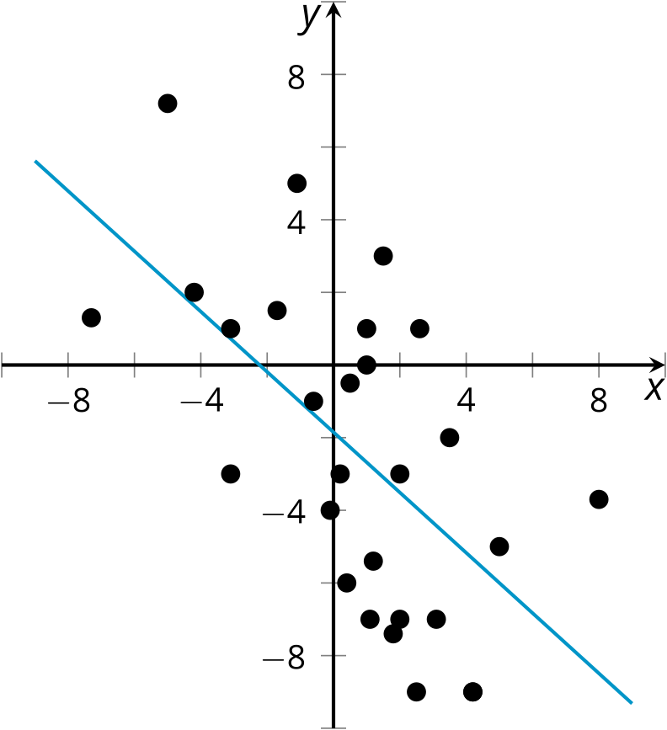

B: $y=\text{-}0.07x+5.63,r=\text{-}0.06$
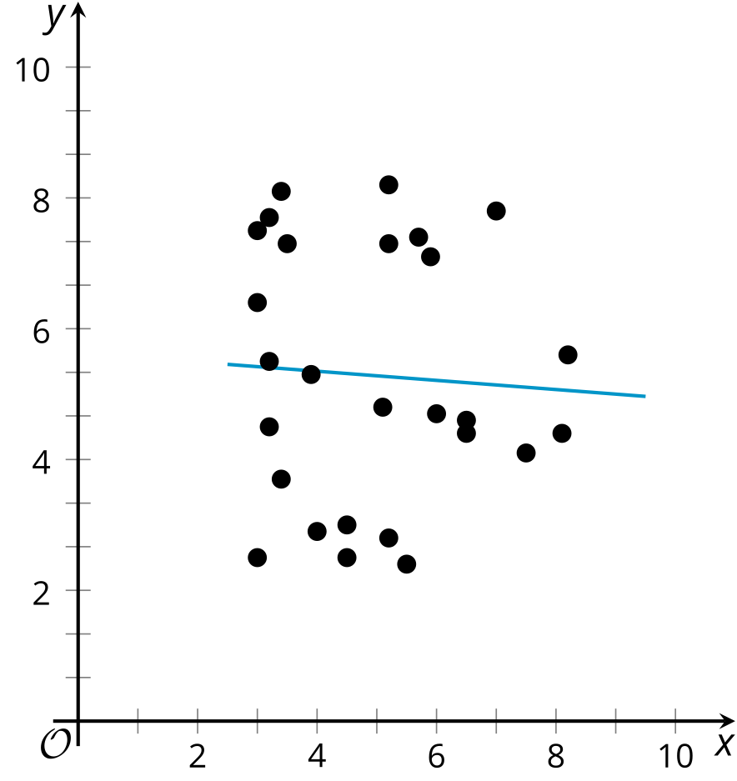

C: $y=\text{-}0.31x+5.76,r=\text{-}0.88$
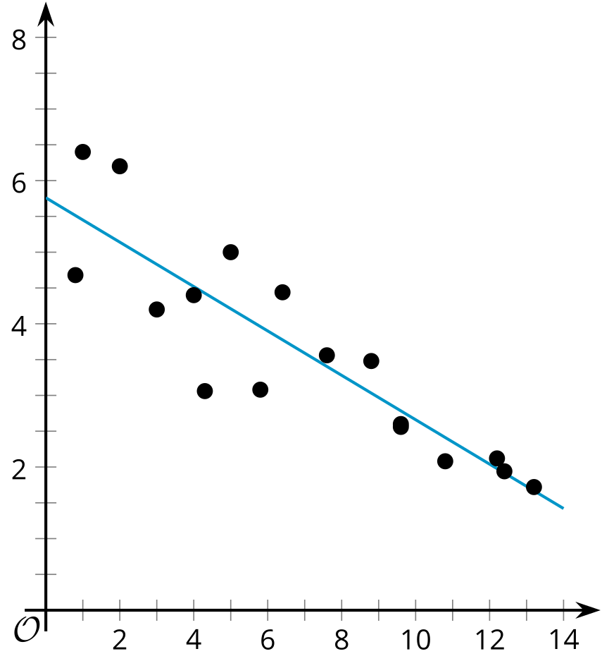

D: $y=\text{-}0.8x+6,r=\text{-}1$
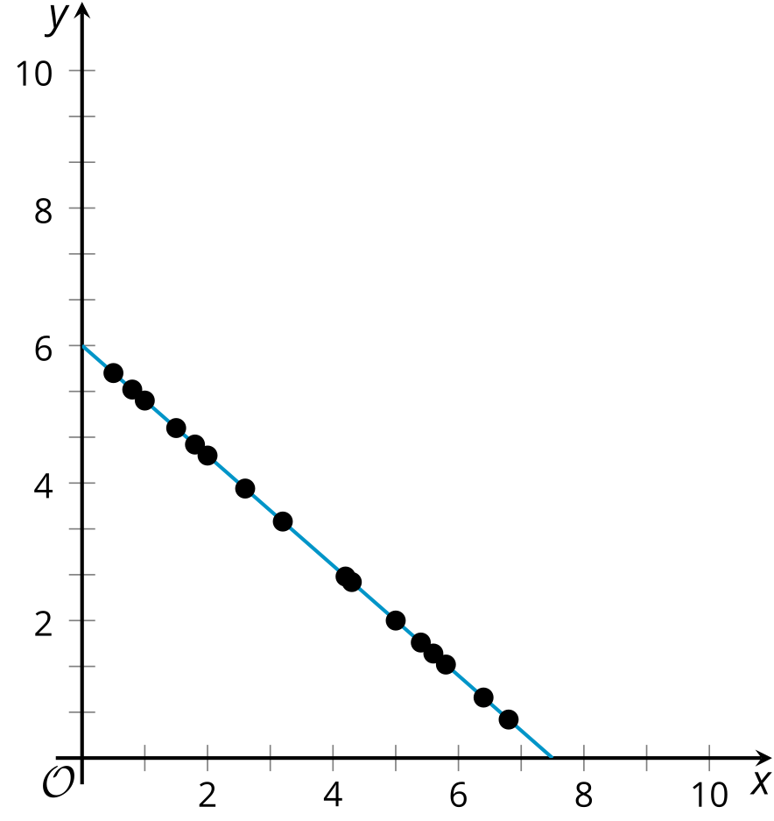

E: $y=0.69x+4.49,r=0.46$
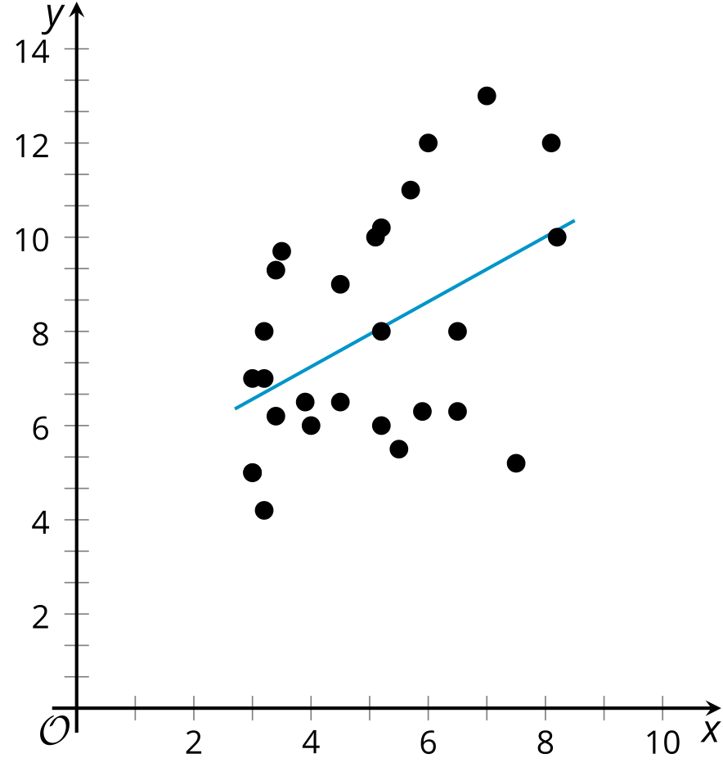

F: $y=1.43x+2.86$, $r=0.94$
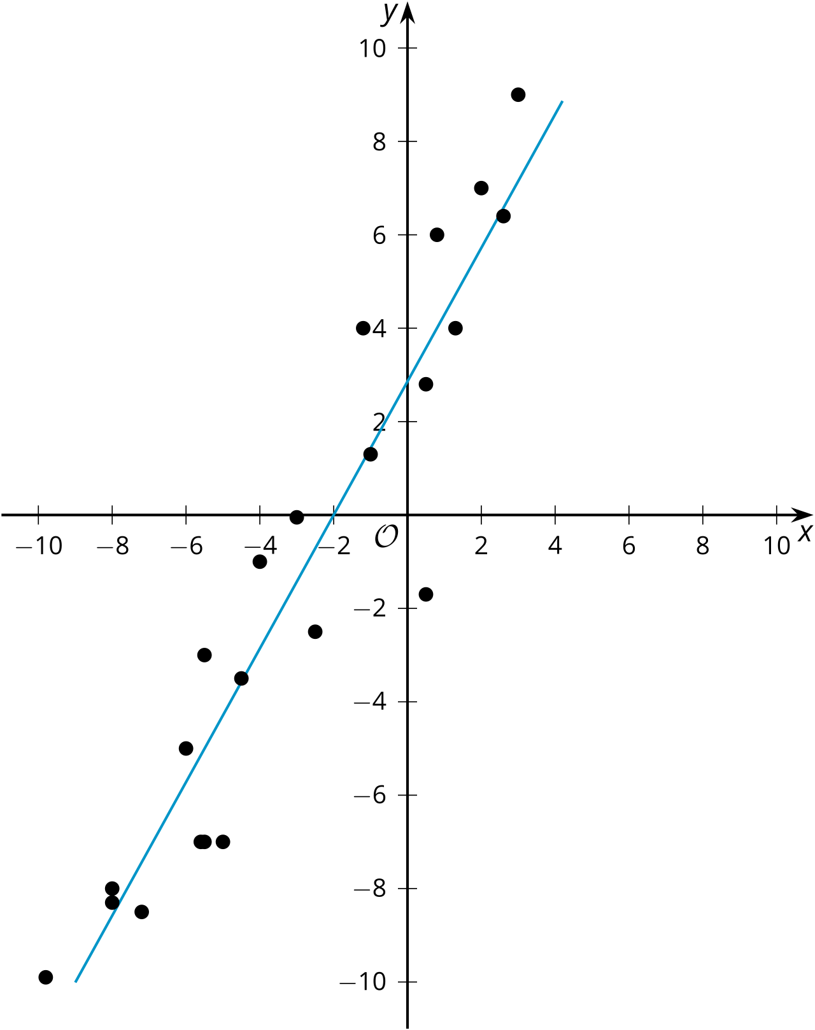

G: $y=3x+2,r=1$
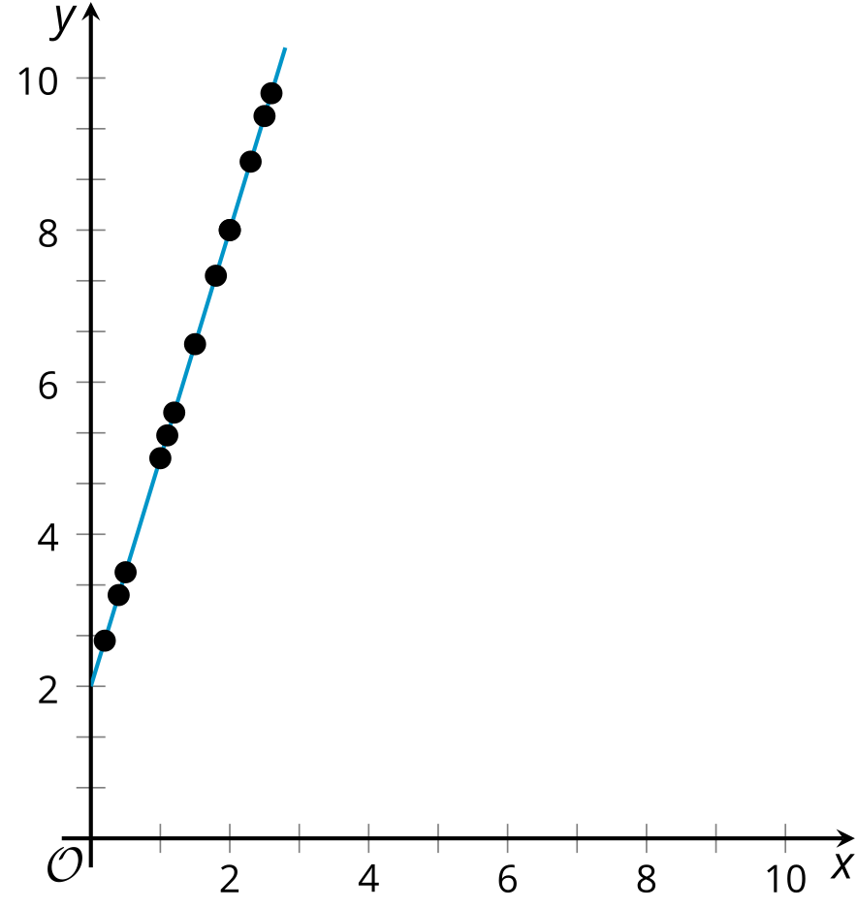

H: $y=\text{-}0.02x+1.64,r=\text{-}0.13$
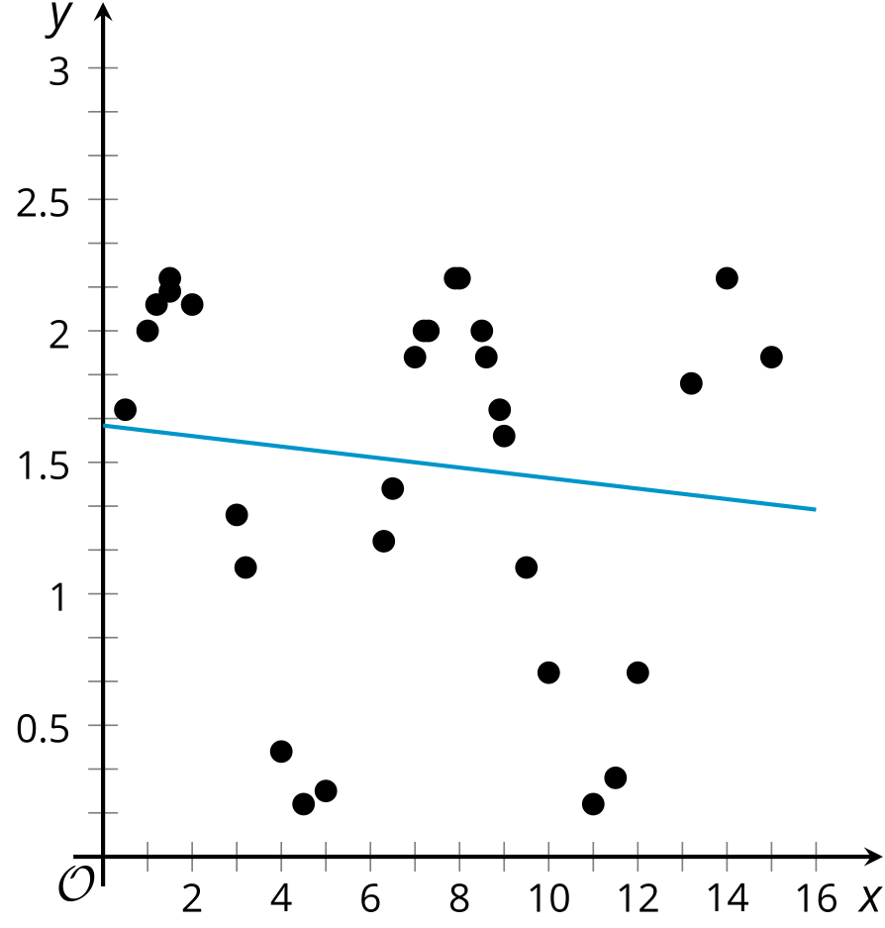

I: $y=14.55x−36.18,r=0.95$
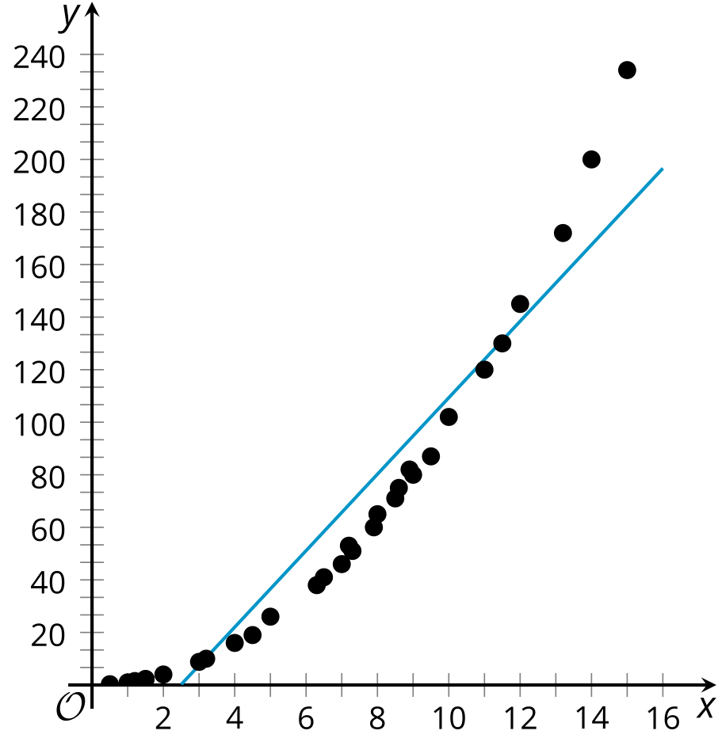

J: $y=\text{-}0.62x+6.52,r=\text{-}0.96$
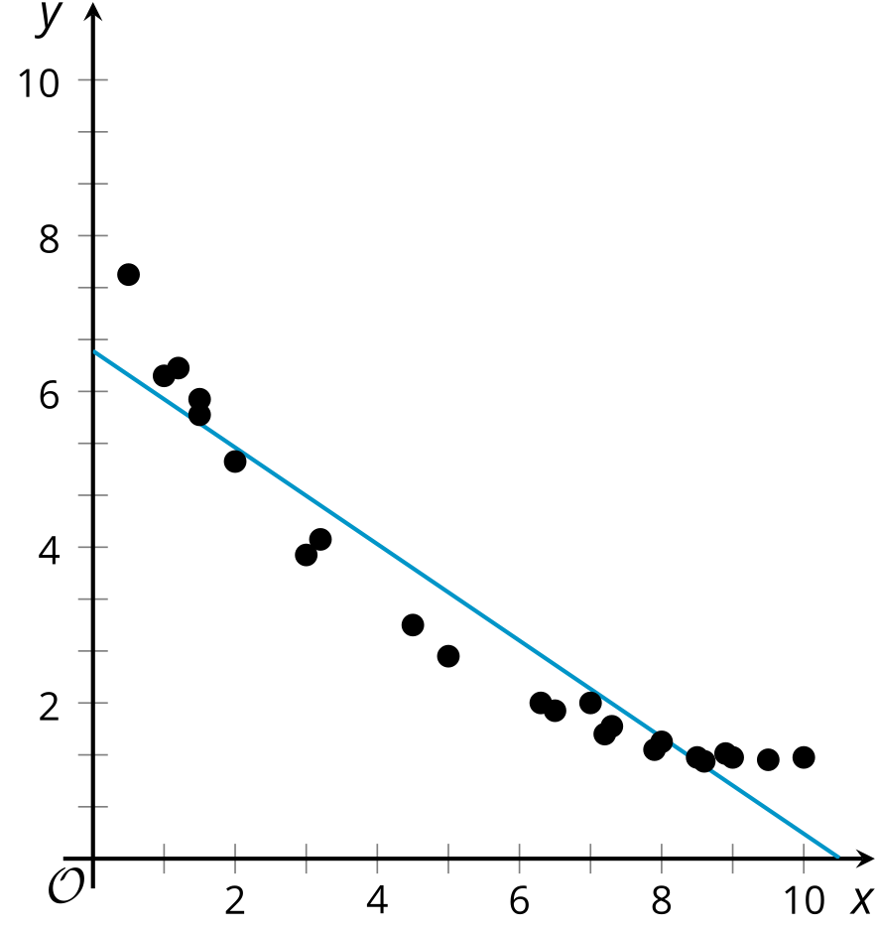

3 Matching Correlation Coefficients

Student Task Statement
- Take turns with your partner to match a scatter plot with a correlation coefficient.
- For each match you find, explain to your partner how you know it’s a match.
- For each match your partner finds, listen carefully to their explanation. If you disagree, discuss your thinking and work to reach an agreement.

A
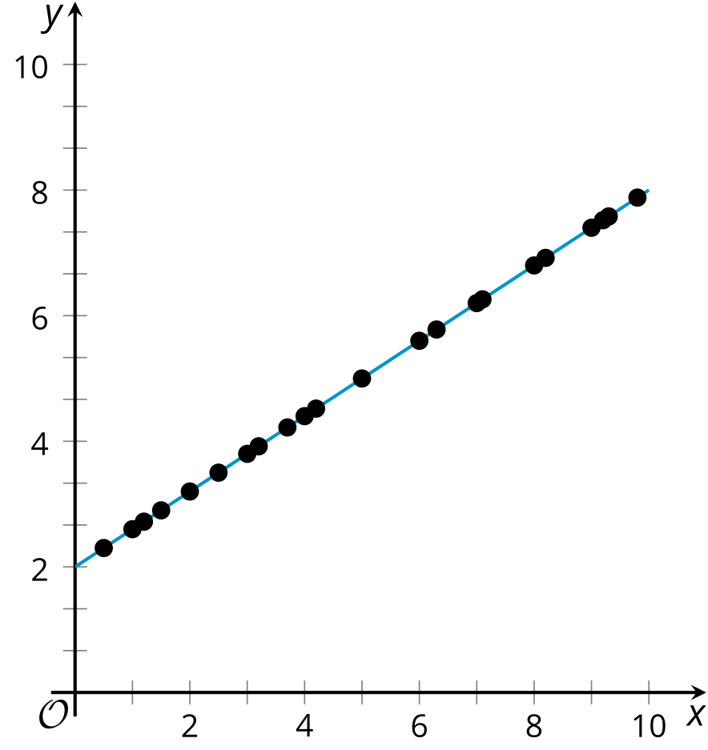
- $r=\text{-}1$
- $r=\text{-}0.95$
- $r=\text{-}0.74$
- $r=\text{-}0.06$
- $r=0.48$
- $r=0.65$
- $r=0.9$
- $r=1$

B
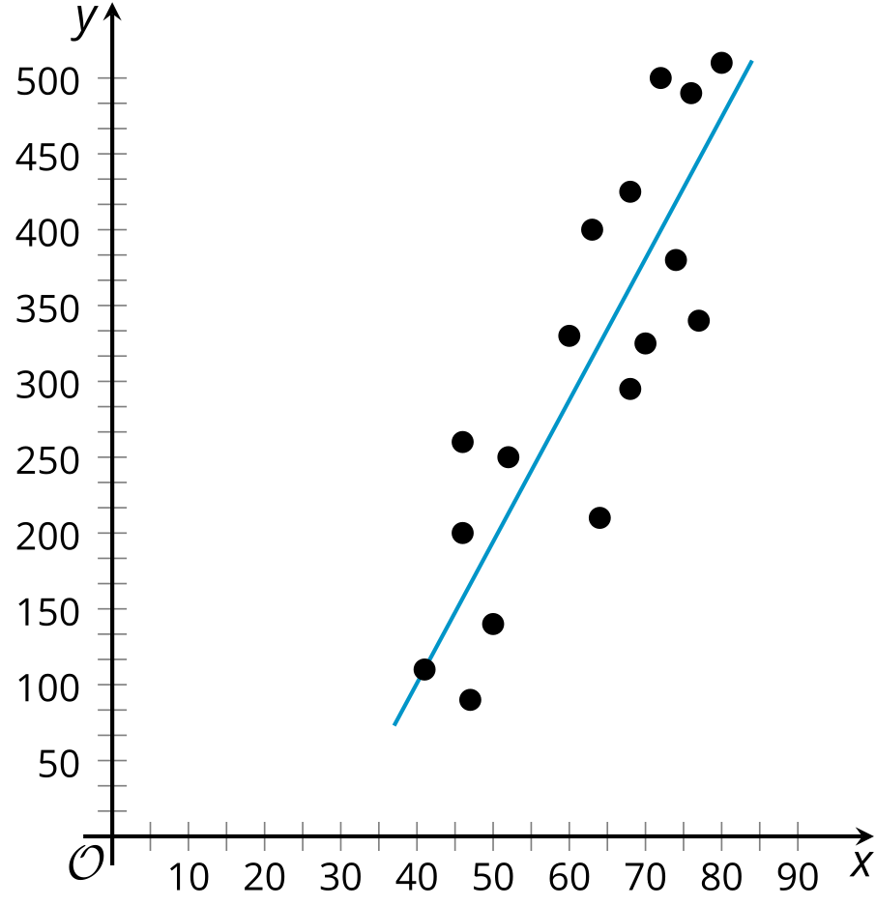

C
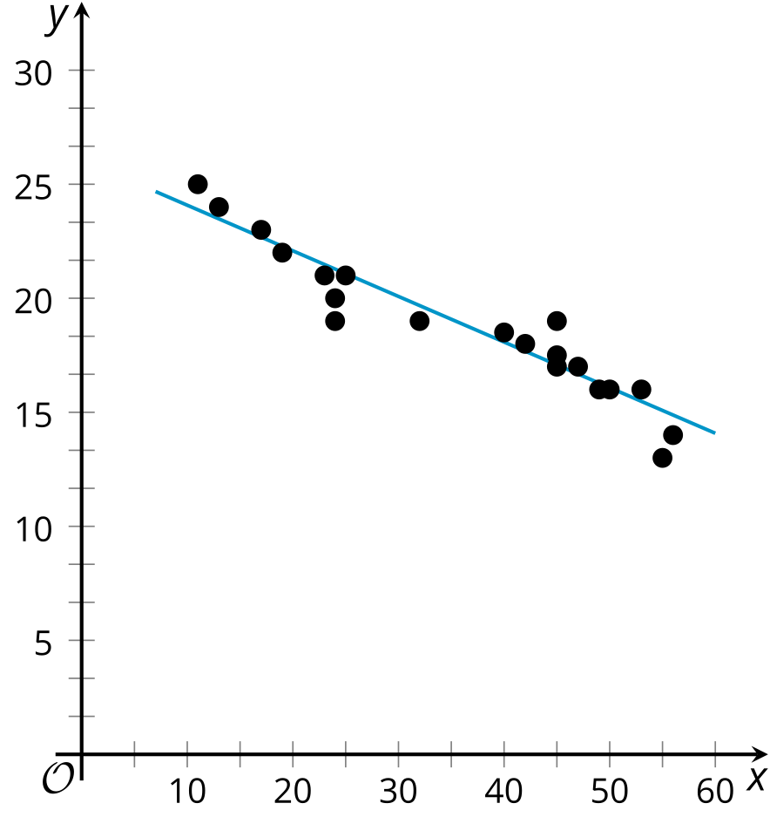

D
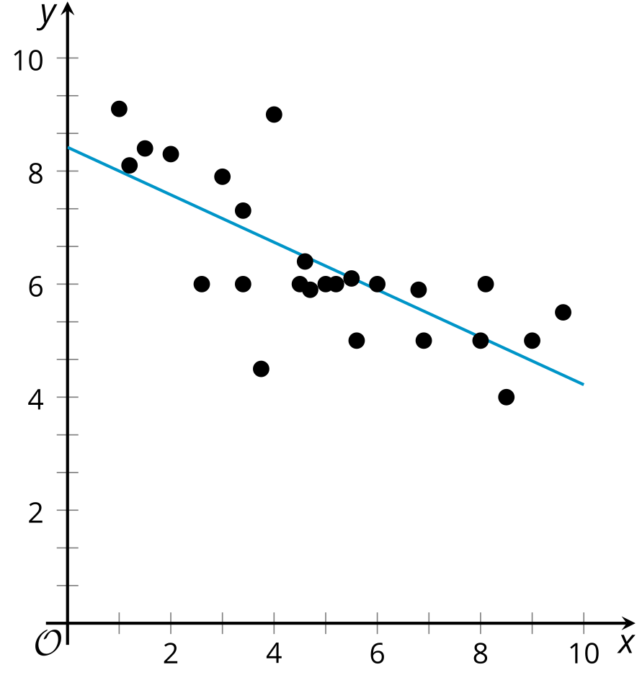

E
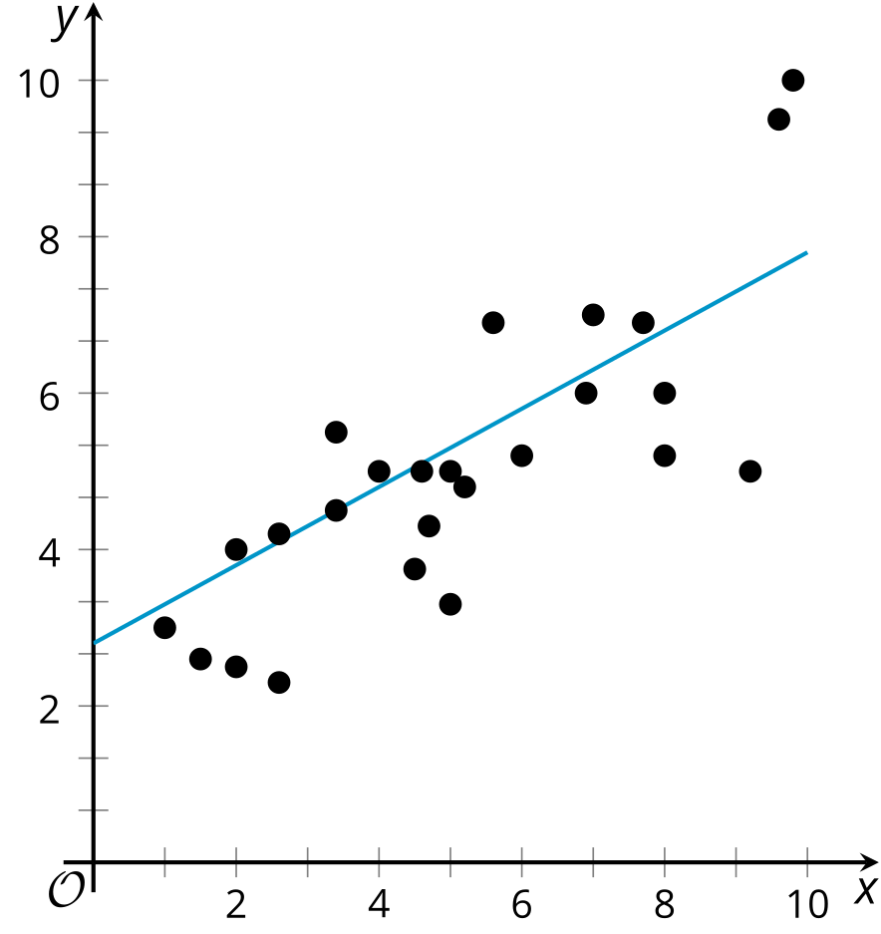

F
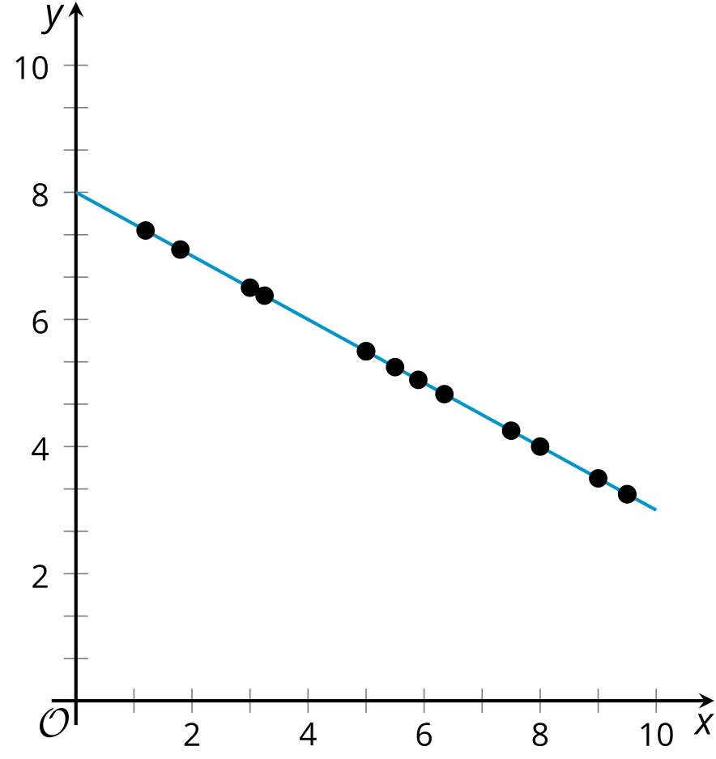

G
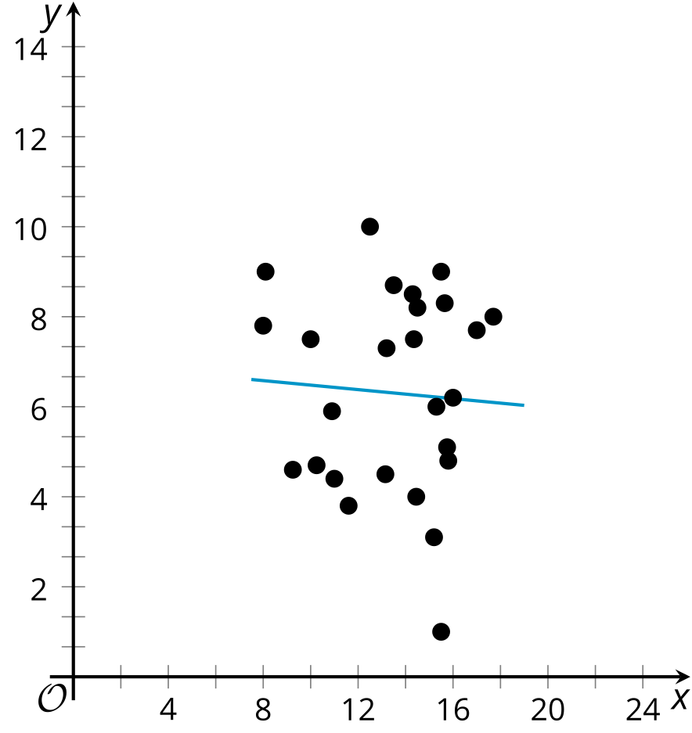

H
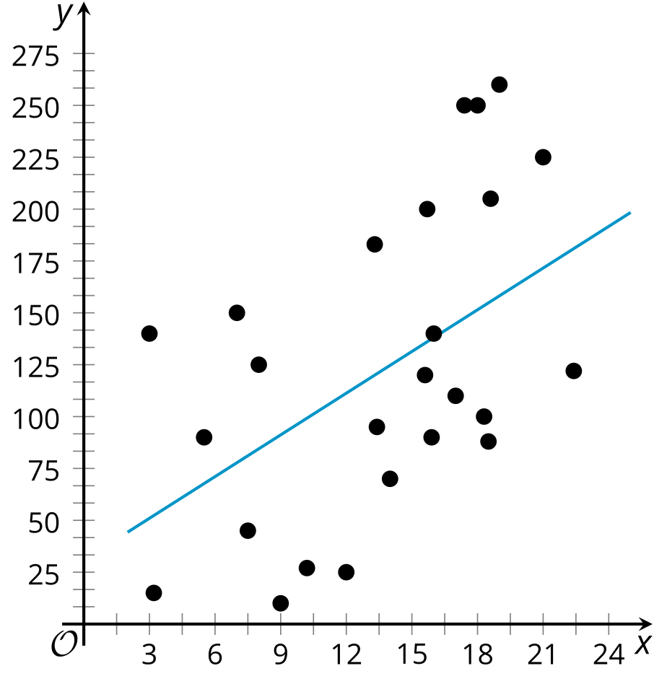
© CC BY 2019 by Illustrative Mathematics®

