Lesson 3 Practice Problems
- Complete the table and determine the rule for this transformation.
- input | - output
- $\left(2,\text{-}3\right)$ | - $\left(\text{-}3,2\right)$
- $\left(4,5\right)$ | - $\left(5,4\right)$
- $\left(,4\right)$ | - $\left(4,0\right)$
- $\left(1,6\right)$
 | - $\left(\text{-}1,\text{-}2\right)$
- $\left(x,y\right)$
- Write a rule that describes this transformation.
- original figure | - image
- $\left(5,1\right)$ | - $\left(2,\text{-}1\right)$
- $\left(\text{-}3,4\right)$ | - $\left(\text{-}6,\text{-}4\right)$
- $\left(1,\text{-}2\right)$ | - $\left(\text{-}2,2\right)$
- $\left(\text{-}1,\text{-}4\right)$ | - $\left(\text{-}4,4\right)$
- Select all the transformations that produce congruent images.
  - dilation
  - horizontal stretch
  - reflection
  - rotation
  - translation
- Here are some transformation rules. For each transformation, first predict what the image of triangle $ABC$ will look like. Then compute the coordinates of the image and draw it.
  - $\left(x,y\right)→\left(x−4,y−1\right)$
  - $\left(x,y\right)→\left(y,x\right)$
  - $\left(x,y\right)→\left(1.5x,1.5y\right)$
- 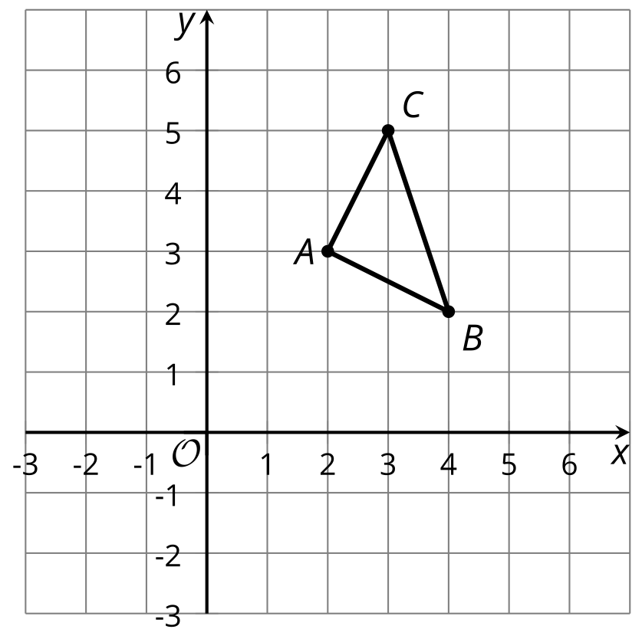
- (From Unit 6, Lesson 2.)
- A cylinder has radius 3 inches and height 5 inches. A cone has the same radius and height.
  - Find the volume of the cylinder.
  - Find the volume of the cone.
  - What fraction of the cylinder’s volume is the cone’s volume?
- (From Unit 5, Lesson 13.)
- Reflect triangle $ABC$ over the line $x=\text{-}2$. Call this new triangle $A^{′}B^{′}C^{′}$. Then reflect triangle $A^{′}B^{′}C^{′}$ over the line $x=0$. Call the resulting triangle $A^{″}B^{″}C^{″}$.
- Describe a single transformation that takes $ABC$ to $A^{″}B^{″}C^{″}$.
- 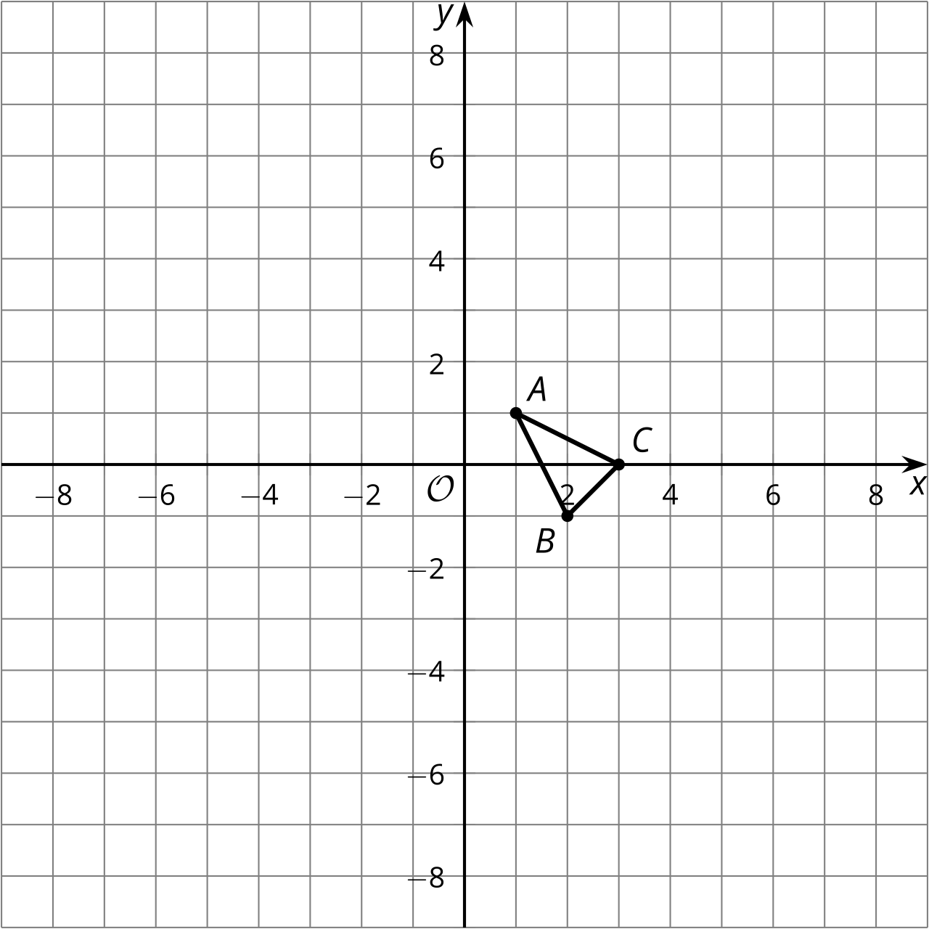
- (From Unit 6, Lesson 1.)
- In the construction, $A$ is the center of one circle, and $B$ is the center of the other.
- 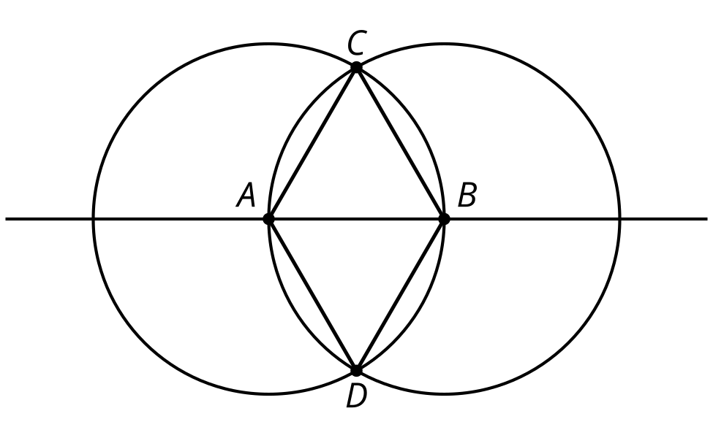
- Explain why segments $AC$, $BC$, $AD$, $BD$, and $AB$ have the same length.
- (From Unit 1, Lesson 2.)
© CC BY 2019 by Illustrative Mathematics®

