Lesson 4: Positive Rational Exponents
- Let’s use roots to write exponents that are fractions.

4.1: Math Talk: Regrouping Fractions
Find the value of each expression mentally.
$\frac{1}{2}⋅5⋅4$
$\frac{5}{2}⋅4$
$\frac{2}{3}⋅7⋅\frac{3}{2}$
$7⋅\frac{5}{3}⋅\frac{3}{7}$

4.2: You Can Use Any Fraction As an Exponent
- Use exponent rules to explain why these expressions are equal to each other:
- ${\left(5^{\frac{1}{3}}\right)}^{2}$ | - ${\left(5^{2}\right)}^{\frac{1}{3}}$

- Write $5^{\frac{2}{3}}$ using radicals.
- Write $5^{\frac{4}{3}}$ using radicals. Show your reasoning using exponent rules.

4.3: Fractional Powers Are Just Numbers
- Complete the table as much as you can without using a calculator. (You should be able to fill in three spaces.)
- $x$ | - 0 | - $\frac{1}{3}$ | - $\frac{2}{3}$ | - 1 | - $\frac{4}{3}$ | - $\frac{5}{3}$ | - 2
- $2^{x}$ (using exponents) | - $2^{0}$ | - $2^{\frac{1}{3}}$ | - $2^{\frac{2}{3}}$ | - $2^{1}$ | - $2^{\frac{4}{3}}$ | - $2^{\frac{5}{3}}$ | - $2^{2}$
- $2^{x}$ (decimal approximation)
  - Plot the points that you filled in.
  - 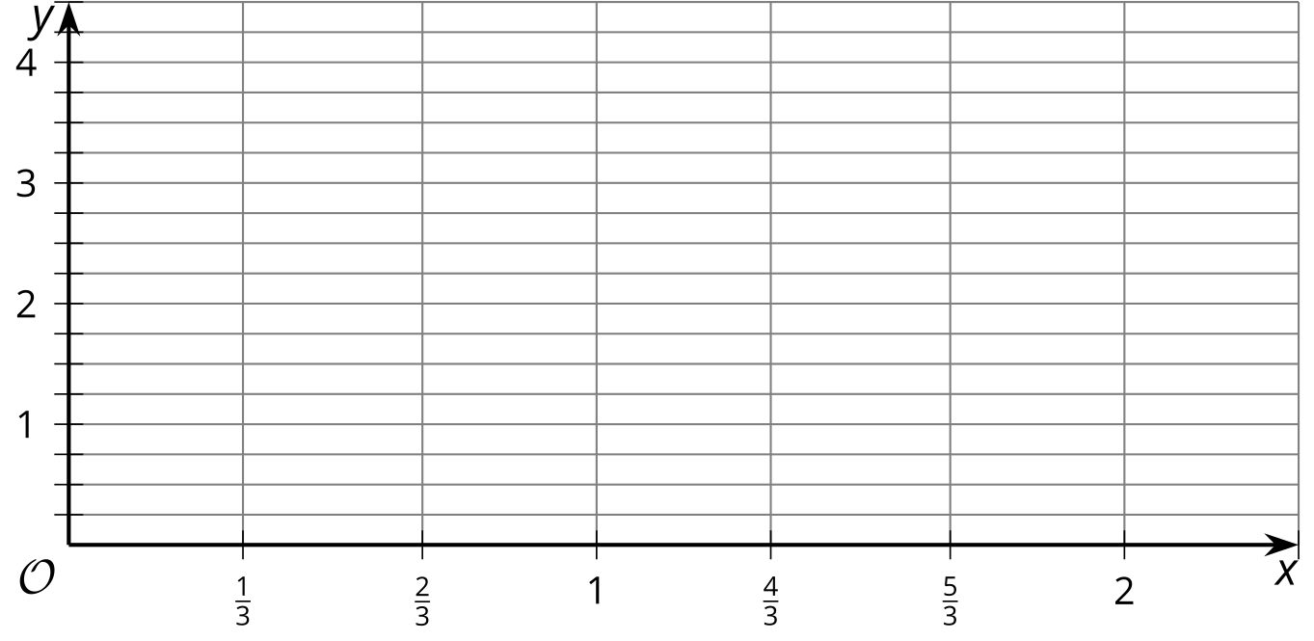
  - Connect the points as smoothly as you can.
  - Use this graph of $y=2^{x}$ to estimate the value of the other powers in the table, and write your estimates in the table.
- Let’s investigate $2^{\frac{1}{3}}$:
  - Write $2^{\frac{1}{3}}$ using radical notation.
  - What is ${\left(2^{\frac{1}{3}}\right)}^{3}$?
  - Raise your estimate from the table of $2^{\frac{1}{3}}$ to the third power. What should it be? How close did you get?
- Let’s investigate $2^{\frac{2}{3}}$:
  - Write $2^{\frac{2}{3}}$ using radical notation.
  - What is the value of ${\left(2^{\frac{2}{3}}\right)}^{3}$?
  - Raise your estimate from the table of $2^{\frac{2}{3}}$ to the third power. What should it be? How close did you get?

Are you ready for more?
Answer these questions using the fact that ${\left(1.26\right)}^{3}=2.000376$.
- Explain why $\sqrt[3]{2}$ is very close to $1.26$. Is it larger or smaller than $1.26$?
- Is it possible to write $\sqrt[3]{2}$ exactly with a finite decimal expansion? Explain how you know.

Lesson 4 Summary
Using exponent rules, we know $3^{\frac{1}{4}}$ is the same as $\sqrt[4]{3}$ because ${\left(3^{\frac{1}{4}}\right)}^{4}=3$. But what about $3^{\frac{5}{4}}$?
Using exponent rules,
$3^{\frac{5}{4}}={\left(3^{5}\right)}^{\frac{1}{4}}$
which means that
$3^{\frac{5}{4}}=\sqrt[4]{3^{5}}$
Since $3^{5}=243$, we could just write $3^{\frac{5}{4}}=\sqrt[4]{243}$.
Alternatively, we could express the fraction $\frac{5}{4}$ as $\frac{1}{4}⋅5$ instead. Using exponent rules, we get
$3^{\frac{5}{4}}={\left(3^{\frac{1}{4}}\right)}^{5}={\left(\sqrt[4]{3}\right)}^{5}$
Here are more examples of exponents that are fractions and their equivalents:
$x$ | 0 | $\frac{1}{3}$ | $\frac{2}{3}$ | 1 | $\frac{4}{3}$ | $\frac{5}{3}$ | 2
$5^{x}$ (using exponents) | $5^{0}$ | $5^{\frac{1}{3}}$ | $5^{\frac{2}{3}}$ | $5^{1}$ | $5^{\frac{4}{3}}$ | $5^{\frac{5}{3}}$ | $5^{2}$
$5^{x}$ (equivalent expression) | 1 | $\sqrt[3]{5}$ | $\sqrt[3]{5^{2}}$ or $\sqrt[3]{25}$ | 5 | $\sqrt[3]{5^{4}}$ or $\sqrt[3]{625}$ | $\sqrt[3]{5^{5}}$ or $\sqrt[3]{3125}$ | 25
© CC BY 2019 by Illustrative Mathematics®

